Let's go on a culinary shopping tour to Celle
Lüneburger Heide Gin, Celler Gekochte or smoked fish from the River Aller – Celle's regional delicacies to take away

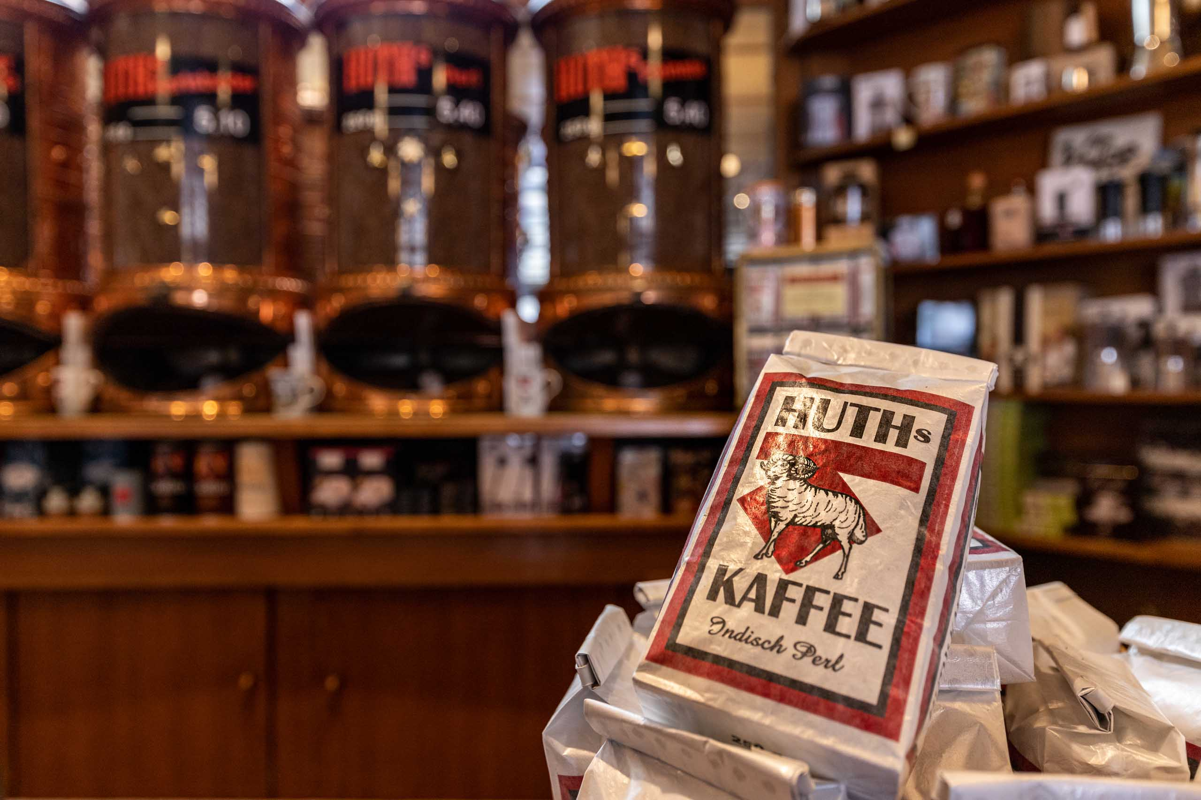
There are many local products to discover in Celle. (Copyright: Celle Tourismus und Marketing GmbH)

CELLE | Whether real gin from the Lüneburg Heath or coffee from the city's own roastery. In the Lower Saxony city of Celle, the visitor can discover culinary delights – especially directly to take away – while strolling through Celle's shops, some of which are still run by its owner. Thus, there will be all the more reason to visit the historic Old Town of Celle with its more than 490 half-timbered houses.

Many regional specialities are coming from the direct vicinity or are grown and harvested here – for more and more tourists, the topics of sustainability and local products are becoming increasingly important. Celle can really score here: In 2017, Celle was the first city in northern Germany which received the award "Sustainable Destination".

So, how about "typical Celle" or "made in South Heath" to take away?
Calluna vulgaris is the botanical name for heather. So, what could be more evident than naming a local product after it and capturing the taste of the Lüneburg Heath in a bottle? Calluna Lüneburger Heide Gin is made of typical local plants such as juniper and heather and tastes particularly good as it is additionally refined with distilled lavender and elderflowers and with an elegant hint of rose distillate. It is available in several local shops.

And coffee-drinkers should not forget to add a packet of Huth's coffee to their shopping bags. Just follow the nose, and you end up at Huth's Kaffee & Feinkost, where the coffee roaster is in motion almost every day. Here, the visitor can choose between about twenty home-roasted coffee and espresso varieties. But what about the sheepskin logo on the coffee bags? And what has a creative idea of the owner Hermann Bock in 1896 to do with it? You get to know the whole story in the shop on request or during a guided tour through the in-house roasting shop with the old Art Nouveau tiles and a coffee roaster from 1964.

A visit to the fish shop Nölke should not be missed. It is absolutely recommended to buy smoked fish fresh from the oven to take away. The professional fisherman is allowed to lay out his pots over a length of 45 kilometres along the river Aller. An idyllic workplace where you can observe not only ospreys and sea eagles but also discover rare plants such as cotton grass and sundew. The river fishing ponds are home to carp, tench and pike. In the old stone oven, the fish is smoked over alder and beech wood.

Or how about something sweet from the Institute for Apiculture? Beekeeping has a long tradition in the heathland. Even our distant ancestors in the Stone Age knew the immense benefits of honey as an energy source. The Middle Ages are considered to be the heyday of beekeeping – and once Celle was one of the largest trading centres in the north. At that time there was already professional beekeeping here. The Institute for Apiology in Celle, which is the only beekeeping school in Germany, opens its doors every Wednesday morning for the weekly sale of honey.

Sweet or bitter?
For everyone with a sweet tooth, the homemade chocolates and pralines of the bakery Baxmann Konditor & Chocolatier are a culinary delight. The pralines which are made of Belgian chocolate were created in honour of Celle's last duchess Éléonore. The honey-lavender creation with dark chocolate should remind of her French origin. The lavender stands for France, the honey for Celle. The creamy praline "Krönchen" with milk chocolate and honey-juniper praliné filling is tied to her new home in the Ducal Town. Honey and juniper are inseparably linked with the heath.

The Alte Provisor that warms the stomach is made in Celle according to an old recipe. It has also been used previously to treat some little aches and pains. The composition – a closely guarded secret. Each week, the mixture is freshly prepared. The older the "Alte Provisor", the softer and more pleasant it's taste – and this not only as a medicine. If you are lucky, you can also get an insight into the lab, while visiting the shop of the same name.

Simply stronger – Ratzeputz
At the end of the 19th century, the distiller Peter Weidmann, a passionate traveller and hunter – still today the guest can admire a stuffed crocodile shot by him which is exposed in the Restaurant Ratskeller – created the Ratzeputz, a world-famous spirit. The schnapps which contains extracts of root ginger was highly estimated as a medicine during the German Spitzbergen expedition in 1937 to warm the "cold bones of the polar travellers". Incidentally, true fans drink their Ratzeputz today out of special Ratzeputz-glasses in proper style.

Lovers of the hearty cuisine are recommended to try the Celler Gekochte, a smoked and boiled pork sausage – which is the uncontested queen at the local meat counters! It is tasty when served warm with potato salad and cold on a slice of bread, especially the Celler Landbrot. What is unique about this sausage is not only its delicious taste but also its preparation: As in former times, the lean meat is only finely minced or roughly chopped. You can buy it in butcher’s shops in and around Celle, especially at the traditional Fleischerei Zimmermann – located directly in the old town of Celle.

And last but not least, you should take a sack of Heide potatoes home with you! Everywhere in the rural district of Celle, you can buy locally grown potato varieties. Packed in different sized nets and sometimes even sorted according to size, the healthy tubers can be purchased at a low price and directly at the entrances of the farms – it’s just like a "drive-in": just stop for a while, throw some money into the cash box and take some potatoes with you.

All these delicacies cannot only be discovered and tasted in Celle, but they can also be taken home straight away – such that your trip to Celle will also remain in your taste memory.
(5.808 letters)
# # #

Please send us a voucher copy after publication.
You will find picture material and further information on our website. Should you require additional picture material, please contact us.
www.celle-tourismus.de
celle.travel

