PRESS RELEASE
Schwaebisch Hall, August 31, 2022

OPTIMA pharma looks back
on a successful ACHEMA
With future-proof, sustainable and efficient solutions, the company struck a chord with the visitors

Optima Pharma's Expert Zone proved to be a big draw for visitors at ACHEMA 2022. The technologies and innovations presented in the exclusive visitor area perfectly reflected the diverse requirements in fill & finish, isolator technology and freeze drying, many visitors agreed. Topics ranged from the premiere of a new machine to the CSPE approach (Comprehensive Scientific Process Engineering) and digitalization. New system concepts, climate-friendly refrigeration technology for freeze drying, and ultra-efficient decontamination systems were also highly sought after.
Despite the vacation season, the Optima Group's Pharma business unit recorded heavy visitor traffic at the important pharmaceutical trade show, which was held for the first time in presence again in Frankfurt am Main from August 22 to 26. Gerhard Breu, Chairman of the Optima Pharma Division, is very pleased with how the trade show went. "Together with our partners, we have risen to the challenges of the pandemic, which has unleashed a wave of innovation. A massive amount of new products are entering the clinical phase. As a result, we are now much more than a machine builder. In fact, we are a strategic partner and solution provider with a holistic approach – from designing complete lines, to providing support in the qualification phase, right through to the start of production. Direct feedback from ACHEMA visitors helps us understand their individual requirements." Many visitors at the trade show focused on the new efficiency potential offered by digitalization, reports Breu. The approaches are many and varied: The services range from the systematic, automated evaluation of performance and sensor data from systems to augmented reality in service. Optima Engineering also actively uses digital technologies, for example, for the comprehensive simulation of complete systems.
Integration of pharmaceutical lines is further increased with CSPE 2.0
These simulations are also part of CSPE 2.0, which was presented at ACHEMA. "Comprehensive Scientific Process Engineering (CSPE) is a technical and scientific approach developed by Optima Pharma that massively accelerates processes from system design to production start-up," says Matthias Poslovski, Vice President Sales at Optima Pharma. Comprehensive simulations as well as integrated factory acceptance tests of complete systems are an integral part of this. The CSPE process particularly offers significant advantages for comprehensive turnkey projects. As part of CSPE 2.0, Optima Pharma is further increasing the degree of integration of the systems, which the trade show visitors found very interesting. For example, in the new CSPE Center II, filling and closing lines with isolators – and for the first time also with freeze-drying systems – will be fully assembled. During integrated Factory Acceptance Tests (iFATs), the system is tested as a single optimally coordinated unit with all functions – all measures that massively shorten the time to production startup, explains Poslovski.
Precision despite top speed with the MultiUse system
The unveiling of the new high-speed version of the OPTIMA MultiUse system was another highlight at the Optima booth. With the up to ten-digit version, up to 24,000 objects can be processed per hour. A special feature here is that all product saving functions and the extremely high filling accuracy are retained even at high output. Flexibility is also part of the concept: Different container types and sizes can be achieved with virtually no format change parts; different product paths – including freeze-drying – are also easy to implement.
Future-proof, alternative refrigeration technologies
In the Expert Zone, future-proof alternatives in refrigeration technology were presented which do not use refrigerants that are harmful to the environment. The most important variants used by Optima Pharma range from cascade refrigeration to liquid nitrogen cooling and air refrigeration. The opportunity to try out an air cooling system at a production system, which Optima Pharma will offer at the beginning of 2023, attracted considerable interest.
Metall+Plastic's award-winning DECOpulse® bio-decontamination system also attracted considerable attention, since rapid cycle times and extremely homogeneous H₂O₂ distribution in isolators continue to be key production advantages. The potentials of a new complementary method of cycle development using enzyme indicators were also presented.
New system concepts for cell and gene therapies were another highlight in the Expert Zone. Optima has developed a holistic concept for producing and filling these particularly high-quality medicines. Visitors to the trade show got the chance to experience the automated, modular and highly flexible machine platform and the digital integration of innovative technologies. Specific machine solutions, for example for highly active ingredients, and energy-saving machine technologies were additional focal points for trade visitors in the Expert Zone at Optima Pharma.
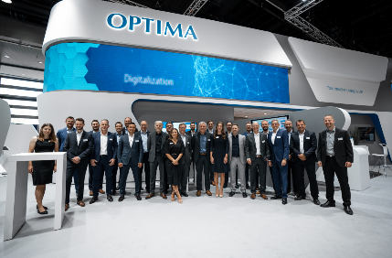The Optima Pharma trade show team informed visitors about future-proof, sustainable and efficient solutions for the current challenges facing the pharmaceutical industry. (Source: Optima)

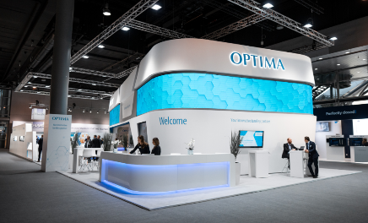
The modern Optima booth at ACHEMA 2022 in Frankfurt am Main turned out to be a big draw for visitors. (Source: Optima)

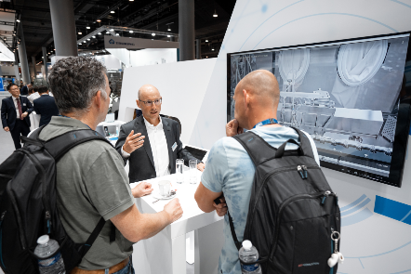Getting direct feedback in a personal conversation proved to be very valuable – both for the trade show visitors and the Optima experts. (Source: Optima)

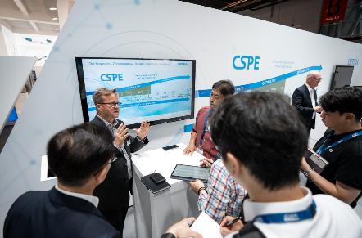
With the CSPE (Comprehensive Scientific Process Engineering) approach, Optima Pharma is accelerating the processes from system design to the start of production. As part of CSPE 2.0, Optima Pharma is further increasing the degree of integration of the systems, which the trade show visitors found very interesting. (Source: Optima)

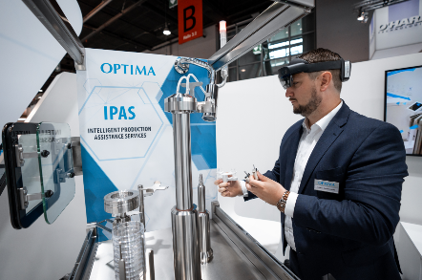
Many visitors to the trade show focused on the new efficiency potential offered by digitization. Intelligent Production Assistance Services, which can make pharmaceutical production safer and more efficient, were presented here. (Source: Optima)

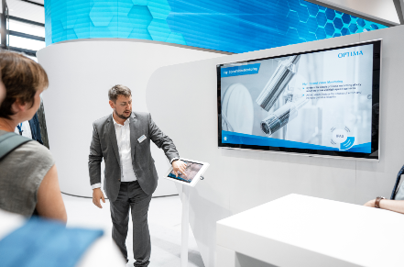
Intelligent Production Assistance Services also include high-speed cameras that monitor key process steps and ensure maximum product yield and machine availability. (Source: Optima)

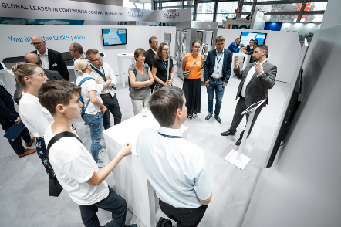Groups of visitors find out more about Optima Pharma's technologies. (Source: Optima)

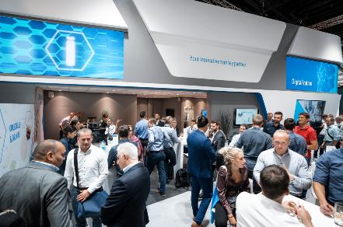
The Optima booth at ACHEMA 2022 in Frankfurt am Main was packed with visitors. Despite the vacation season, visitors seized the opportunity for an in-person exchange of ideas. (Source: Optima)

Characters (incl. spaces): 5,190

Press contact:
OPTIMA packaging group GmbH
Jan Deininger
Group Communications Manager
+49 (0)791 / 506-1472
jan.deininger@optima-packaging.com
www.optima-packaging.com

About OPTIMA
Optima supports companies worldwide with flexible and customer-specific filling and packaging machines for pharmaceuticals, consumer goods, paper hygiene and medical devices markets. As a provider of solutions and systems, Optima accompanies these companies from the product idea through to successful production and throughout the entire machine life cycle. Over 2,800 experts around the globe contribute to Optima's success. 20 locations in Germany and abroad ensure the worldwide availability of services. In 2022, Optima celebrates the company's 100th anniversary.
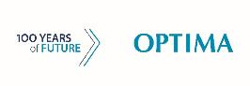
Exciting stories from 100 years of Optima: www.100-years-of-future.com

Thank you very much for your publication. We look forward to receiving a digital specimen copy.

