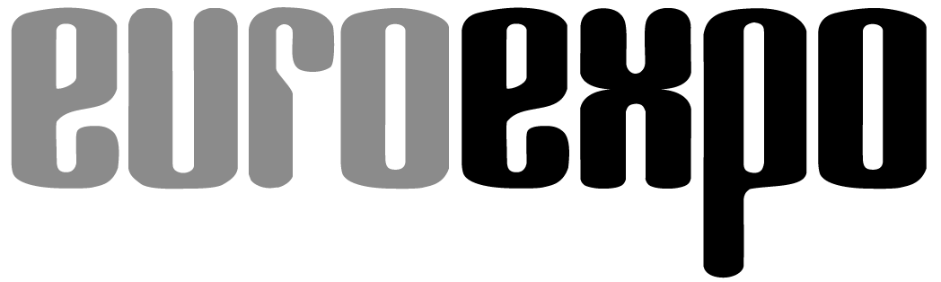
Messe- und Kongress-GmbH
Joseph-Dollinger-Bogen 7
D-80807 Munich, Germany
Phone: +49 89 32 391 259
Fax: +49 89 32 391 246
www.euroexpo.de/en
www.logimat-messe.de/en

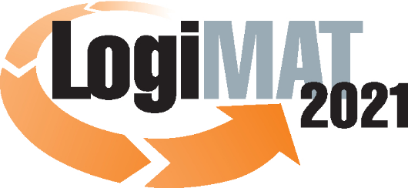

International Trade Fair for
Intralogistics Solutions and Process Management

Munich, September 23, 2020

LogiMAT 2021 in Stuttgart
Precautionary Postponement of LogiMAT 2021—
New Date: June 22–24, 2021

LogiMAT, International Trade Fair for Intralogistics Solutions and Process Management, is being postponed until early summer 2021 as a precaution amid the ongoing coronavirus. Event organizer EUROEXPO Messe- und Kongress-GmbH is responding proactively to give exhibitors and partners the certainty they need for long-term planning. LogiMAT 2021 will now take place at Messe Stuttgart June 22–24, 2021, to ensure the accustomed internationality of the trade fair.

Large trade fairs such as LogiMAT, International Trade Fair for Intralogistics Solutions and Process Management, need a reliable lead time of at least four to six months. The health and safety strategy developed by both the event organizer EUROEXPO Messe- und Kongress-GmbH as well as Landesmesse Stuttgart and the state-of-the-art architectural features of the Messe Stuttgart convention center give utmost priority to the well-being of exhibitors and visitors and eliminate any obstacle to holding the event as planned. But the latest figures from Germany’s disease control and prevention center do not give us the security we need for our exhibitors and our visitors from abroad to move forward into the final planning phase for March 2021 with confidence. That is why LogiMAT, in keeping with its reputation as one of the most important international industry events for intralogistics worldwide, will be postponed until June 22–24, 2021.

“The Messe Stuttgart convention center has outstanding safety standards in place. The air circulation and ventilation system meets all specifications, and the venue can easily comply with the other strict hygiene requirements. So as far as that is concerned, there is nothing to prevent us from hosting the event in March 2021,” explains Michael Ruchty, Exhibition Director of LogiMAT Stuttgart. “A key factor in LogiMAT’s reputation is its international character. At present, it is not possible to predict how long the travel restrictions will remain in March 2021. They will have an impact on the expected number of industry professionals from abroad who will wish to attend. That is one of the main reasons for making this decision early.”

Moving the date from March 2021 to early summer is also a clear signal to local hotels and restaurants, which are really counting on the internationality of exhibitors and visitors.

LogiMAT will take place in March once again starting in 2022.

Organizer: EUROEXPO Messe- und Kongress-GmbH
Joseph-Dollinger-Bogen 7 | 80807 Munich, Germany
Phone: +49 89 32 391 259 | Fax: +49 89 32 391 246
www.logimat-messe.de/en

2.460 characters (with spaces)

Munich, September 23, 2020—This text may be reprinted free of charge, but please send a copy to EUROEXPO Messe- und Kongress-GmbH, Press and Public Relations Department, 80912 Munich.

