PRESS RELEASE
Schwaebisch Hall, February 23, 2023

Dr. Stefan Koenig takes over responsibility of OPTIMA nonwovens GmbH
Dr. Stefan Koenig takes over further areas of responsibility in his function as Managing Director at OPTIMA

As of March 1, 2023, Hans Buehler, CEO of the Optima Group, will transfer responsibility for the business unit Optima Nonwovens to Dr. Stefan Koenig, Managing Director of OPTIMA packaging group GmbH. Dr. Koenig takes over the responsibility of all associated nonwovens units worldwide.
"With this decision, we are enhancing intensive cooperation between all units that supply machines and services for the consumer goods market. Dr. Stefan Koenig can draw on a wealth of specialist and management knowledge. The positions and tasks of the managing directors of Optima Nonwovens, Dr. Georg Pfeifer and Oliver Rebstock, will remain unchanged", explains Hans Buehler.
Since March 2021, Koenig has been a member of the Optima management board and is responsible for the Consumer and Life Science business units as well as corporate sustainability. Before Koenig joined Optima, he had held senior management positions for over 20 years, including four years spent in Asia. In his last position, Koenig was CEO at a globally active company.

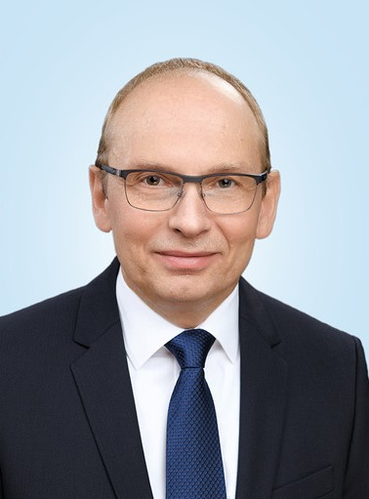
Since March 2021, Dr. Stefan Koenig is managing director of OPTIMA packaging Group GmbH. By March 2023, he takes over the responsibility for the business unit Optima Nonwovens in addition. (Source: Optima)

Characters (incl. spaces): 1,032

Press contact:
OPTIMA packaging group GmbH
Jan Deininger
Group Communications Manager
+49 (0)791 / 506-1472
pr-group@optima-packaging.com
www.optima-packaging.com

About OPTIMA
Optima supports companies worldwide with flexible and customer-specific filling and packaging machines for pharmaceuticals, consumer goods, paper hygiene and medical devices markets. As a provider of solutions and systems, Optima accompanies these companies from the product idea through to successful production and throughout the entire machine life cycle. Over 3,000 experts around the globe contribute to Optima's success. 20 locations in Germany and abroad ensure the worldwide availability of services.

Thank you very much for your publication. We look forward to receiving a digital specimen copy.

