PRESS RELEASE
Schwaebisch Hall, July 6, 2020

Thousands of miles away but still close at hand
OPTIMA introduces its new digital service

Optima has developed a new software application called "Remote Assist". The program puts the company in contact with customers and, together with the operating staff, solves any challenges that may arise directly with the machine and in real time. The central Industrial IT department has developed the digital service and the COVID-19 pandemic has accelerated its completion even more.
The current situation makes traveling more difficult, and on-site service visits even harder. The new "Remote Assist" software allows Optima to remain in close contact with customers. "Thanks to our employees' great commitment, we have succeeded in completing the new Smart Service even earlier than planned," says Dr. Benjamin Haefner, Head of Industrial IT. After a trial phase, the software is now being successfully used in a variety of customer projects. "The corona pandemic has boosted the development of digital products even more," explains Haefner. The fact that Optima set up a digitalization strategy at an early stage is now paying dividends.
Service assistance in real time
The primary function of "Remote Assist" is real-time communication for the rapid resolution of technical problems. If a problem arises during ongoing production, the Optima service expert can be immediately on the spot. The Optima Expert is right at the heart of the production line within seconds via live video and audio transmission. This enables him to purposefully guide the operator, provide direct support with troubleshooting or carrying out urgently needed work, and so get production up and running again as quickly as possible. This can be done via all mobile devices such as smartphones, tablets or augmented reality glasses. Documents like videos and operating instructions can also be streamed live.
Digital support replaces numerous on-site interventions
“At the present time, it would be almost impossible to put some systems into operation without this tool," explains Michael Weber, Director Service of OPTIMA consumer GmbH. A plant in Poland was recently commissioned in just this way. "It is already becoming clear that Remote Assist will have a significant impact on the quality and speed of support, and that in the future, some service calls on site can be dropped", says Weber. The Remote Assist complements the Format Change Assistant, which has also been recently developed to assist with format changes. Consequently, Optima's digital portfolio is continuing to take shape. All Smart Services are part of the comprehensive OPTIMA Total Care life cycle management program and are available to all of Optima's business unit customers.

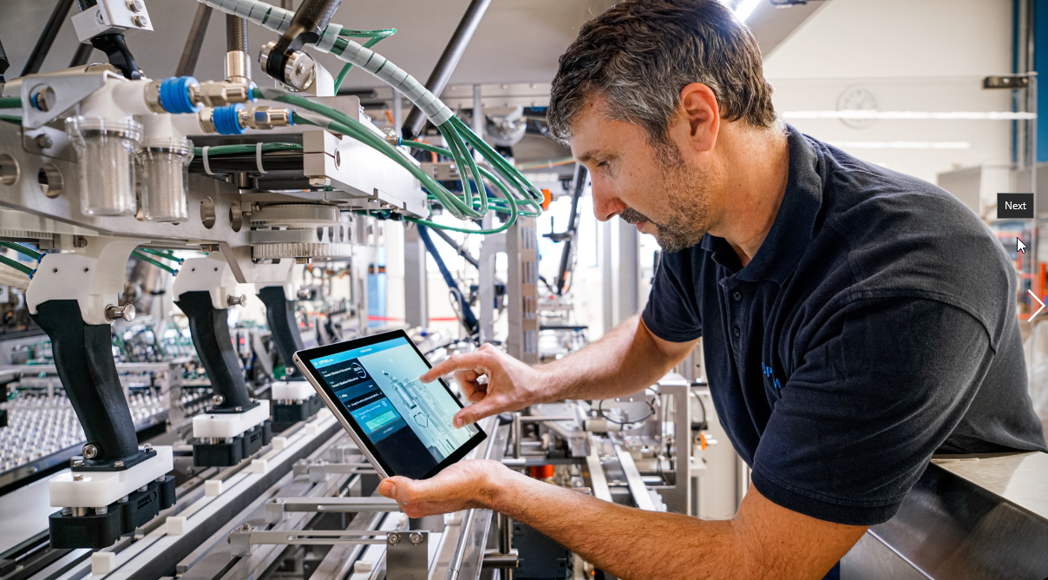
All of Optima's Smart Services can be called up at any time and any place from any mobile device in a central online platform. (Source: Optima)

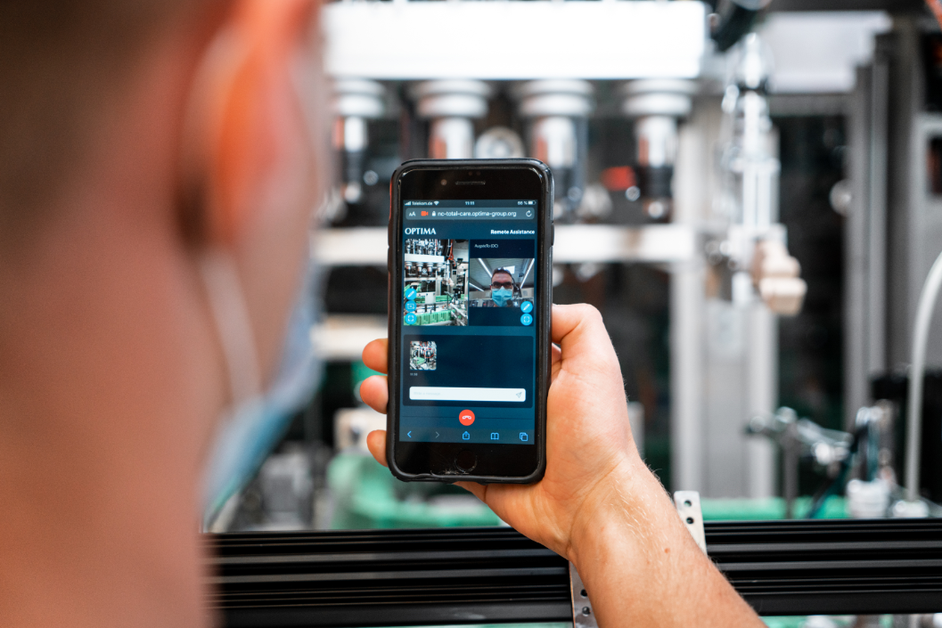
Remote Assist is a real-time communication system that enables Optima service experts to communicate with the customer. (Source: Optima)

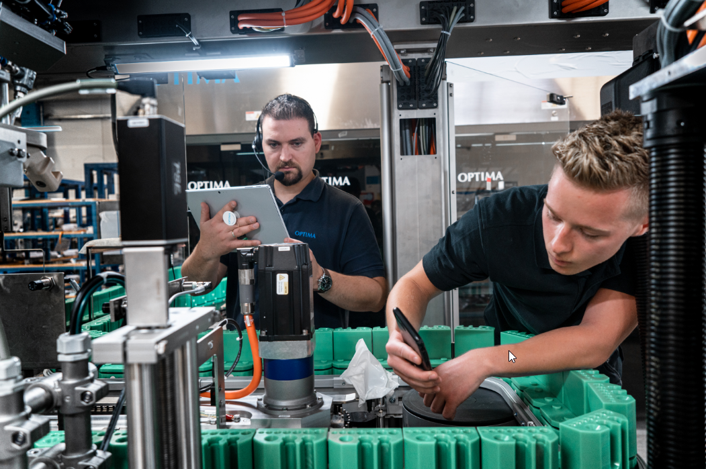
The operating personnel can exchange live information with the Optima Service – for example, images and videos of malfunctions that occur. (Source: Optima)

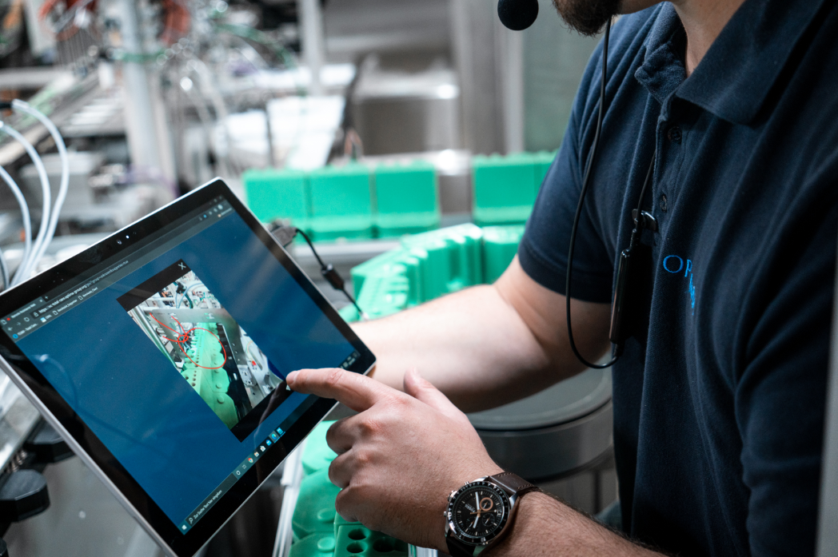
The software offers a variety of functionalities for the exchange of information. For example, problem areas can be marked and Optima service experts and operating personnel can find a solution together via chat, video and audio transmission. (Source: Optima)

Characters (incl. spaces): 2,723

Press contact:
OPTIMA packaging group GmbH
Jan Deininger
Editor
+49 (0)791 / 506-1472
jan.deininger@optima-packaging.com
www.optima-packaging.com
Thank you very much for your publication. We look forward to receiving a specimen copy.

