PRESS RELEASE
Schwaebisch Hall, June 4, 2020

SARS-CoV-2 and safe blood tests
OPTIMA BCT-200 assembly line specifically for blood collection tubes

Diagnostics play a vital role in containing pandemics. Currently, identifying the SARS-CoV-2 pathogens via antibodies in the blood is becoming increasingly important, for example to detect an infection with only mild symptoms. For this type of diagnosis, blood is often drawn from the patient with the help of blood collection tubes. Manufacturing these tubes requires several high precision assembly, dispensing and packaging steps. As a total solution, Optima Automation offers an efficient machine line for this purpose.
The Optima Automation solution combines the many functions inline up to the final transport packaging of the blood collection tubes. The first key step is to clean the tubes with deionized air and then irradiate them with UV-C LED light to effectively reduce the number of potential germs. The next step is a dispensing station for additives, which are then added according to laboratory diagnostic requirements. The OPTIMA BCT-200 can therefore be used to manufacture blood collection tubes for almost all diagnostic applications of this type. Liquid, gel-like and pulverized additives are dispensed with high precision, which is essential for the subsequent proper mixing ratio with the blood.
Some additives require a drying process which is carried out in the system. This special drying system makes it possible to maintain the high line output of up to 200 blood collection tubes per minute. Once this process is complete, the tubes are then vacuum sealed. The vacuum used here is also necessary for easily and accurately collecting blood from the patient later on as well as conducting a reliable blood analysis. Alongside the OPTIMA BCT-200 assembly line, the caps are pre-assembled by a second Optima machine, the OPTIMA BCA-200. This machine compresses rubber stoppers into plastic caps and ensures they are properly assembled. The caps are then ready for use on the assembly line.
Process controls, in particular the customized feeding systems for all components, enable highly efficient processes and outstanding product quality. The Optima BCT-200 dispensing systems are a key quality factor. Since additives can vary from manufacturer to manufacturer and from application to application, Optima Automation has set up its own dispensing laboratory to provide customer-specific solutions.

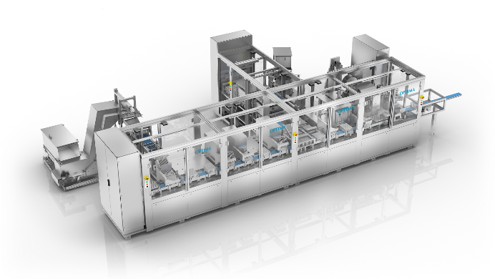

The OPTIMA BCT-200 assembly line for blood collection tubes has many functions. These include cleaning, bacteria reduction, various dispensing stations for additives, drying and vacuum sealing all the way up to the final packaging. (Source: Optima)

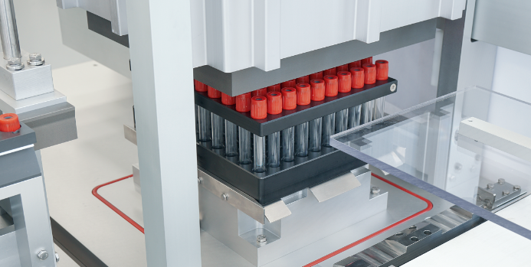
The OPTIMA BCT-200 assembly line manufactures and packages blood collection tubes. Additives are dispensed into the tubes, which are then vacuum sealed (picture). (Source: Optima)

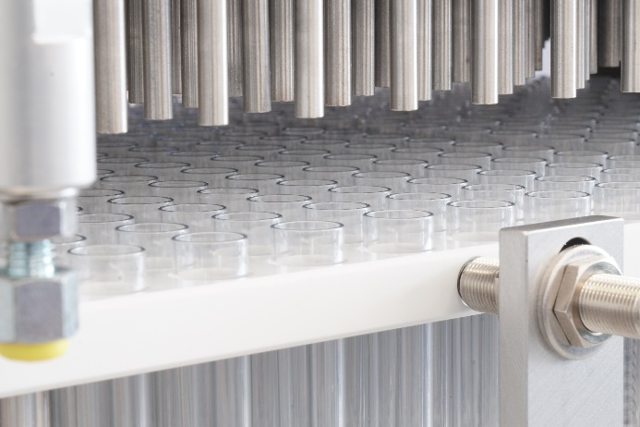
Drying additives in blood collection tubes. Based on the OPTIMA BCT-200, Optima Automation implements a wide range of customer-specific requirements for both assembly and manufacturing processes. (Source: Optima)

Characters (including spaces): 2,423

Press contact:
OPTIMA packaging group GmbH
Jan Deininger
Editor
+49 (0)791 / 506-1472
jan.deininger@optima-packaging.com
www.optima-packaging.com
Thank you for publishing this information. We would be pleased to receive a file copy.

