GEA acquires stake in heat storage provider Caldera

Duesseldorf (Germany), March 31, 2025 – GEA is investing twelve million euros in the British company Caldera. Caldera has developed electric Storage Boilers that can store electricity in the form of heat that can be extracted on demand. The product is suitable for a wide area of applications. GEA sees it as an important element within holistic concepts for decarbonizing process heat demand between 100 and 200°C, which is typical for many industrial processes.

Decarbonization of industrial process heat: GEA heat pumps and Caldera Storage Boilers are complementing each other

GEA combines its process and heating expertise to develop systems to reduce energy consumption, reuse energy and upcycle waste heat streams in customer sites. Heat pumps are a key enabler for the decarbonization of process heating in industries such as food manufacturing, dairy production, breweries, distilleries and the pharmaceutical sector.

By combining GEA's heating solutions with Caldera's innovative storage boilers, it is possible to offer an affordable and reliable way of providing industrial customers with all-electric - and therefore low-carbon – heat. A combined system joins the benefits of a highly efficient heat pump with the flexibility and fast response time of a storage boiler. This allows for the efficient decarbonization of steam networks with varying demand profiles that are typical across a broad range of industries.

“We are seeing major benefits in electrification and using thermal storage to deal with supply and demand volatility in generating heat throughout our end-markets. At GEA, we are committed to leading this transition. That's why we have invested into Caldera,” says Kai Becker, CEO of GEA's Heating & Refrigeration Technologies Division. Becker continues: “Caldera's storage boiler is a milestone. It bridges the gap between variable renewable electricity generation and industrial process heat demand and offers a scalable, economically viable alternative to fossil fuel boilers.” Kai Becker concludes: "Caldera storage boilers in combination with GEA heat pumps are ideally suited to decarbonize fluctuating industrial heat demand between 100 and 200°C. With GEA's global reach, process and industrial heating expertise, we can accelerate the deployment of such complementary solutions to industries worldwide.”

“The investment from GEA is a game-changing opportunity for our company and a strong endorsement of our technology,” says James Macnaghten, CEO of Caldera. “Having just started to sign early orders we know that we are on the right track. I believe that working with GEA and especially leveraging GEA's vast experience will help deploy our Storage Boilers into even more companies such as breweries, distilleries, the dairy industry as well as the food and pharmaceutical industries, with the ultimate goal of reducing carbon emissions for the benefit of all,” Macnaghten concludes.

Photos:

Photo 1:



Photo 1, caption: James Macnaghten, CEO of Caldera (left) and Kai Becker, CEO of GEA's Heating & Refrigeration Technologies Division (right), seal GEA's investment in Caldera. (Photo: GEA/Mike Henning)

Photo 2:

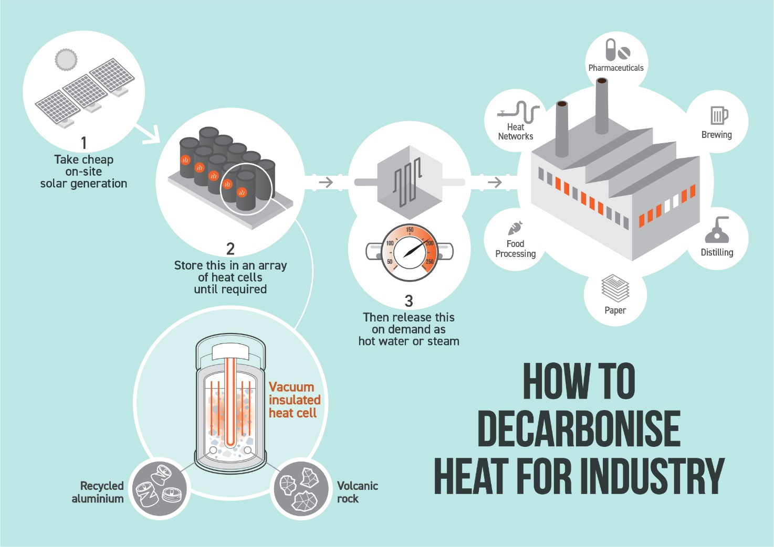

Photo 2, caption: Decarbonization of industrial process heat: GEA heat pumps and Caldera Storage Boilers are complementing each other. (Graphic: Caldera)

Photo 3:

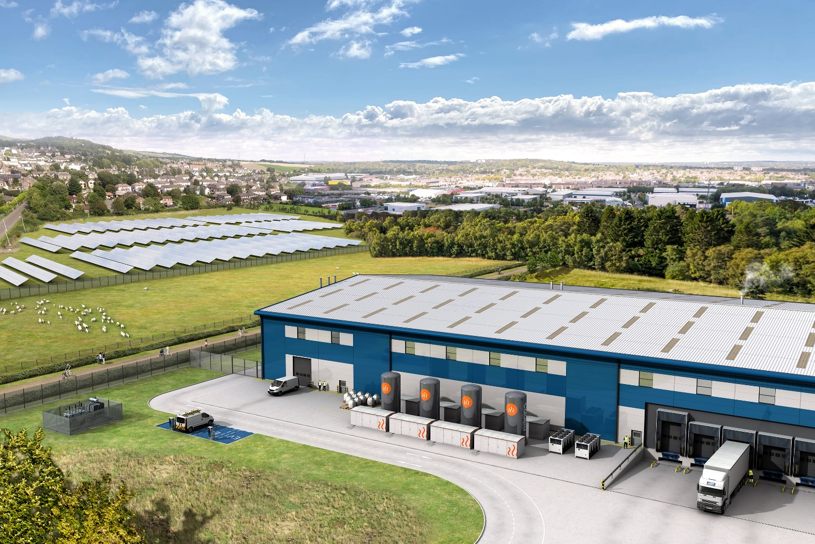

Photo 3, caption: GEA is investing twelve million euros in the British company Caldera. Here is a photo of the factory. (Photo: Caldera)

Background information:

About Caldera
Caldera is a British manufacturer transforming how industry generates heat. Founded in 2017 and based in Hampshire, the company has developed a novel electric Storage Boiler that converts renewable electricity into clean, on-demand heat for industrial applications.

Caldera’s system uses a thermal storage material made from volcanic rock and recycled aluminium, insulated using a proprietary vacuum technology to retain heat for extended periods.

The solution enables industrial users—such as brewers, distillers, food processors, and pharmaceutical manufacturers—to replace fossil-fuel boilers with a cost-effective, low-carbon alternative. With growing international interest, Caldera is now scaling up, manufacturing and deploying systems across the UK and Europe.

Learn more at www.caldera.co.uk

About GEA
GEA is one of the world’s largest suppliers of systems and components to the food, beverage and pharmaceutical industries. The international technology group, founded in 1881, focuses on machinery and plants, as well as advanced process technology, components and comprehensive services. For instance, every second pharma separator for essential healthcare products such as vaccines or novel biopharmaceuticals is produced by GEA. In food, every fourth package of pasta or every third chicken nugget are processed with GEA technology. With more than 18,000 employees, the Group generated revenues of about EUR 5.4 billion in more than 150 countries in the 2024 fiscal year. GEA plants, processes, components and services enhance the efficiency and sustainability of customers’ production. They contribute significantly to the reduction of CO2 emissions, plastic usage and food waste. In doing so, GEA makes a key contribution toward a sustainable future, in line with the company’s purpose: ”Engineering for a better world.”

GEA is listed on the German MDAX, the European STOXX® Europe 600 Index and is also a constituent of the leading sustainability indices DAX 50 ESG, MSCI Global Sustainability and Dow Jones Best-in-Class World.

More information can be found online at gea.com.
If you do not wish to receive any further information from GEA, please send an e-mail to pr@gea.com.

NOTE TO EDITORS

- Further information about GEA
- To the GEA Press page
- To the GEA Media Center
- Background information on current topics can be found at Features
- Follow GEA on  

GEA
Media Relations GEA
Dr. Michael Golek
Peter-Müller-Str. 12, 40468 Düsseldorf
Phone +49 211 91361505
Tel. +491736205746
michael.golek@gea.com

Caldera
Neil Davidson
neil@neildavidson.org
+44(0) 7545 735402

