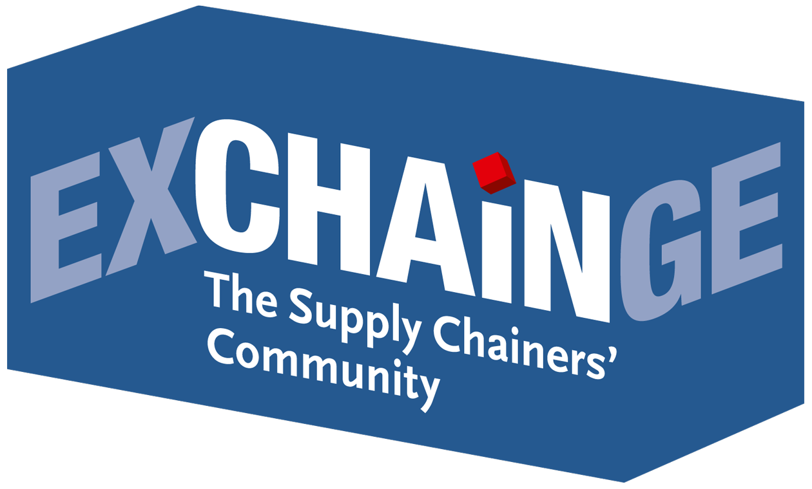
“EXCHAiNGE stands for genuine dialog in an interactive atmosphere – for clear and even cautionary messages.”
Interview with Dr. Petra Seebauer, the creative force behind the EXCHAiNGE conference and Managing Director of EUROEXPO Messe- und Kongress-GmbH
Interview by Sabine Ursel, Communications | Press | Network,
journalist and communications consultant in Wiesbaden (focus: procurement/distribution)

Dr. Seebauer, when an event takes place for the sixth time, it doesn’t seem too early to speak of tradition. This year, EXCHAiNGE is migrating from its traditional base at HOLM, the House of Logistics and Mobility, to a new home at Messe Frankfurt. Why?
Dr. Petra Seebauer: We’re only moving 15 kilometers – hardly a problem for logistics experts. But to be serious: Hypermotion and EXCHAiNGE complement each other perfectly, with a combined program spanning a wide range of forward-looking themes. This partnership offers critical added value for visitors and exhibitors alike. EXCHAiNGE links trends with the strategic core functions of the supply chain. The Hypermotion trade show offers a broader context in which smart systems and vendor solutions for mobility, transport, logistics, and digital infrastructure come to life. EXCHAiNGE, as a forum for SCM experts, aligns wonderfully with Hypermotion’s diverse mix of conferences, tech talks, and start-up pitches.
EXCHAiNGE debuted in 2013. What was your vision at the time? EXCHAiNGE has, after all, long since evolved into more than just an annual event.
Seebauer: At the time, we wanted to establish an entirely new kind of platform. Our goal was to integrate supply chainers with other functional areas. Global supply chains and structures for new and sometimes disruptive business models work smoothly only if logistics, purchasing, and finance professionals all come together to develop a shared vision and accepted approach. We want to continue driving this network. And today, six years later, we now talk about “EXCHAiNGE – the Supply Chainers’ Community.” The idea is to begin with genuine, face-to-face dialog in an interactive atmosphere with various topical sessions that then develop into new cross-disciplinary and cross-enterprise networks around specific themes. People ask questions, offer help – and sometimes find new business partners. So our platform offers a special added value that people find extremely valuable.
In addition to our annual event, we also offer EXCHAiNGE seminars, forums, and panel discussions – at the intralogistics trade show LogiMAT, for example, held in the first quarter of each year in Stuttgart. Here, too, visitors appreciate the interactive approach in an open atmosphere and the exciting mix of experts from companies of all sizes and industries. The feedback we receive from participants is very important to us. And what it teaches us is that the general concept of “EXCHAiNGE – the Supply Chainers’ Community” has fully lived up to its vision. So we have a mission that we take very seriously.
What special themes will you address in November at the EXCHAiNGE conference in Frankfurt?
Seebauer: The theme for 2018 is “Management 4.0 – New Work & Digital Business” Our program committee also incorporated the input received from last year’s participants. We’ll explore the larger themes of innovation, digital disruption, sustainability, and the culture of digital transformation. We’ll ask, for example, where pioneering innovations can be achieved along the supply chain and what role non-industry players might play in the future. I am also intrigued by the question of how companies will respond to the trend of sustainability over speed – and whether that’s what they really want. One can certainly offer thought-provoking arguments here. The idea that blockchain, big data, and AI are the foundation of strategic initiatives is not new. We intend to “cut to the chase” in our discussions.
EXCHAiNGE stands for clear and even cautionary messages. Our participants will quickly see through any attempt to whitewash the issues. It should be clear to everyone by now that disruption of any type shakes up the previously dominant structures. New processes cannot be managed through experience and level-headedness alone. Presentations often highlight change as the critical factor for success when it comes to leadership, mindsets, and culture. But what does that actually mean in reality from a business psychology perspective? We will address this difficult issue at EXCHAiNGE – once again, with the help of interactive exercises. This approach proved most enlightening in previous years, including for me.
What else is on the program besides the sessions?
Seebauer: We’re introducing supply chain simulations on all three days, November 20–22. Participants will have one hour to figure out how collaboration and interdepartmental cooperation equal success in a real-life scenario. The aim is to squeeze new life out of “The Fresh Connection,” a fruit juice company. This kind of simulation is also a lot of fun for everyone involved.
And I’m eager to see who will win the Supply Chain Management Award this year. The finalists will present their ideas live on November 20. The audience will use a voting tool to weigh in, then the jury will convene. We will also introduce a new special prize in 2018, the Smart Supply Chain Solution Award. The idea is to honor solutions with the potential to fundamentally transform traditional value chains. The winners will be announced at the Award Night on November 21.
Dr. Seebauer, one last question: Who absolutely must attend EXCHAiNGE – and above all, why?
Seebauer: I’ll return to our imaginary fruit juice company. “The Fresh Connection” desperately needs a well-connected management team of supply chain, production, purchasing, and sales experts. This underscores why it’s a dead end to pursue only your own interests. Companies that wish to position themselves as drivers of innovation and hope to gain critical competitive advantages must bring all participants on board. Our community shows how internal and external networking is done. EXCHAiNGE brings together companies of all sizes, from start-ups to large enterprises. We supply chainers are more than happy to get new ideas from our colleagues in purchasing, sales, HR, and accounting. Everyone is invited to ask questions and even offer answers.

Save the date:
EXCHAiNGE – the Supply Chainers’ Community 2018
6th international supply chain meeting
with sessions, panel discussions, live simulations, the presentation of finalists, and an Award Night ceremony
November 20 and 21, 2018
at Hypermotion in Frankfurt am Main
Learn more about EXCHAiNGE 2018, now for the first time in combination with the Hypermotion trade show!
Learn more about Hypermotion.

On the agenda of EXCHAiNGE 2018:
- Start-ups, corporates or customers: Who is actually doing the innovating?
- Sustainable supply chains: Can customers and logistics players find common ground?
- Culture and mindsets for the digital transformation: Reinvigorate your business by eliminating barriers to innovation
- Digital disruption: How are big data, blockchain, and AI changing traditional business concepts and organizational models?
- Supply chain simulation: How collaboration and interdepartmental cooperation breed success
- Supply chain best practices: Details behind the scenes (live presentation of award finalists)
- Award Night: Presentation of Supply Chain Management Award 2018
Learn more at www.exchainge.de.
To sign up online, go to www.exchainge.de/en and click on “Register” in the top navigation.
About EUROEXPO Messe- und Kongress-GmbH
EUROEXPO Messe- und Kongress-GmbH was founded in 1996. Today, EUROEXPO organizes LogiMAT – the annual international trade show for intralogistics solutions and process management – as well as LogiMAT China and TradeWorld, the professional platform for trade processes.
EUROEXPO also organizes “EXCHAiNGE – the Supply Chainers’ Community.” The international business conference, now in its sixth year, targets leaders from the areas of SCM, finance, logistics, and purchasing at start-ups, small and medium-sized businesses, and large enterprises. EUROEXPO is also a service provider offering B2C and B2B event management services, such as the organization and implementation of the LOGISTIK HEUTE series.
For more information, please visit: www.euroexpo.de.

Images are available at www.exchainge.de/en under BLOG/PRESS in the top navigation.

For more information, please contact:
Hendrikje Rother
Marketing/Press
EUROEXPO Messe- und Kongress-GmbH
Phone: +49 89 323 91 240
hendrikje.rother@euroexpo.de
www.exchainge.de/en

(Characters with spaces: 7,563)

EUROEXPO blog postings may be reprinted free of charge. Texts and images can be found at the EXCHAiNGE blog page under www.exchainge.de.
Please send a copy of any republication by email to hendrikje.rother@euroexpo.de or by postal mail to EUROEXPO Messe- und Kongress-GmbH | Presse- und Öffentlichkeitsarbeit | Joseph-Dollinger-Bogen 7 | 80807 München.

