Annual report of the LAMILUX Heinrich Strunz Group

LAMILUX continues to grow

2021 was another successful year for the LAMILUX Group: despite the still ongoing challenges of the corona pandemic and a very tense raw materials' situation, the Rehau-based family business was able to achieve the highest turnover in the company's history last year. The company also increased the number of employees by 5 percent and thus reached the highest number of employees since its foundation in 1909.

The now more than 1250 employees of the family-owned company generated a turnover of 335 million euros, which corresponds to a 15 percent increase in turnover compared to the previous year. Further milestones for LAMILUX in the past year were numerous awards and product launches.

"We not only achieved the highest turnover in the company's history in 2021, but now also employ the highest number of staff and have generated a solid result despite the difficult raw material situation and enormous price increases, which I have never come close to experiencing in my 36 years as LAMILUX Managing Director. Our company has a solid foundation, and we look back proudly on 2021 and positively into the new year 2022," summarizes LAMILUX Managing Director Dr. Heinrich Strunz.

LAMILUX Skylights
Promising new products prove LAMILUX's innovation leadership in the market. In 2019, LAMILUX already developed a glass roof that can withstand fire and heat for up to 30 minutes - certified according to German and European standards. Now the skylight and fire protection specialist has succeeded in extending this protection for people, property and buildings: The new LAMILUX Glass Roof Fire Resistance REI60 defies fire for a whole hour. But not only fire protection plays a role for Europe's leading manufacturer of skylight systems: with the new Flat Roof Access Hatch Comfort Square LAMILUX combines purist design and function in a new form.

LAMILUX Composites
In the LAMILUX Composites division, too, new product launches took unique positions in the market. With LAMILUX FireShield®, the company presents flame-retardant, fibre-reinforced plastics that meet the most diverse flame protection requirements as well as a wide range of requirements in terms of mechanics, appearance, hygiene and functionality. And in 2022, LAMILUX also has new, innovative product developments from the field of fibre-reinforced plastics in store.

10-times award-winning
A total of 10 awards confirms the growth and innovative strength of the LAMILUX Group. In addition to the Axia Best Managed Company Award, which names LAMILUX as one of the best-managed companies in Germany, the trade journal Handelsblatt identified the Rehau-based family business as one of the fastest-growing medium-sized companies in Germany in 2021.

In the field of skylight systems, the German Design Award 2021, Red Dot Award 2021, Architects' Darling 2021 all honour the outstanding design quality of LAMILUX products. The digital solutions that LAMILUX offers for the construction industry were also highly praised: the German Innovation Award 2021 and Digital Champions Award 2021 honour the LAMILUX BIM and product configurator as well as LAMILUX World, its virtual showroom, which the company published online in November. In addition, the EUROBAUSTOFF specialist group Roof&Facade awarded LAMILUX as "Top Supplier 2021".

In the field of fibre-reinforced plastics, the company is delighted to have received design awards from the German Design Awards 2021 as well as being listed among the 500 secret world market leaders 2022, as determined by WirtschaftsWoche. LAMILUX Composites also won the Focus Money Award for "Germany's best jobs with a future".

Focus on qualified employees
LAMILUX was not only concerned about the corona pandemic and the raw materials' situation in 2021, but also about the shortage of qualified employees. To counteract this, LAMILUX focuses on the training and further education of skilled workers. "The training and further education of qualified employees is one of the most decisive factors in times of a shortage of skilled workers. This is why we currently have 95 apprentices undergoing our award-winning training concept 'EDUCATION for EXCELLENCE'. This corresponds to a very high apprenticeship rate of 8 percent. In addition, we support our employees in their professional and personal development with our internal training programme 'TRAINING for EXCELLENCE'. After all, qualified specialists are the engine of every company," explains Dr. Dorothee Strunz, Managing Partner.

Future-oriented investments
In addition to the numerous awards, new products and turnover figures, the investments made by the family-owned company also confirm that LAMILUX is looking positive into the future and planning for the long term. Two new production facilities are currently being built at the Rehau headquarters, which will enable the company to produce new products and increase current production capacities. In addition, existing production facilities have been expanded, and a new office building has been developed, providing jobs for around 50 employees. In this way, LAMILUX is creating friendly workplaces for the constantly growing number of employees, where the motto can be implemented: "Customized Intelligence - Serving the customer as a programme".

...

www.lamilux.com

LAMILUX Heinrich Strunz Group, Rehau (Germany)
Continuous rooflights, glass roofs or rooflight domes: The LAMILUX Heinrich Strunz Group is one of the leading manufacturers of skylights in Europe. The skylights ensure efficient use of natural daylight in a wide variety of buildings. In addition, special smoke and heat exhaust ventilation systems provide safety in case of fire and are thus essential components of fire protection concepts. LAMILUX is also known for its solutions for smoke extraction for buildings. Furthermore, the medium-sized family business founded in 1909 is one of the world's largest producers of carbon and glass fibre reinforced plastics. These composite materials provide stability, lightweight construction and impact resistance, for example as roof, wall and floor linings in commercial vehicles. The company currently employs a workforce of more than 1250 people and achieved a turnover of roughly 335 million euros in 2021.

The LAMILUX Group in 2021
Turnover: 335 million euros (2020: 293 million)
Employees: around 1250 (increase of 5 percent compared to the previous year)
Awards: Axia Best Managed Company 2021, Germany's fastest-growing medium-sized company 2021, German Design Award 2021, German Innovation A-ward 2021, Red Dot Award 2021, Digital Champion Award 2021, Architects' Darling Award 2021, Eurobaustoff Top Supplier 2021.
Internationality: Export quota over 50 percent, 84 sales partners worldwide
Management: Dr Heinrich Strunz, Dr Dorothee Strunz, Johanna Strunz and Dr Alexander Strunz (managing partners), Niklas Braun, Oliver Liebsch, David Plaetrich, Norbert Schug, Dr Marcus Seitz (authorized signatories, extended management)

Image description:

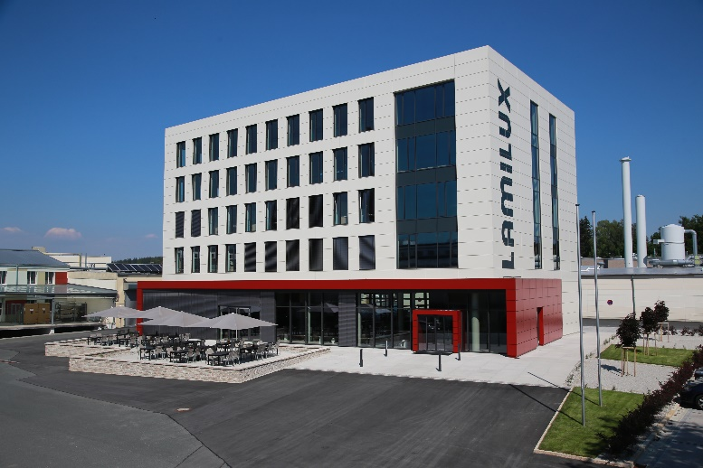The LAMILUX administration building in Rehau, Upper Franconia - the headquarters of the family-owned company.

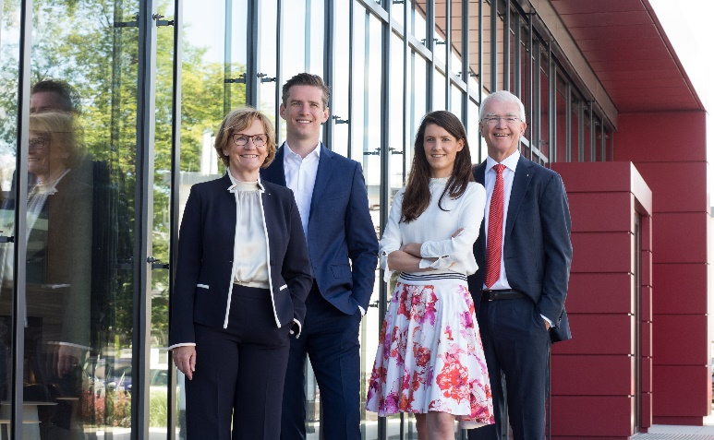
The managing partners: f.l.t.r.
Dr. Dorothee Strunz,
Dr. Alexander Strunz,
Johanna Strunz,
Dr. Heinrich Strunz

