**PRESS RELEASE**

Schwaebisch Hall, May 02, 2023

**Holistic cooperation with new**   
**technologies and sustainable design**

OPTIMA supports the development of a   
sustainable travel set for personal hygiene

**Optima has supported the development of a sustainable travel set for daily personal hygiene from renewable, fiber-based raw materials as a technology partner. The concept is named “Trific”. Successful cooperation throughout the entire value chain and new technologies have made this solution possible. In addition to Optima, the companies Holmen Iggesund, Yangi® and FutureLab & Partners also contributed to this project. The project intends to motivate brands to switch to sustainable packaging and will be introduced at Interpack. The packaging trade show begins on May 4 in Düsseldorf. Optima is presenting other sustainable packaging innovations alongside this.**

Greater sustainability can only be achieved by working together in close partnership throughout the entire value chain. That is one of the principles of Optima’s sustainability strategy since its introduction. The approach has proven itself once again, this time in developing a travel set for short two-day trips in cooperation with three partner companies from Sweden: Holmen Iggesund, Yangi® and FutureLab & Partners.

**The aim of the cooperation: to speed up the development of sustainable packaging solutions**

"For our customers, we are an innovation partner for sustainable packaging. In cooperation with partners, we develop a wide range of sustainable packaging concepts. The Trific concept shows that new technologies, above all, achieve faster market readiness through cooperation across the value chain. With the solutions developed, we want to support our customers in achieving their own sustainability goals as well as offer the end consumer more sustainable options,” adds Dominik Bröllochs, Head of the Sustainable Solutions department at Optima. Another project goal is to expedite the introduction of new sustainable premium packaging solutions for the health, hygiene and cosmetic industries. “The approach demonstrates how companies and brands find solutions together to develop alternatives to their current plastic packaging as quickly as possible. We are continuing to set trends on the market.” explains Bröllochs.

**Benefits: renewable materials, low-energy manufacturing**   
**and user convenience**

During the development of the biobased concept, the partner companies researched designs optimized for the circular economy, materials, dry forming technologies and end-of-line barrier solutions. The end result is a circular packaging solution that eliminates material waste. Additionally, it combines three elements of modern travel cases: renewable materials, low-energy manufacturing and user convenience. The prototype was developed within six months. The unique travel set is aimed at people who want to travel responsibly. It contains three dry and innovative products: a solid shampoo bar, body soap as well as solid toothpaste which turn into liquid when used. The packaging itself consists of 100 percent recyclable and renewable materials. Depending on the product and the required product protection, the packaging can also be designed to be biodegradable.

**OPTIMA provides support with expertise in barrier technologies**

Optima provided significant support to the project with their comprehensive expertise in various barrier technologies for protecting products. This expertise has been developed and deepened during countless cooperations. Optima checks various barrier solutions on their premises to comply with different requirements. “Our materials and technologies for molding, barrier solutions, as well as filling and handling sophisticated products make a valuable contribution to improving health, safety and quality of life,” adds Dr. Stefan König, Managing Director of the Optima Group. "Attractive products are created when they offer a high level of added value and at the same time have a holistic sustainable design. This is achieved with new technologies and a close cooperation in the value chain. The Trific travel set is the best proof of this and serves as an example of application," says König.

**Renewable, eco-friendly wood fibers**

“This all sounds so simple, but offering dry cosmetics in a travel set from renewable materials – that’s never been done before,” says Hein van den Reek, Director Future Packaging at Holmen Iggesund. The Swedish packaging manufacturer supplied the renewable wood materials used to make the Trific travel set. The company Yangi®, also based in Sweden, transformed wood fibers into moldable packaging using minimal resources. “With our groundbreaking dry molded technology, we are pioneering the next generation of fiber-based solutions and reshaping the world of packaging,” says Anna Altner, founder of Yangi®. FutureLab & Partners, the third partner company, was the design partner for the Trific packaging. “Visualization and prototyping bring together what the technology can offer and what the users need,” adds Liselotte Tingvall, CEO at FutureLab & Partners, regarding the strengths of their company.

In addition to the Trific concept, Optima is presenting other sustainable packaging solutions at Interpack. These include a new sustainable can portfolio with different shapes and closure solutions, as well as fiber-based solutions for the single-serve sector.

Find out more about the project at: www.optima-packaging.com/trific

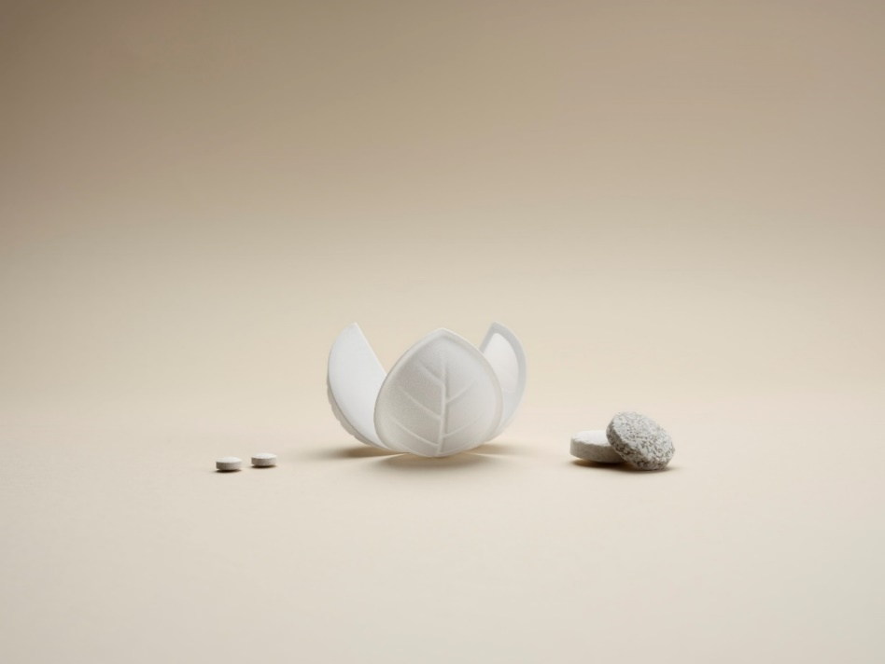

With the new travel set “Trific” the cooperation partners Optima, Holmen Iggesund, Yangi® and FutureLab & Partners are revolutionizing the value chain for personal hygiene travel sets. (Source: Optima)

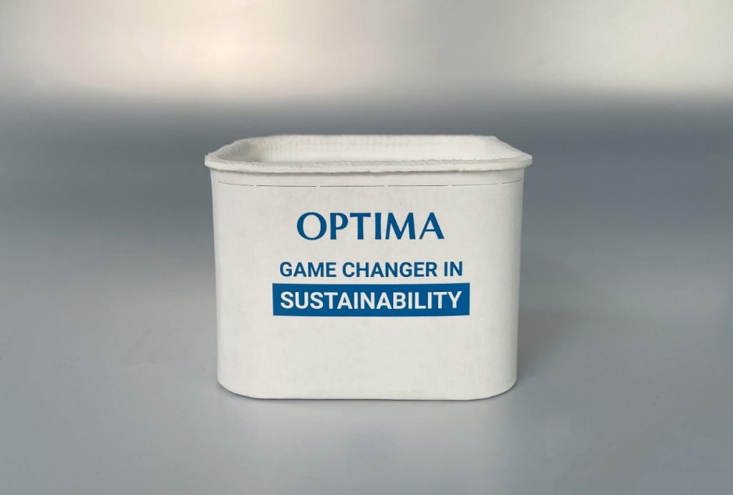

Optima is presenting a new sustainable can portfolio at Interpack with different shapes and closure solutions. The highlights include aluminum-free barrier solutions and a completely fiber-based lid with hinge function. (Source: Optima)

Characters (incl. spaces): 5,424

Press contact:

OPTIMA packaging group GmbH

Jan Deininger

Group Communications Manager

+49 (0)791 / 506-1472

pr-group@optima-packaging.com

www.optima-packaging.com

**About OPTIMA**

Optima supports companies worldwide with flexible and customer-specific filling and packaging machines for pharmaceuticals, consumer goods, paper hygiene and medical devices markets. As a provider of solutions and systems, Optima accompanies these companies from the product idea through to successful production and throughout the entire machine life cycle. Over 3,000 experts around the globe contribute to Optima's success. 20 locations in Germany and abroad ensure the worldwide availability of services.

Thank you very much for your publication. We look forward to receiving a digital specimen copy.