|  |
| --- |
| Technical University  Brunswick  **Institute of Bioprocess Engineering**  Rebenring 56 38106 Brunswick  June 02, 2026 |

|  |
| --- |
| **Press release**  **for the commissioning of a GEA Group disc separator at the Center for Pharmaceutical Process Engineering (PVZ) at TU Braunschweig** |

**Key technology for bioprocesses: The Center for Pharmaceutical Process Engineering at TU Braunschweig expands its capacities with a GEA disk stack separator and homogenizer**

**Düsseldorf/Braunschweig, June 2, 2025** - Advances in biopharmaceutical research require continuous development of the technical infrastructure. Efficient and precise separation of cells from culture supernatants is a crucial step in biotechnological processes. In order to meet these challenges, the Center for Pharmaceutical Process Engineering (PVZ) at the Technical University of Braunschweig is expanding its biotechnology center with a state-of-the-art disk stack separator from machine and plant manufacturer and solution provider GEA. By supplying the device, GEA is supporting biopharmaceutical research at the PVZ. A *Pathfinder* with a throughput capacity of up to 200 l/h will be used. The *Pathfinder* is specially designed for applications in biopharmaceutical pilot plants and will also open up new paths in bioprocess engineering here.

**Research work at TU Braunschweig's PVZ is important for the further development of modern medicine and pharmaceuticals**

The PVZ is an interdisciplinary research center in which around 100 scientists from the fields of process engineering, biotechnology, pharmacy and other natural and engineering sciences work together. The aim is to develop and optimize manufacturing processes for innovative biopharmaceutical products that can be individually tailored to patients. A major focus of the *Pharmaceutical-Biological Process Technology* department at the PVZ is on biotechnological processes that are used in the production of active ingredients such as therapeutic proteins, antibodies for immunotherapy, enzymes for industrial biocatalysis and the biotechnological production of new antibiotics. These processes are essential for modern medicine and the pharmaceutical industry.

**GEA homogenizer PANDA already successfully in use at PVZ**

Some time ago, GEA supplied the PVZ with a PANDA PLUS high-pressure homogenizer. The PANDA is particularly suitable for the high-pressure processing of nanoparticles and cell disruption. The homogenizer has a touch panel for easy control of all machine functions and is suitable for *cleaning-in-place* (CIP) and *sterilization-in-place* (SIP) procedures. Its compact design makes it easy to install, use and maintain.

With the addition of the *Pathfinder* plate separator from GEA to the biotechnology center, the PVZ is now able to carry out the entire value chain of a biotechnological process on a pilot scale, from pre-culture and cultivation through to cell separation and purification of active ingredients. This enables cultivation with bioreactors of up to 100 liters and efficient cell separation. The GEA *Pathfinder* is available in three drum sizes with a throughput capacity of 15 to 300 liters per hour. It achieves a very high separation performance thanks to up to 20,000-fold acceleration due to gravity and can therefore continuously separate even fine particles and cell fragments from cultivation media. The separator is equipped with a hydrohermetic product feed and the gentle feed system prevents shear forces from acting on the product when it is fed into the separator bowl. Thanks to its self-cleaning bowl, the unit is suitable for fully automatic CIP. The GEA *Pathfinder* is also equipped with a package of basic *Good Manufacturing Practice* (GMP) certificates. This complete package enables fast, scalable and reproducible process control, which is crucial for the development of tomorrow's biopharmaceutical products.

**Strategic cooperation with GEA - major industrial projects planned**

In addition to conducting basic research projects, the use of the separator forms the basis for extended applied industrial research and development collaborations. As early as summer 2025, two industrial projects led by Prof. Rainer Krull and M. Sc. Jan-Angelus Meyer from the Institute of Bioprocess Engineering (ibvt) at TU Braunschweig will be carried out with the *Pathfinder*, building on the new technical possibilities of the Biotechnikum. "In future, the PVZ will thus offer extended opportunities for collaboration with partners from the pharmaceutical and biotechnology industry in order to advance innovative and application-oriented research," say the ibvt researchers.

**Photos:**

Photo 1:  
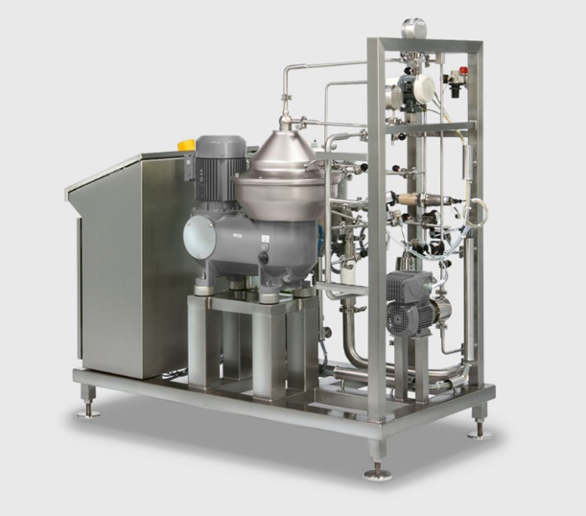  
GEA Pathfinder GMP (Photo: GEA)

Photo 2:

Ein Bild, das Toaster, Gerät enthält.

PANDA PLUS high-pressure homogenizer (Photo: GEA)

Photo 3:

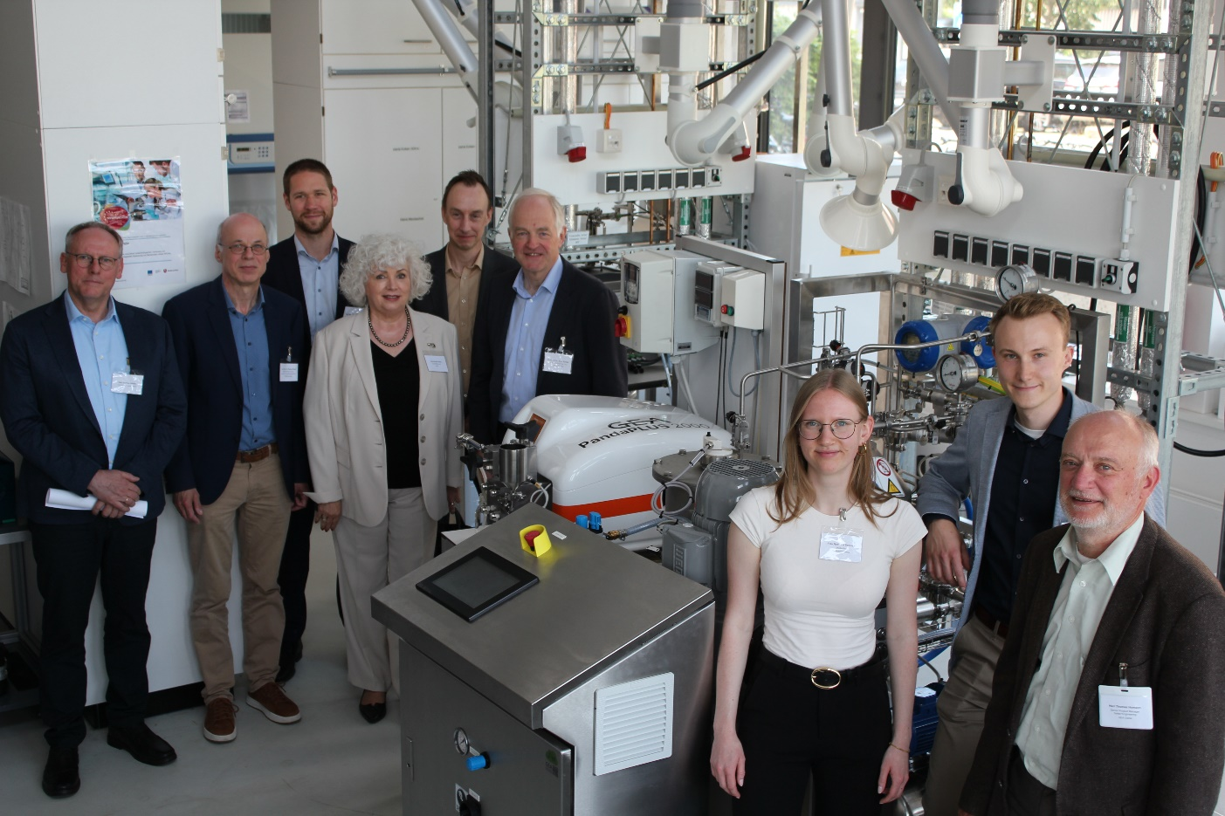

Photo 3, caption: The PVZ team, the Technical University of Braunschweig and GEA are pleased about the commissioning of the GEA technology at the PVZ Braunschweig, Germany. (Photo: PVZ)

About GEA

GEA is one of the world's largest system providers for the food, beverage and pharmaceutical industries. Founded in 1881, the internationally active technology group focuses on machines and plants as well as sophisticated process technology, components and comprehensive services. For example, every second pharmaceutical separator for essential healthcare products such as vaccines or novel biopharmaceuticals is manufactured by GEA. In the food sector, every fourth packet of pasta or every third chicken nugget is processed with technology from GEA. With more than 18,000 employees, the Group generated sales of around EUR 5.4 billion in over 150 countries in the 2024 financial year. GEA's plants, processes and components improve the efficiency and sustainability of customers' production worldwide. They make a significant contribution to reducing CO2 emissions, the use of plastic and food waste. In this way, GEA is making a decisive contribution on the path to a sustainable future, in line with the company's mission statement: "Engineering for a better world".

GEA is listed on the German MDAX and the European STOXX® Europe 600 Index and is also included in the leading sustainability indices DAX 50 ESG, MSCI Global Sustainability and Dow Jones Best-in-Class World and Best-in-Class Europe.

Further information can be found on the Internet at **gea.com**.

If you do not wish to receive any further communications from GEA, please send an e-mail to pr@gea.com.

GEA Media Relations

Dr. Michael Golek

Peter-Müller-Str. 12, 40468 Düsseldorf

Phone +49 211 91361505

Tel. +491736205746

[michael.golek@gea.com](mailto:michael.golek@gea.com)