GEA presents PERFORMA D at PMEC India

Duesseldorf, November 21, 2025 – At the world-renowned CPHI/PMEC India trade fair at the India Expo Centre, Greater Noida, Delhi NCR, global process-technology specialist GEA is unveiling a significant innovation for the pharmaceutical manufacturing industry: the PERFORMA D high-volume rotary tablet press.

This event marks the official market launch of the PERFORMA D and represents an important milestone in GEA’s long-term commitment to the region. Now manufactured in India, the PERFORMA D reinforces GEA’s strategy to localize key technologies and enhance service capability for pharmaceutical manufacturers across India and South Asia.

PERFORMA D solution for challenges faced by manufacturers of oral solid dosage forms
In today's dynamic pharmaceutical industry, characterized by stricter regulatory standards, the demand for faster line changes, and the increase in complex formulations (including bilayer tablets), the PERFORMA D offers a compelling solution to the challenges faced by pharmaceutical manufacturers: high production output, flexibility, and the highest quality. With improved tablet quality and consistency, the PERFORMA D offers a market-leading size-to-performance ratio, both in terms of cost and square footage of equipment per tablet. "With the introduction of the PERFORMA D in India, we are not only introducing another tablet press but also offering manufacturers a powerful new tool for producing complex bilayer formulations and high-volume products," said Raman Singh, Senior Director, Pharma & Healthcare Business APAC, GEA Group. "The Indian pharmaceutical industry is one of the most dynamic markets in the world, and this technology reflects our commitment to delivering locally manufactured, globally benchmarked equipment that increases efficiency, ensures quality and prepares manufacturers for the next generation of oral solid dosage form manufacturing," says Raman Singh. He adds: "This development underscores GEA's leadership position in high-performance tablet press technology for the Indian market and beyond."

Tablet production technology taken to a new level thanks to GEA technology

The PERFORMA D is designed for large-scale, cost-efficient production of oral solid dosage forms. With its double-sided configuration, the machine offers both high-volume mass production and the ability to process complex (1:10) bi-layer formulations. In addition, its advanced and future-proof design allows for easy integration of high-performance feeding and blending capacity of 600 kg/h for seamless direct compression. With a turret that can accommodate up to 106 stations, optional segmentation, and a production capacity of up to 1.14 million tablets per hour, this press is designed to handle large orders with minimal downtime.
The key features of the PERFORMA D at a glance
- Patented bi-layer tablet capability with independent weight control for each layer – enables complex formulation strategies without compromising throughput.
- Extended dwell time during pre-compression (both first and second layers) for better deaeration and defined hardness at maximum turret speed.
- A unique dual control and dual reject mechanism with weight control during pre-compression and hardness control during main compression.
- Compact footprint, intuitive MC5 control system, and a design that allows for easy maintenance and cleaning to maximize uptime.
- A turret enclosure that enables quick changeovers, improved operator protection, and GMP-compliant production.
- The press also offers six compression modes (including an option for equal dwell time).
Live demonstration at the GEA booth
At booth 10.B07 (November 25, 11 a.m. local time), visitors will have the opportunity to witness the live introduction and talk to GEA experts about how advanced tablet production can enhance their operational excellence.

Photo:

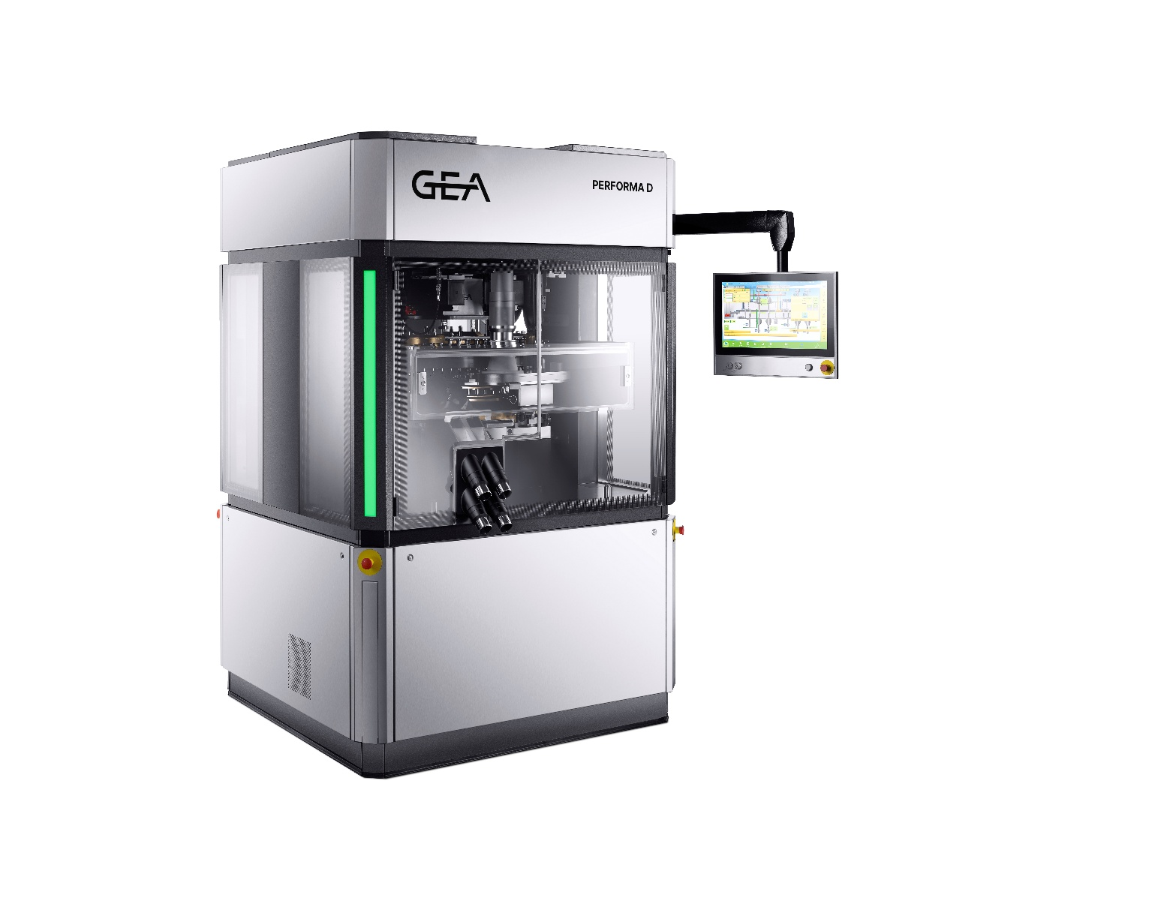
Photo, caption: PERFORMA D to Set a New Benchmark for High-Volume Tablet Production at PMEC India. (Photo: GEA)

About GEA
GEA is one of the world’s largest suppliers of systems and components to the food, beverage and pharmaceutical industries. The international technology group, founded in 1881, focuses on machinery and plants, as well as advanced process technology, components and comprehensive services. For instance, every second pharma separator for essential healthcare products such as vaccines or novel biopharmaceuticals is produced by GEA. In food, every fourth package of pasta or every third chicken nugget are processed with GEA technology. With more than 18,000 employees, the group generated revenues of about EUR 5.5 billion in more than 150 countries in the 2024 fiscal year. GEA plants, processes, components and services enhance the efficiency and sustainability of customers’ production. They contribute significantly to the reduction of CO2 emissions, plastic usage and food waste. In doing so, GEA makes a key contribution toward a sustainable future, in line with the company’s purpose: ”Engineering for a better world.”

GEA is listed on the DAX, the STOXX® Europe 600 Index and is also a constituent of the leading sustainability indices DAX 50 ESG, MSCI Global Sustainability and Dow Jones Best-in-Class World.

More information can be found online at gea.com.
If you do not want to receive any further information from GEA, please send an e-mail to pr@gea.com.

NOTE TO EDITORS

- Further information about GEA
- To the GEA Press page
- To the GEA Media Center
- Background information on current topics can be found at Features
- Follow GEA on  

GEA
Media Relations GEA
Dr. Michael Golek
Ulmenstraße 99, 40478 Düsseldorf
Phone +49 211 91361505
Tel. +491736205746
michael.golek@gea.com

