120 years with the global market leader

LAUDA honors three long-serving employees

Lauda-Königshofen, October 17, 2025 – LAUDA DR. R. WOBSER GMBH & CO. KG honored three employees for their extraordinary 40-year company anniversaries in a special ceremony. Barbara Schmitt, Volker Mott, and Bernd Volkert began their careers at the family-owned company on September 9, 1985, and have played a key role in shaping the development of the global market leader for temperature control devices and systems over four decades.

In his laudatory speech, Dr. Gunther Wobser, President & CEO, praised the impressive career paths of all three jubilarians. Barbara Schmitt completed her training as an industrial clerk at LAUDA and initially worked in the switchboard and financial accounting departments before moving to human resources and payroll accounting in 2018. “Barbara Schmitt is characterized by great precision and a sense of responsibility. Her expertise in payroll accounting is invaluable to our company. With around 50 internal training courses, she always keeps her finger on the pulse,” emphasized Dr. Wobser. Sandra Braun, Director Human Resources, praised her willingness to learn and her reliability: “Barbara's work is characterized by a high degree of reliability – she is conscientious, calm, and precise, and has an eye on both the company and its employees.”

Volker Mott has undergone remarkable development within the company. After training as an industrial mechanic and later completing further training as a master craftsman and quality management technician, he worked in various areas – from assembly and quality management to marketing. For twelve years now, he has been at home in purchasing, where he contributes his high level of technical expertise. “Mr. Mott has always dared to think outside the box and has continuously acquired new skills. His versatile development within the company demonstrates his willingness to take on responsibility and face new challenges,” accentuated Dr. Wobser. Chris Moschüring, Purchasing Manager, added: “Purchasing benefits immensely from Volker's technical knowledge. Particularly noteworthy are his responsibility for first-class trainee support and his enthusiasm for change.”

Bernd Volkert has proven himself to be a real top performer with a passion for plant engineering. After completing his training as an energy equipment electronics technician and subsequently studying part-time to become a state-certified electrical engineer at the DAG Technical College in Würzburg, he gained extensive experience in research and development. He has been working in plant engineering since 1990 and has held a management position since 2009. “Mr. Volkert has pursued his career with determination and developed impressive technical expertise in the process. His various further training courses and his many years of commitment make him an indispensable employee. His enormous expertise across all types of systems and his analytical thinking in project planning are exceptional,” praised Dr. Wobser. Dr. Jürgen Dirscherl, Director Research & Development, emphasized: “Bernd Volkert has spent more than two-thirds of his life at LAUDA. His positive charisma, helpfulness, and high level of technical understanding in project planning are impressive.”

Dr. Lukas Braun, mayor of the city of Lauda-Königshofen, highlighted the special significance of high employee loyalty at LAUDA in his welcoming speech. He explained that the three anniversaries represent mutual recognition between the company and its employees. The high number of honors at LAUDA demonstrates a strong sense of community and significant team spirit. The family-owned company is characterized by loyalty and responsibility towards its employees and is an important employer for the city. In recognition of their achievements, the mayor presented the jubilarians with a certificate of honor from the state of Baden-Württemberg from Minister President Winfried Kretschmann and a gift of wine.

Works council chairman Elmar Mohr conveyed the greetings of the workforce and emphasized the similarities between the honorees: “All three completed their training at LAUDA and have remained loyal to the company for 40 years – despite taking different individual paths within the company.”

The three anniversaries impressively underscore the special culture of the family-owned company LAUDA, where long-term employee loyalty and mutual appreciation have been practiced for generations. Dr. Wobser presented all the jubilarians with LAUDA certificates as a token of appreciation for their decades of loyalty and exceptional achievements and wished them continued health, happiness, and many more successful years.

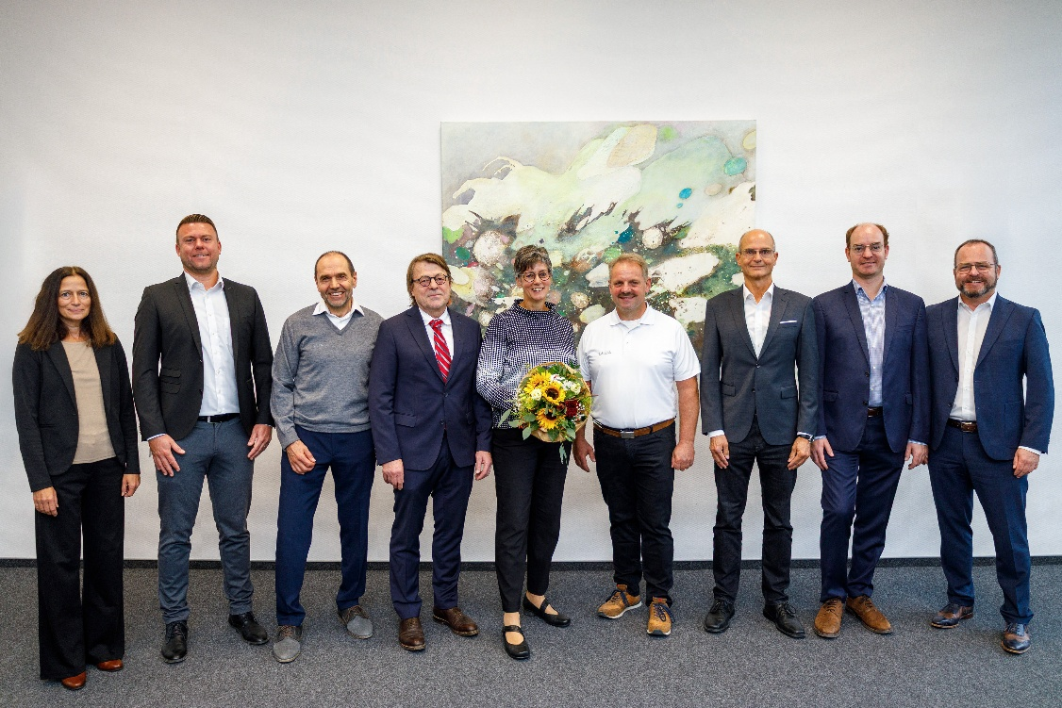

Picture: Volker Mott, Barbara Schmitt, and Bernd Volkert (4th, 5th, and 6th from left) celebrate their 40th company anniversaries and decades of loyalty to the family-owned company LAUDA together with President & CEO Dr. Gunther Wobser (right) and (from left to right) Sandra Braun (Director Human Resources), Chris Moschüring (Purchasing Manager), Elmar Mohr (Works Council Chairman), Dr. Jürgen Dirscherl (Director Research & Development) and Dr. Lukas Braun (Mayor of Lauda-Königshofen). © LAUDA

We are LAUDA – the world leader in precise temperature control. Our constant temperature equipment and systems are at the heart of important applications, contributing to a better future. As a complete one-stop supplier, we guarantee the optimum temperature in research, production and quality control. We are the reliable partner for Aerospace, Electromobility, Hydrogen, Chemistry, Pharmaceuticals/Biotech, Semiconductors and Medtech. We have been inspiring our customers for almost 70 years with our expert mentoring and innovative solutions – every day anew and all over the world.

In our company, we always go one step further. We support our employees’ development and are constantly developing ourselves: to create a better future together.

Press contact
We are more than happy to make prepared information about our company, the LAUDA Factory Gallery and our projects in the area of innovation promotion, digitalization and idea management available to the press. We look forward to hearing from you – just give us a call!

CHRISTOPH MUHR
Director Corporate Communications
T + 49 (0) 9343 503-349
christoph.muhr@lauda.de

LAUDA DR. R. WOBSER GMBH & CO. KG, Laudaplatz 1, 97922 Lauda-Königshofen, Deutschland/Germany. Limited partnership: Headquarters Lauda-Königshofen, Registration court Mannheim HRA 560069. General partner: LAUDA DR. R. WOBSER Verwaltungs-GmbH, Headquarters Lauda-Königshofen, Registration court Mannheim HRB 560226. Managing Directors: Dr. Gunther Wobser (President & CEO), Dr. Mario Englert (CFO), Dr. Marc Stricker (COO)

