PRESS RELEASE
Schwaebisch Hall, September 14, 2021

New machine solutions for
stoma products and glass syringes
OPTIMA life science and OPTIMA automation at the trade shows Compamed and Medica 2021

Compamed and Medica are both important trade shows for the Optima Group and will take place between November 15 and 18, 2021. Optima Life Science and Optima Automation are appearing together at Compamed in Duesseldorf. Optima Life Science is presenting the first of its kind in the world – a production line for stoma accessories. Optima Automation is focusing on a new assembly solution for glass syringes. At the adjacent Medica, Optima Life Science will provide information about machine solutions for diagnostics. The focal exhibit is OPTIMA ImmuCoat® for coating microtiter plates and a new solution for filling diagnostic vials.
Optima Life Science develops and implements modular manufacturing and packaging solutions for web processing medical products, also known as web converting. The focus at Compamed is on these. The systems assemble and package, for example, wound dressings, transdermal patches and oral film strips. The latest technologies in this area are being introduced at Compamed. This is the first time that a converting system has been equipped with an inline ultrasound perforation. This means perforation takes place directly in the system, thus another machine is no longer necessary. That reduces the costs and footprint for Optima customers. A new plaster sealing station allows even higher speeds and more pressure in sealing. Packaging machines for four-side-seal pouches, such as the OPTIMA 4SS, complete Optima Life Science’s range of products. This is the first time that the OPTIMA CPS1 plate sealing machine has been used to manufacture three-side-seal pouches. A high-speed die cutting system is used in this line, which punches holes from the continuously running web.
World's first continuous manufacturing machine for stoma flanges
Another new development is the world’s first continuously running manufacturing machine for stoma flanges. These will be used for supplying artificial stomas. So Optima Life Science now offers a suitable machine solution for stoma producers, too. Key advantages are the merging of two separate converting processes in one line. Process stations have been developed for this line, which previously could only be operated synchronized.
Gentle handling of glass syringes
Optima Automation, also a subsidiary of the Optima Group, will provide information at Compamed about a new assembly solution for glass syringes, among other things. The OPTIMA GSM has been optimized for even gentler product handling and now offers clearly higher efficiency and greater flexibility. The assembly machine covers the processes of tray handling, product separation, inserting and bonding the cannula as well as various hardness and test procedures. Optimal for limited space in the clean room: Despite the large number of process steps, the machine footprint is reduced to a minimum by the proven rotary transfer platform. Maximum safety is guaranteed with 100 % in-process controls: Tension test, flow test, optical inspection of several factors such as the needle's angular tilt position or checking of bonding surface. Defective parts are discarded separately to ensure high output. Plastic grippers from the 3D printer allow gentle handling of fragile glass barrels. Individual requirements, for example in adhesives, can be taken into account at any time. Optima Automation will advise on this at the trade show.
Modular and scalable machine solution for diagnostic test kits
Optima Life Science offers a whole range of machines for the automated production of diagnostic test kits. The complete package for diagnostics companies includes OPTIMA ImmuFill®, OPTIMA ImmuCoat® and OPTIMA ImmuPouch®. This enables reagents to be filled, and microtiter plates to be coated and packaged. Visitors can gain an impression of OPTIMA ImmuCoat® at Medica. It covers the entire coating process of microtiter plates. Every required process step can be integrated into this platform, for example, incubators in which the microtiter plates are stored between the individual process steps. The diagnostics experts will also present another innovation – a modular entry-level solution for the filling, closing and labeling of diagnostic vials.
Optima Life Science and Optima Automation at Compamed: November 15 to 18, 2021, Messe Düsseldorf, hall 8A, booth J12
Optima Life Science at Medica: November 15 to 18, 2021, Messe Düsseldorf, hall 01, booth 1D23

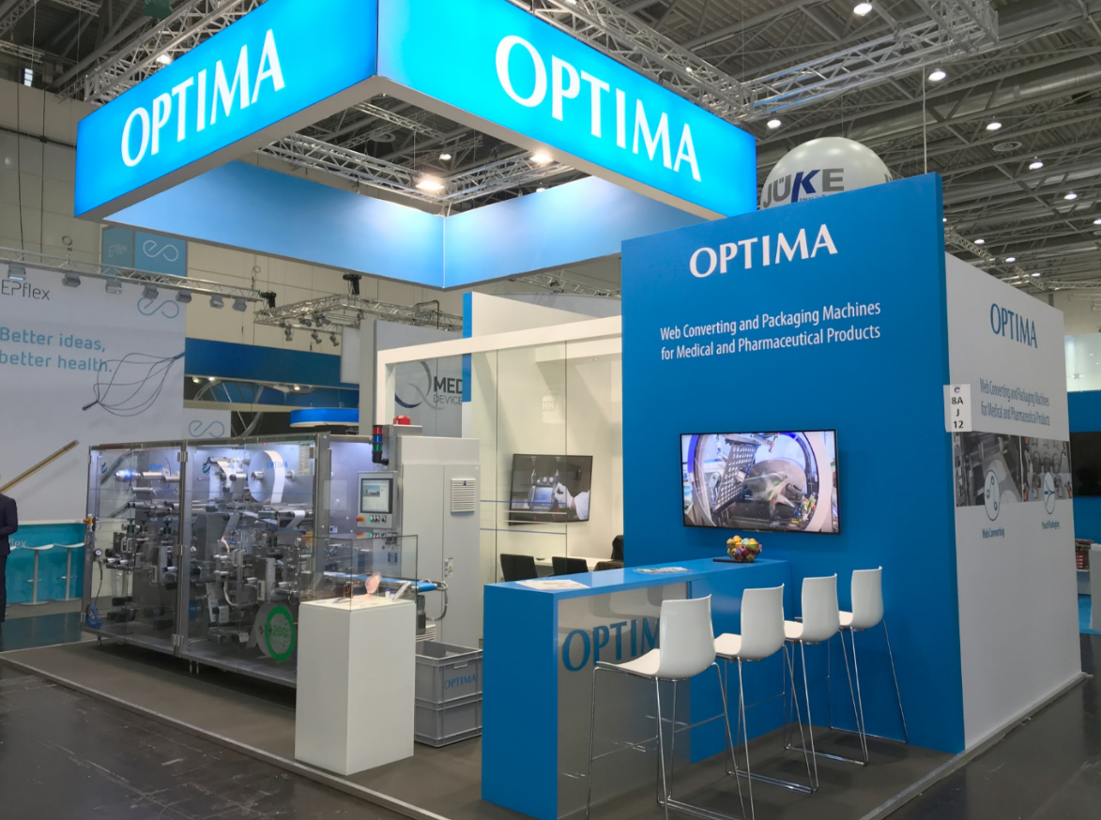
Optima last appeared at Compamed, the number one event for medical technology producers, in 2019. (Source: Optima)

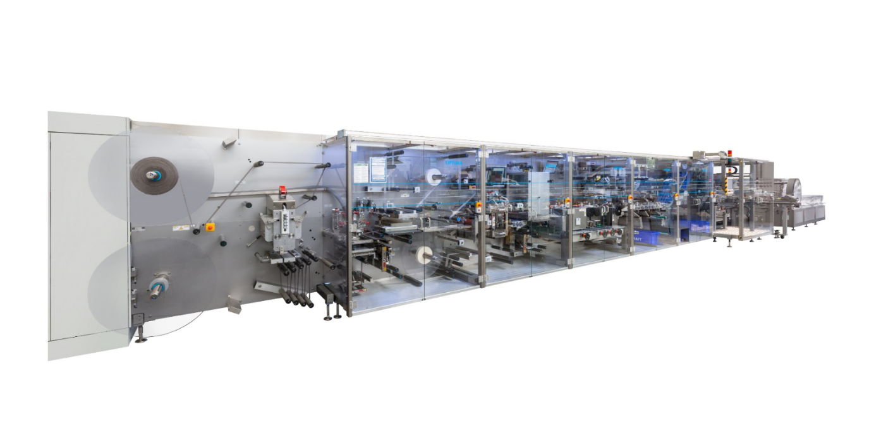
With the OPTIMA MDC300 Advanced, medical products such as wound dressings can be manufactured at a speed of up to 600 products/minute. (Source: Optima)

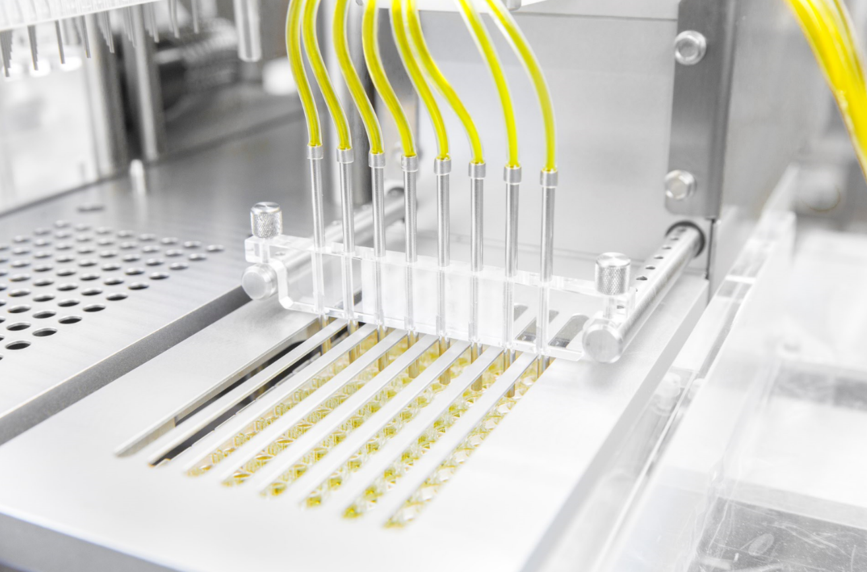
With the OPTIMA ImmuCoat® microtiter plates can be coated for diagnostic test kits. Diagnostic tests are particularly in demand during the COVID-19 pandemic. (Source: Optima)

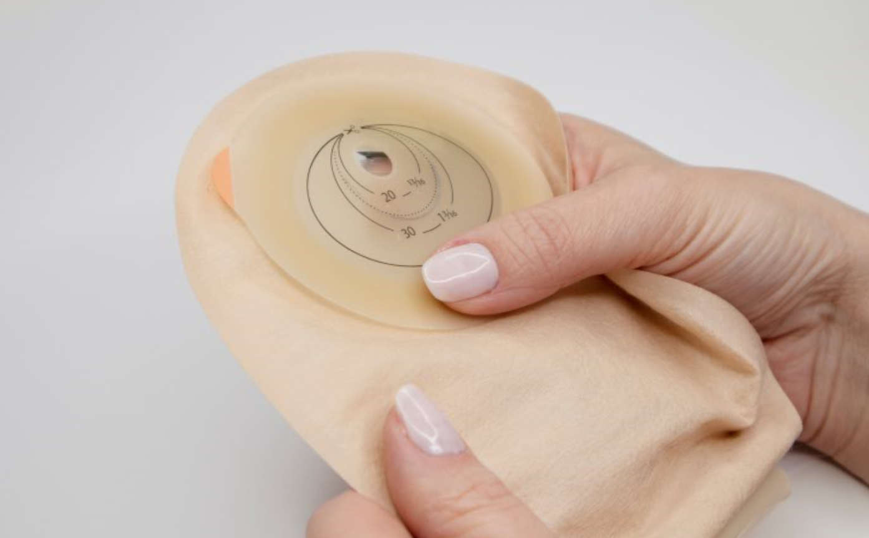
Stoma pouches are used in medicine to provide artificial bowel outlets (stomas). (Source: shutterstock.com/matuska)

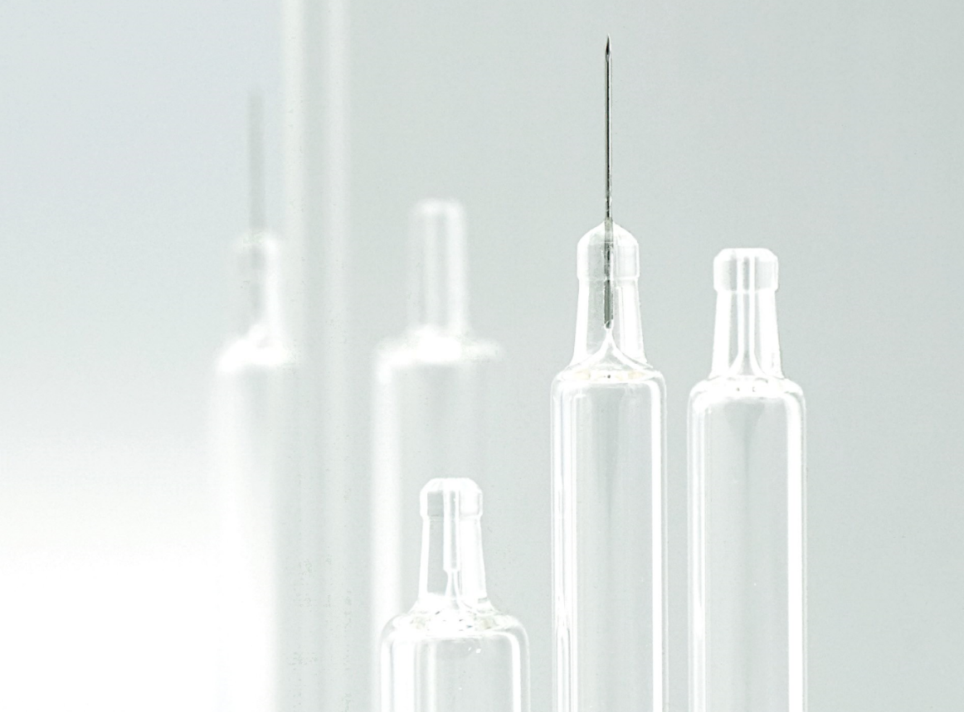
Glass syringes place particular demands on machine technology. Optima Automation has developed an appropriate solution for this with the OPTIMA GSM. (Source: Optima)

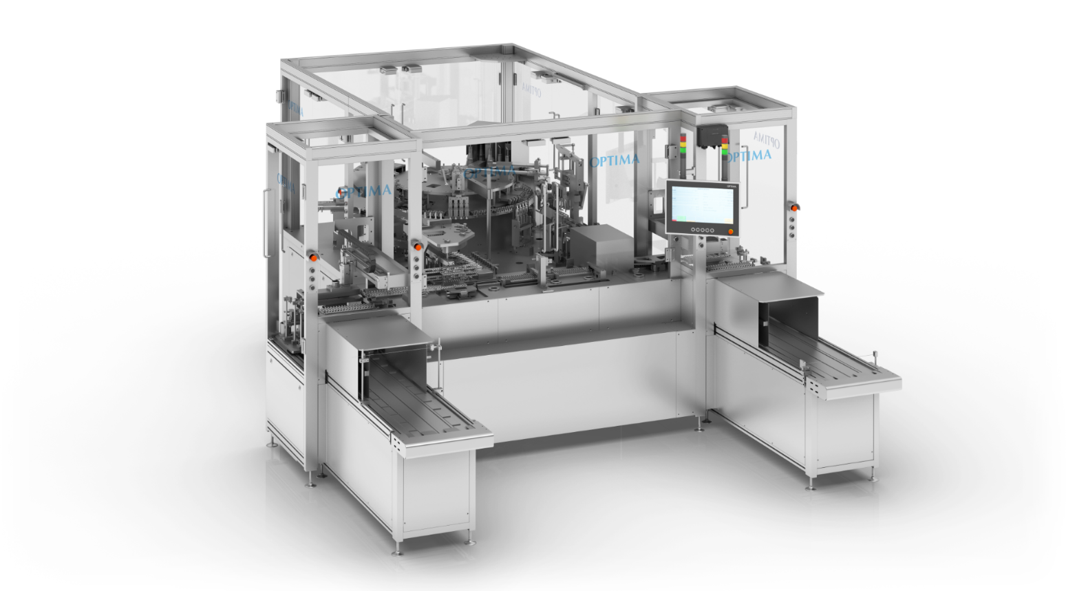
The OPTIMA GSM has been optimized for even gentler product handling and now offers clearly higher efficiency and greater flexibility. (Source: Optima)

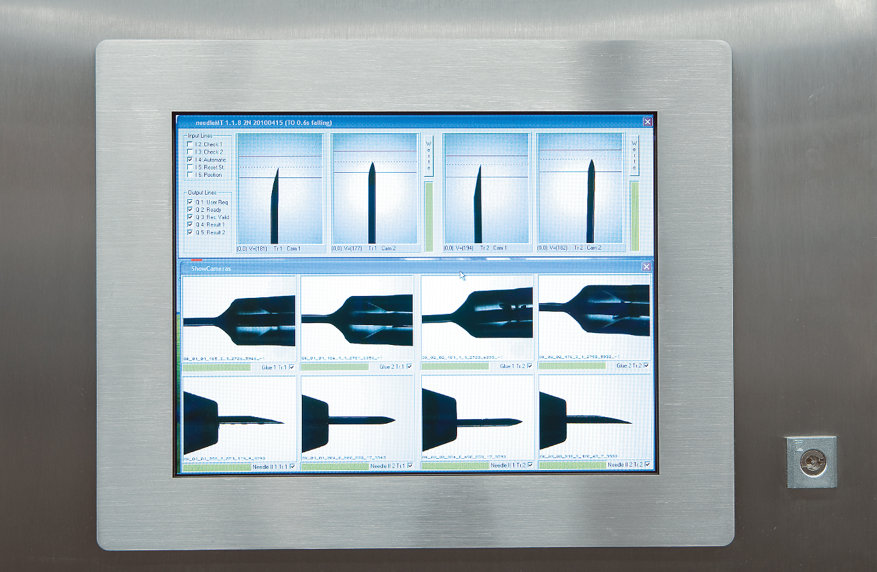
100 % in-process controls ensure maximum production reliability in the Optimal Automation machine solution. Here, the needle’s angular tilt position and the bonding surface are visually inspected, for example. (Source: Optima)

Characters (incl. spaces): 4,327

Press contact:
OPTIMA packaging group GmbH
Jan Deininger
Group Communications Manager
+49 (0)791 / 506-1472
jan.deininger@optima-packaging.com
www.optima-packaging.com

About OPTIMA
Optima supports companies worldwide with flexible and customer-specific filling and packaging machines for pharmaceuticals, consumer goods, paper hygiene and medical devices markets. As a provider of solutions and systems, Optima accompanies these companies from the product idea through to successful production and throughout the entire machine life cycle. Over 2,650 experts around the globe contribute to Optima's success. 19 locations in Germany and abroad ensure the worldwide availability of services.

About OPTIMA life science

For wound dressings and immunoassays (ELISA test kits) Optima Life Science offers flexible production and packaging solutions along the entire process chain. Core competencies are web processing technologies and liquid handling processes.

About OPTIMA automation

OPTIMA automation GmbH plans and realizes assembly lines and feeding systems for individual requirements and highest quality standards. By utilization of various processes and latest technologies, machines in rotary indexing principle as well as assembly transfer lines are developed. With these, injectors, needle systems, syringes, blood collection tubes and many other medical consumables can be assembled.

Thank you very much for your publication. We look forward to receiving a specimen copy.

