PRESS RELEASE
Schwaebisch Hall, September 23, 2019

Perfection for Pharma
OPTIMA at Maghreb Pharma 2019

At Maghreb Pharma, Optima Pharma will be providing information on the safe and efficient filling and closing systems for pharmaceuticals, including up- and downstreams. The company offers a comprehensive range of technology, from highly flexible types of machines for small batches to complex turnkey systems. Also included in the range of services are isolator technology and freeze-drying. At the trade fair, Optima Pharma will also be presenting specific plant technology for areas of application such as oncology, blood plasma and hyaluronic acid products.
Optima Pharma's slogan for the Maghreb 2019 is "Smart Solutions for Pharma Experts". The company's range of systems covers a wide variety of requirements. These include entry-level machines with a modular design for vials and pre-filled syringes, highly flexible systems for small batches and highly potent pharmaceuticals and high-performance systems for large batches.
Optima Pharma is a turnkey manufacturer, providing the entire process chain, including filling and sealing, pharmaceutical freeze drying and isolator technology. Fully-automated lines range from unpacking machines to external washing machines for filled and sealed containers. The machines are used to process vials, pre-filled syringes and cartridges.
Specific requirements also apply to oncology and blood plasma products: Small batches of often very expensive drugs require a system technology that makes the best possible use of the amount of product available. For this application alone, Optima Pharma has a large number of system functions in our product range.
Besides product protection, protecting operators is essential for highly potent drugs. Optima Pharma systematically implements this protection using specific, comprehensive system concepts. When hyaluronic acid pharmaceuticals are being processed, for example, special rotary pumps are required to precisely dispense what are highly viscous products. Products with no bubbles are a key quality criterion here; this is achieved by Optima Pharma by filling and sealing under vacuum.
Optima Pharma at Maghreb Pharma, Algiers, Algeria: October 1 to 3, 2019, Stand D02

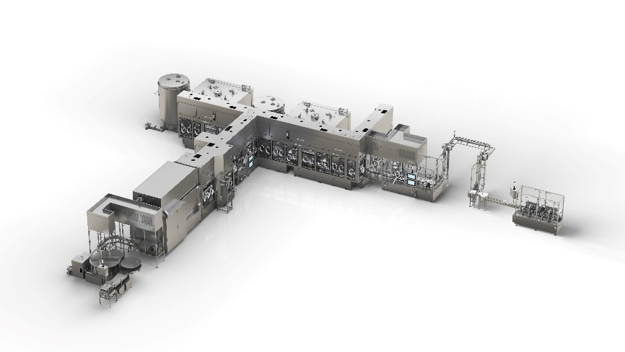
Complex turnkey projects from Optima Pharma that span the complete processing range for filling and sealing. Also included in the range of services are isolator technology and freeze-drying.

Characters (including spaces): 2,239

Press contact:
OPTIMA packaging group GmbH
Jan Deininger
Editor
+49 (0)791 / 506-1472
jan.deininger@optima-packaging.com
www.optima-packaging.com
Thank you for publishing this information. We would be pleased to receive a file copy.

