LogiMAT Award “Best Product” for new, omnidirectional AGV from Grenzebach
Grenzebach
Maschinenbau GmbH

Albanusstrasse 1–3
86663 Asbach-Bäumenheim,
Germany

Contact:
Cathrin Gros
Tel.: +49-906-982-2161
Cathrin.Gros@Grenzebach.com
The Automated Guided Vehicle OL1200S from Grenzebach allows easier, quicker, and safer transportation of long goods carriers thanks to its omnidirectional drive and smart sensors. Users benefit from saving space, investment cost and time for the implementation. The new vehicle has been awarded “Best Product” of LogiMAT 2021.

More autonomous, quicker, and smarter – with the new OL1200S, Grenzebach presents the next generation of automated guided vehicles for long goods carriers and payloads of up to 1,200 kg. It is omnidirectionally drivable and is equipped with smart sensors. This allows the OL1200S to transport large components in the smallest of spaces.

Specialist for long Load Carriers
The high maneuverability of the OL1200S especially allows for space-saving cross-docking of long goods or load carriers. Further transport in direction of the shorter edge does not require any rotation of the AGV. An autonomous load carrier detection identifies inaccurately placed loads carriers and allows the OL1200S to pick them up autonomously. No additional sensor technology or adaptions of the loads carriers are needed. Stations are no longer necessary. In early adopter customer projects, the space required for delivery stations could be reduced by 75% as opposed to a classic tugger train or an AGV-based solution with differential drive. Additionally, users benefit from lower investment costs and shorter time for implementation. Existing solutions can be adapted easier and quicker than has been the case so far. This is why the OL1200S is particularly beneficial for production environments that need a high degree of flexibility.

All-round safe
Equipped with both Lidar and 3D vision systems, the AGV also sets new standards for personnel and transportation safety. This enables its simultaneous use in areas with pedestrian traffic and prevents transportation damage caused by collisions with obstacles in the operating area, such as protruding components, partially open roller doors, or forklift tines. The AGV can reach speeds of up to 6 km/h and handle inclines of up to 5%.

Holistic Solution for automated Goods Transport
The new vehicle can be used along with the trusted L1200S with conventional drive in one system. Combining the strengths of both vehicles results in a highly optimized automated goods transport in manufacturing and logistics. Both the Grenzebach Fleet Manager and the new OL1200S are VDA 5050-compatible. This makes a combination with AGVs from third-party manufacturers in one system a nonissue.

OL1200S: Award-winning technology package
This also convinced the independent jury of the LogiMAT “Best Product” award. Each year, the prize is given to products, which contribute significantly towards rationalization, cost-savings and increasing productivity in in-company logistics, according to LogiMAT. It has become one of the most coveted in the intralogistics sector and products can be submitted in three categories. The OL1200S is the 2021 winner in the category order picking, conveying, lifting, storage technology.

Footage:

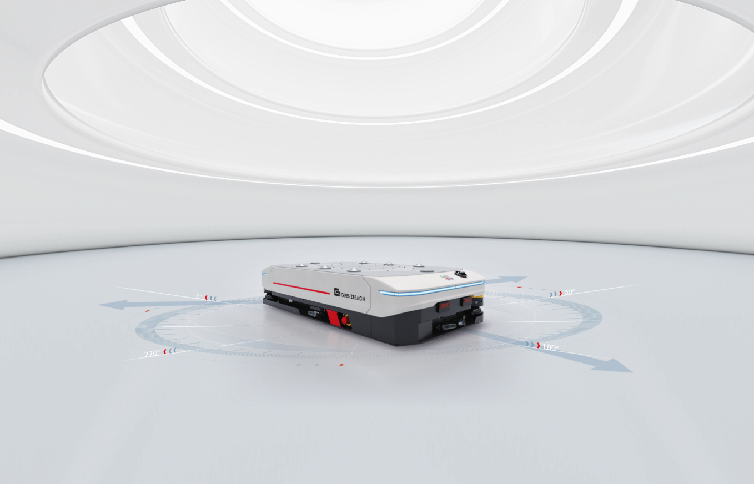
360° Head Start: Thanks to its omnidirectional drive and smart sensors, the Automated Guided Vehicle OL1200S from Grenzebach allows easier, quicker, and safer transportation, particularly of long goods carriers.
© Grenzebach

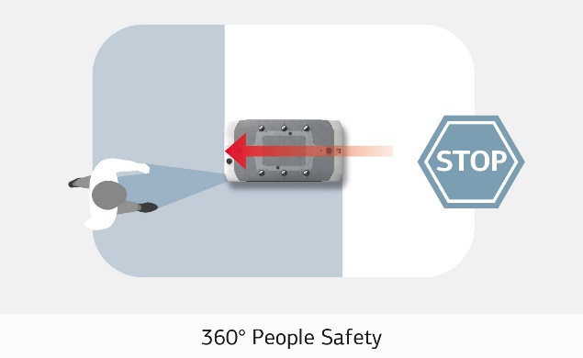 | 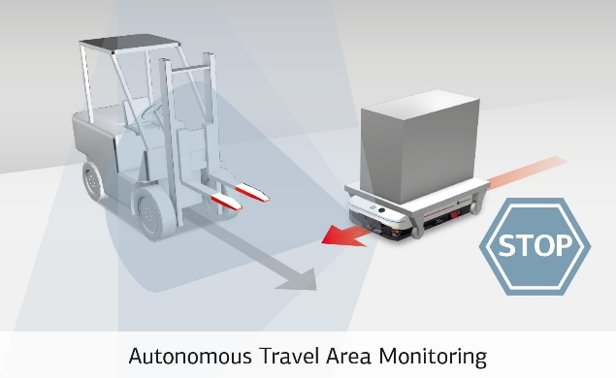
Equipped with blue light and two Lidar laser scanners, the OL1200S combines efficiency and productivity with maximum personnel safety.  © Grenzebach | A 360° 3D vision system detects disruptive factors with a minimum size of approximately 50 mm (2 inches). This prevents transportation damage caused by collisions with obstacles in the operating area, such as protruding components, partially open roller doors, or forklift tines.  © Grenzebach
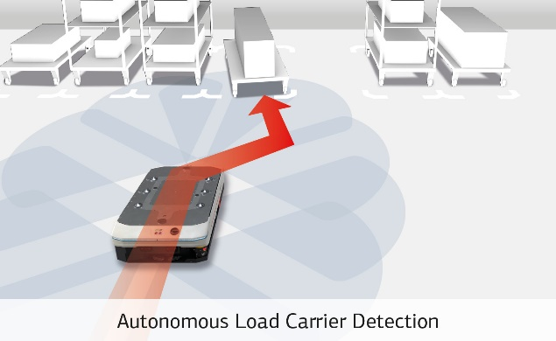 | 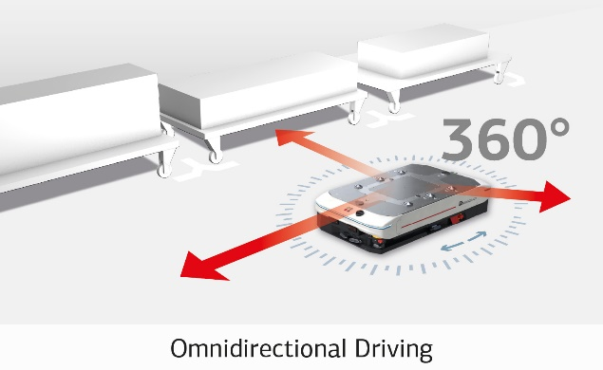
The OL1200S detects the position of inaccurately placed goods carriers within a variance range of +/– 250 mm (9.8 inches). The autonomous detection of goods carriers enables the vehicle to pick up the loads automatically without a problem.  © Grenzebach | The OL1200S is omnidirectional; it can move freely in any direction and rotate on its axis while stationary. Narrow pathways, 90° curves, turning maneuvers, and cross-docking of goods carriers are tasks easily accomplished by this vehicle.  © Grenzebach
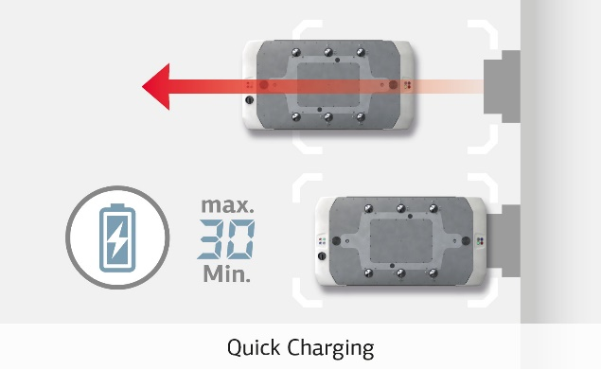 | 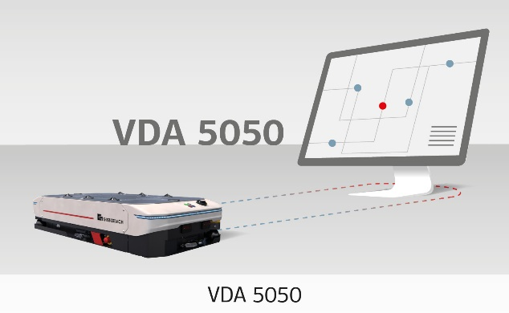
Lithium power, 48 DC, up to 80 amperes charging current. With top speeds of up to 6 km/h (3.7 mph), the OL1200S is designed for maximum uptime in demanding industrial environments that operate around the clock.  © Grenzebach | Maximum freedom for plant planning: The OL1200S can be combined with automated guided vehicles from other manufacturers under a single software control center via the VDA 5050 interface.  © Grenzebach

About Grenzebach Intralogistics:
Grenzebach offers Automated Guided Vehicles (AGVs) for automated goods transport in production and manufacturing as well as goods-to-person solutions for warehouse logistics. The holistic automation solutions include hardware, software and service. AGVs are manufactured at the company's own production sites. Grenzebach sees itself as a reliable partner that supports customers throughout the entire product life cycle. They aim to provide intralogistics solutions that are precisely tailored to the needs of their customers.

About Grenzebach as a Company:

Grenzebach is a leading automatization solution provider for the global glass, building material and intralogistics market. In addition, the company develops new application areas, such as Friction Stir Welding, the automatization of industrial additive manufacturing and digital networking. The digitization platform SERICY allows customers to develop their own future-proof digital know-how. Grenzebach ranks among the international technology leaders in its markets. The global manufacturing footprint with production sites in Germany, Romania, the US and China, as well as additional worldwide locations ensure customer support on-site. More than 3,000 systems installed in more than 55 countries stand for quality and reliability. Since the company opened its doors 60 years ago, it has been owned by the founding family. With an export ratio of more than 90 percent, Grenzebach is a global player.

