Photo Credits

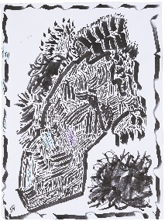
Arthur Simms, Look!, Arthur Drawing in St.Gallen, Series of 20 Drawings, 2023
Kunstmuseum St.Gallen, Donation from the artist, 2024

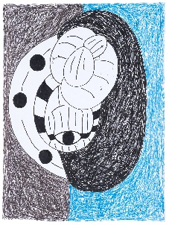
Elena Dah, Torsos, 2023
Kunstmuseum St.Gallen, Long-term loan from the Ursula-Trunz-Fonds, 2024

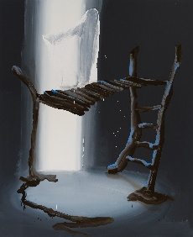
Tala Madani, Shit Mom (Playground), 2024
Kunstmuseum St.Gallen, Acquired with the support of the Susanne and Martin Knechtli-Kradolfer Foundation and Dr. Fred Styger Foundation, 2024

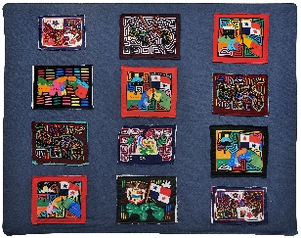
Sam Durant, Correspondencias, 2012
Kunstmuseum St.Gallen, Donation from Sam Durant and Praz-Delavallade Gallery, 2024

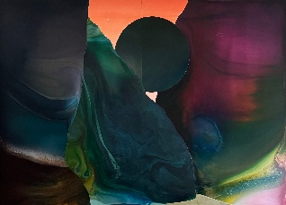
Dave Bopp, Intrusion, 2024
Kunstmuseum St.Gallen, Donation from Felix Falkner, 2024

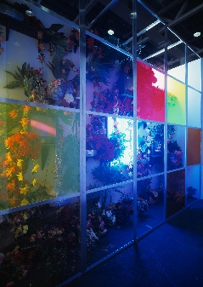
John M Armleder, Untitled, 2004
Kunstmuseum St.Gallen, Donation from John M Armleder and Susanna Kulli, 2024

