Red Dot Design Award

Hartbodenreiniger FC 7 Cordless mit Designpreis ausgezeichnet

Pressekontakt
Moritz Dittmar
Pressereferent
Alfred Kärcher SE & Co. KG
Alfred-Kärcher-Str. 28-40
71364 Winnenden
T +49 71 95 14-3919
moritz.dittmar@de.kaercher.com
Winnenden, April 2021 – Der Hartbodenreiniger FC 7 Cordless von Kärcher wurde für seine herausragende Designqualität ausgezeichnet und darf nun den weltweit bekannten Red Dot Design Award tragen. Der 1955 initiierte Preis zählt zu den anerkanntesten Design-Wettbewerben weltweit und genießt weit über die Fachkreise hinaus hohes Ansehen.
Der akkubetriebene Hartbodenreiniger FC 7 Cordless entfernt alle Arten von trockenem und feuchtem Alltagsschmutz in einem Arbeitsgang und ist seit September 2020 auf dem Markt. Das neue Flaggschiff der Kärcher-Hartbodenreiniger arbeitet mit vier gegenläufig rotierenden Reinigungswalzen, die permanent mit Frischwasser und Reinigungsmittel befeuchtet werden. Die Walzen nehmen jeglichen Haushaltsschmutz zuverlässig auf und wischen den Boden sowohl in der Vorwärts- als auch in der Rückwärtsbewegung. Dank eines 2-Tanksystems wird das Schmutzwasser in einem separaten Behälter aufgenommen und nicht auf dem Boden verteilt. Auch größere Teilchen wie Cornflakes und Haare stellen für den FC 7 Cordless keine Herausforderung dar, vorheriges Staubsaugen ist nicht nötig.
„Der Gewinn des Red Dot Design Awards für den FC 7 freut mich außerordentlich“, freut sich Michael Meyer, Director Industrial Design Consumer Products bei Kärcher. „Die Jury hat den FC 7 neben seiner ansprechenden Ästhetik insbesondere für das revolutionäre Produktkonzept inklusive einer herausragenden Funktionalität und Ergonomie ausgezeichnet. Das Gerät konnte in allen Bewertungskriterien überzeugen und bietet als cleverer Problemlöser echte Kärcher Erlebnisse für unsere Kunden!“
Die Red Dot Jury besteht aus rund 50 internationalen Experten und setzt sich aus unabhängigen Gestaltern, Design-Professoren und Fachjournalisten zusammen. Sie testen, diskutieren und bewerten jede Einreichung individuell. Die Produkte stehen demnach nicht im Wettbewerb zueinander, sondern werden einzeln evaluiert. Zur Bewertung werden dabei Kriterien wie Ästhetik, Funktionalität, Ergonomie und Innovationsgrad herangezogen.
Der Red Dot Design Award zählt zu den anerkanntesten Design-Wettbewerben weltweit und genießt weit über die Fachkreise hinaus hohes Ansehen.
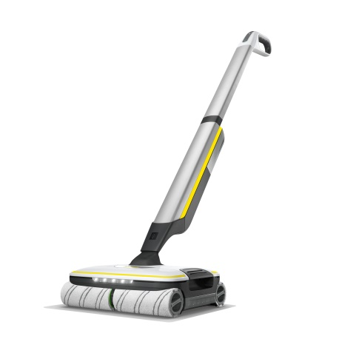
Der FC 7 Cordless hat bereits zahlreiche Auszeichnungen erhalten und konnte nun auch beim Red Dot Design Award überzeugen.

