Anne Marie Jehle  Jeder Spiesser ein Diktator  November 9, 2024 – March 9, 2025, Kunstmuseum St. Gallen  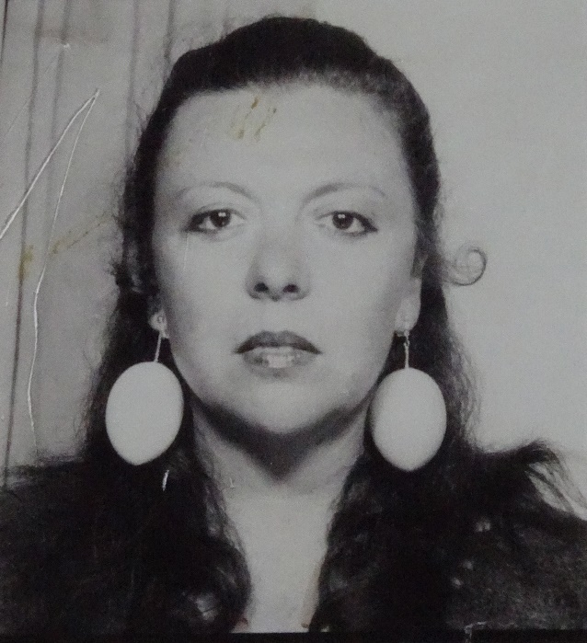  Anne Marie Jehle (1937–2000), Untitled, undated, B/W photograph, 4.9 x 4.4 cm, Kunstmuseum Liechtenstein, Vaduz, Gift by Anne Marie Jehle Stiftung © Estate of Anne Marie Jehle / Kunstmuseum Liechtenstein, Vaduz  The visionary work of the Austrian-Liechtenstein artist Anne Marie Jehle (Feldkirch, 1937–2000, Vaduz) encompasses a wide range of media including sculpture and installation, painting, drawing, photography and text. A critical examination of social structures and power dynamics, especially those concerning female identity and gender roles, lies at the core of her practice.  Jehle gained international recognition in the 1970s, when her work was situated within the context of the feminist avant-garde and the Fluxus movement. In the mid 1980s, she withdrew from public life, abruptly halting her artistic career.  Her ability to transform everyday objects and personal experiences into powerful works of art gives her work a continued relevance, especially amid today’s discussions on gender and self-determination in art.  To mark a generous donation from the Anne Marie Jehle Foundation, Vaduz, in 2021, the Kunstmuseum St. Gallen is showcasing the significant oeuvre of this underrepresented artist. The exhibition has been made possible thanks to generous loans from private collections as well as from the Kunstmuseum Liechtenstein, Kunstmuseum Stuttgart, Frauenmuseum Hittisau, SAMMLUNG VERBUND, Vienna, and Kontakt Collection, Vienna.  Scenography  The exhibition was conceived and designed in collaboration with the internationally renowned scenography studio chezweitz | museale und urbane Szenografie, Berlin.  Support  The exhibition is generously supported by the H.E.M Foundation, Vaduz.  Publication  A publication accompanying the exhibition, to be released through Scheidegger & Spiess, Zurich, will feature contributions from Nadia Veronese, Senior Curator at Kunstmuseum St. Gallen; Letizia Ragaglia, Director of Kunstmuseum Liechtenstein, in conversation with gallerist Wilma Lock; and Dagmar Streckel, former director of the Anne Marie Jehle Foundation. The publication will provide in-depth insights into various aspects of Jehle’s artistic oeuvre.  Anne Marie Jehle (Feldkirch 1937–2000 Vaduz)  Anne Marie Jehle worked obsessively and experimentally. Her oeuvre aligns with the feminist avant-garde of the 1970s, and its actualization of artistic self-empowerment places it in the context of radical female sculptors like Louise Bourgeois (1911–2010) and Alina Szapocznikow (1926–1973), who also drew great inspiration from personal experience. Jehle’s work was also influenced by the Neo-Dada, Fluxus, Happening and Conceptual Art movements. Her art consistently conveys subversive critiques of gender-specific power structures, with contradictory gender roles in both private and global contexts often parodied with ironic humor. She brilliantly subverted the male-dominated art world, addressing the cult of genius and gender relations by referencing historically significant artists.  Jehle’s childhood home in Feldkirch served as the base and center of her artistic production, as well as a retreat from the outside world. In 1965, she began creating her artistic works, exhibiting and storing them in the house. The uncanny and oppressive feelings associated with familiar, sheltered spaces became recurring motifs, often expanding to fill entire rooms within the house. The themes of the body, womanhood, sensuality, and eroticism were fundamental to her artistic practice, as were explorations of gender stereotypes, feminism, and personal identity. She remained active until she gave up her life as an artist. In the mid 1980s, she withdrew from the art world, sealing up her house and studio in a radical final act. She traveled to the USA in 1989, living on the East Coast until 1993. After returning from the USA, she lived in Liechtenstein until her death in 2000. Like the American conceptual and performance artist Lee Lozano (1930–1999), Jehle decisively turned away from the art world, only to be rediscovered after her death.  “For Vorarlberg, she’s just too far ahead” – Anne Marie Jehle  Jehle’s artistic work remains largely unknown, her fame barely extending beyond Vorarlberg and Liechtenstein. Her oeuvre was met with misunderstanding during her lifetime. Nevertheless, between 1965 and 1989, she produced a substantial and unique body of work comprising over 1,600 pieces.  After her death in 2000, family and friends established the Anne Marie Jehle Foundation to preserve and promote her art.  Her first retrospective was held at the Bildungshaus Batschuns in 2003; this was followed by a 2009 exhibition at Palais Liechtenstein in Feldkirch and a 2013 exhibition on the theme of “Being at Home” at the Frauenmuseum Hittisau. Her work has also been featured in numerous group exhibitions, including at the Kunstmuseum Liechtenstein, the 11th Fellbach Small Sculpture Triennial, QuadrART Dornbirn, Villa Claudia in Feldkirch, the Kunstmuseum Appenzell, and the Galerie Hollenstein in Lustenau, organized by the Vorarlberg Museum.  The Kunstmuseum Liechtenstein showcased her work in 2017 and today holds the largest share of her estate, thanks to another donation of works from the Anne Marie Jehle Foundation. Her hometown of Feldkirch hosted a solo exhibition in 2009 at Palais Liechtenstein, a forum for contemporary art. Dagmar Streckel, former director of the Anne Marie Jehle Foundation, has cataloged and curated the artist’s vast body of work. In Eastern Switzerland, Wilma Lock presented objects and installations by Jehle in her namesake gallery as early as 1977. | Exhibition Dates  Nov 9, 2024–Mar 9, 2025  Kunstmuseum St. Gallen  Press Conference  Nov 8, 2024  11:00 a.m.  Exhibition Opening  Nov 8, 2024  6:30 p.m.  Opening Hours  Tue – Sun: 10:00 a.m. – 5:00 p.m.  Thu: 10:00 a.m. – 8:00 p.m.
Press Contact

Nadine Sakotic
Head of Communications
Museumstrasse 32
9000 St. Gallen
T +41 71 242 06 84

kommunikation@kunstmuseumsg.ch
kunstmuseumsg.ch

Factsheet
Anne Marie Jehle – Jeder Spiesser ein Diktator

Exhibition Dates | November 9, 2024 – March 9, 2025
Exhibition Venue | Kunstmuseum St. Gallen
Press Conference | November 8, 2024, 11 a.m., Kunstmuseum St. Gallen
Exhibition Opening | November 8, 2024, 6:30 p.m., Kunstmuseum St. Gallen
Curator | Nadia Veronese
Opening Hours | Tue – Sun: 10:00 a.m. – 5:00 p.m.  Thu: 10:00 a.m. – 8:00 p.m.
Admission | Adults  Seniors  Students  Members of the Kunstverein St. Gallen | CHF 12.–  CHF 10.–  CHF 6.–  Free
Press Contact | Nadine Sakotic  T +41 71 242 06 84  kommunikation@kunstmuseumsg.ch
Website | kunstmuseumsg.ch
Press Photos | kunstmuseumsg.ch/presse

