Dr. Marc Stricker with LAUDA for ten years

Managing Director has been shaping the development of the global market leader for a decade

Lauda-Königshofen, October 22, 2024 – At a ceremony, LAUDA DR. R. WOBSER GMBH & CO. honored Dr. Marc Stricker's ten years of service and the managing director's associated significant contribution to the company's success.

In his speech to the executives present, Dr. Gunther Wobser, President & CEO of LAUDA, looked back on Dr. Stricker's impressive career: “Marc not only brings many years of experience from well-known heating technology companies, but also an outstanding academic career. His combination of technical expertise and business know-how makes him an indispensable pillar of our company.” In addition, Dr. Wobser emphasized that Dr. Stricker is characterized by perseverance, discipline and the will to get to the bottom of things. Many construction projects and R&D projects in recent years bear Dr. Stricker's unmistakable signature. Within the three-person management team, which also includes Dr. Mario Englert, the engineer is responsible for research & development, production, logistics, quality and environmental management, as well as for the three foreign production sites in Spain, China and the US.

In his acceptance speech, Dr. Stricker emphasized the importance of being open to new ideas and his appreciation of medium-sized companies. He deliberately chose LAUDA because he can make the best possible use of his skills and enjoys his work. He emphasized with great appreciation: “I appreciate the support of my colleagues and the opportunity to work in a family business.” In conclusion, Dr. Stricker praised the current management team of the global market leader and said he was confident and well positioned for future challenges.

Dr. Wobser stated: “Marc embodies the perfect combination of technical expertise and entrepreneurial tact that LAUDA needs. His keen sense of the dynamics of family businesses is invaluable. We thank him for ten years of passion, commitment and extraordinary dedication, which have contributed significantly to the success of LAUDA.” As a token of his appreciation, Dr. Wobser presented his fellow Managing Director with the LAUDA certificate of honor, a certificate from the Chamber of Industry and Commerce and a gift.

With Dr. Stricker's anniversary, LAUDA once again underlines its position as a future-oriented family-owned company that focuses on long-term cooperation and continuous innovation. With its experienced management team, the world market leader for precise temperature control is well equipped to continue setting standards in the industry in the future.
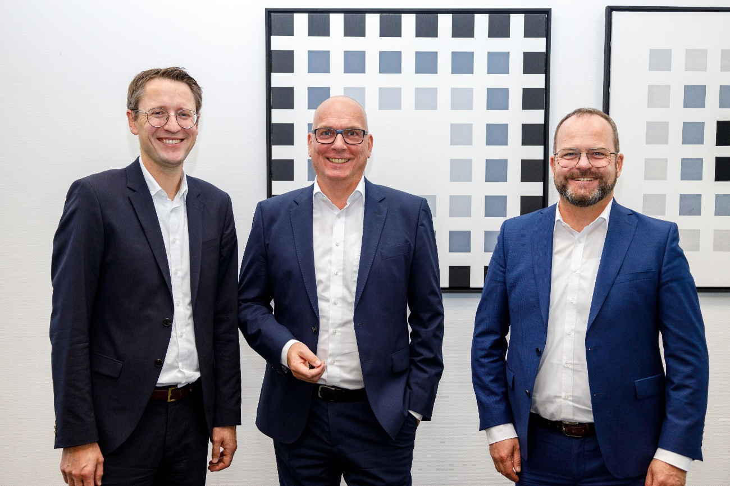

Fig.: Anniversary celebration at LAUDA: Dr. Marc Stricker (center), COO of LAUDA DR. R. WOBSER GMBH & CO. KG, was honored for his ten years of service. His fellow managing directors, CFO Dr. Mario Englert (left) and President & CEO Dr. Gunther Wobser (right), congratulated him at a ceremony. © LAUDA

We are LAUDA – the world leader in precise temperature control. Our constant temperature equipment and systems are at the heart of important applications, contributing to a better future. As a complete one-stop supplier, we guarantee the optimum temperature in research, production and quality control. We are the reliable partner for electromobility, hydrogen, chemicals, pharmaceuticals/biotech, semiconductors and medical technology. We have been inspiring our customers for almost 70 years with our expert mentoring and innovative solutions – every day anew and all over the world.

In our company, we always go one step further. We support our employees’ development and are constantly developing ourselves: to create a better future together.

Press contact
We are more than happy to make prepared information about our company, the LAUDA Factory Gallery and our projects in the area of innovation promotion, digitalization and idea management available to the press. We look forward to hearing from you – just give us a call!

CHRISTOPH MUHR
Director Corporate Communications
T + 49 (0) 9343 503-349
christoph.muhr@lauda.de

LAUDA DR. R. WOBSER GMBH & CO. KG, Laudaplatz 1, 97922 Lauda-Königshofen, Deutschland/Germany. Limited partnership: Headquarters Lauda-Königshofen, Registration court Mannheim HRA 560069. General partner: LAUDA DR. R. WOBSER Verwaltungs-GmbH, Headquarters Lauda-Königshofen, Registration court Mannheim HRB 560226. Managing Directors: Dr. Gunther Wobser (President & CEO), Dr. Mario Englert (CFO), Dr. Marc Stricker (COO)

