PRESS RELEASE
Schwaebisch Hall, September 3, 2020

Joining forces to fight COVID-19
OPTIMA has chartered one of the world's biggest cargo aircraft to deliver equipment to the USA

Optima has pulled out all the stops to deliver a filling system to the US-based company Catalent at its Biologics facility in Bloomington, Indiana. The vial system with an isolator will be the second vial line installed at the site and is intended to be used initially for the filling of a candidate vaccine to fight COVID-19. For the first time in Optima’s company history, one of the world's cargo aircraft, the Antonov An-124, was chartered for transportation. At the end of August, the system reached its destination in Bloomington on time, after Optima worked in close collaboration with logistics companies from the area.
The COVID-19 pandemic is placing particular demands on vaccine producers and machine manufacturers. Optima did everything in its power to deliver a vial system to Catalent's US-based biologics site as quickly as possible. The first partial shipment had already been shipped to the US at the beginning of August. There were weeks of planning and numerous logistical challenges to resolve before an Antonov An-124 was able to take off from Liège, Belgium for Chicago at the end of August. On board was the rest of the equipment weighing a total of 38,000 kg packed into 15 crates. Seven heavy trucks were needed to transport the equipment to the airport. "We would like to express our appreciation to our extremely professional shipping and packing department team, who completed this historic task in record time," says Juergen Rothbauer, Managing Director of the OPTIMA pharma GmbH.
Regional logistics partnership
"Of course we would also like to thank our partners, the Pfitzer company in Schwaebisch Hall and the freight forwarders FRACHT FWO AG (Stuttgart) and Kuebler (Schwaebisch Hall), for their dedicated assistance," adds Sarah-Maria von Berg, who heads up the Optima shipping department. It would be hard to carry out projects like these without close collaboration with long-standing partners in the region.

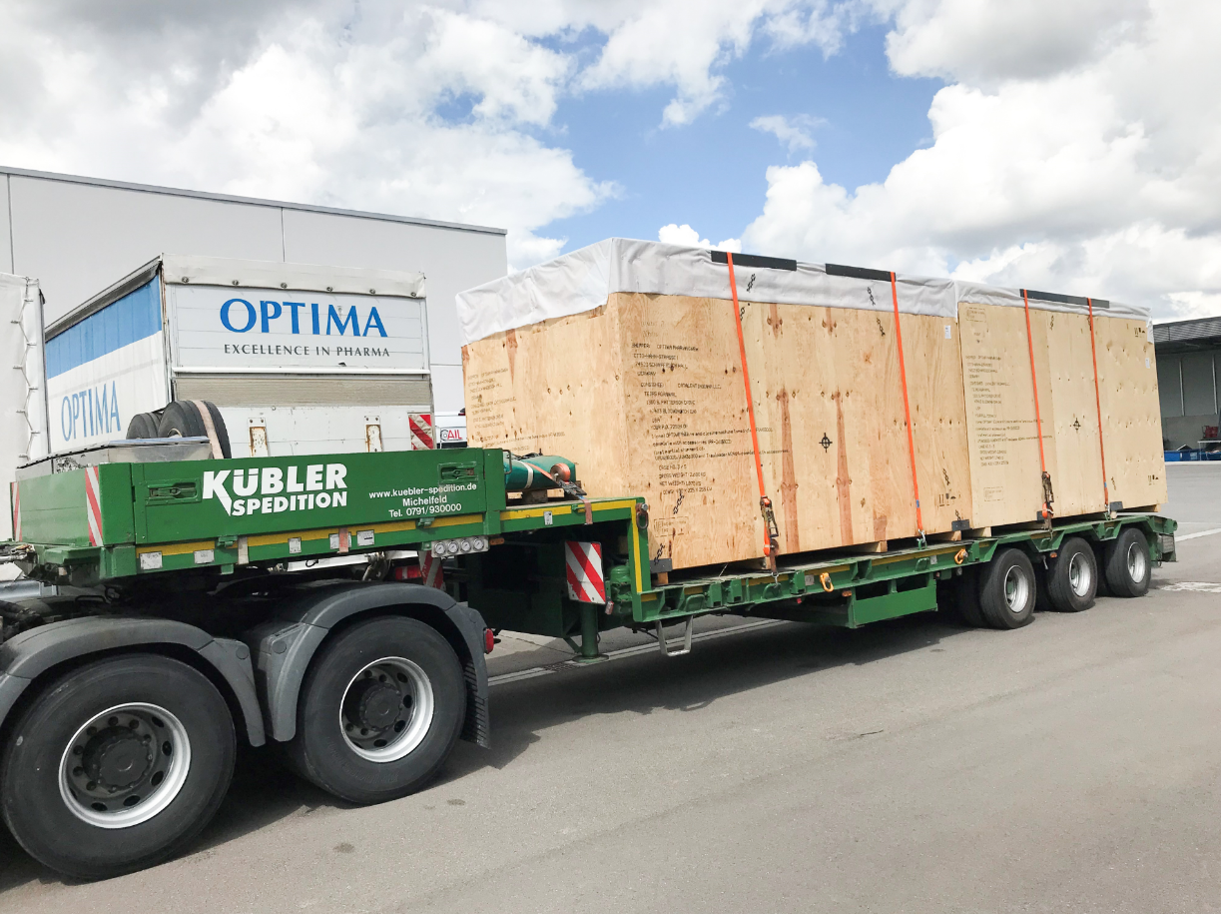
Loading of the filling system onto the trucks in Schwaebisch Hall. (Source: Optima)

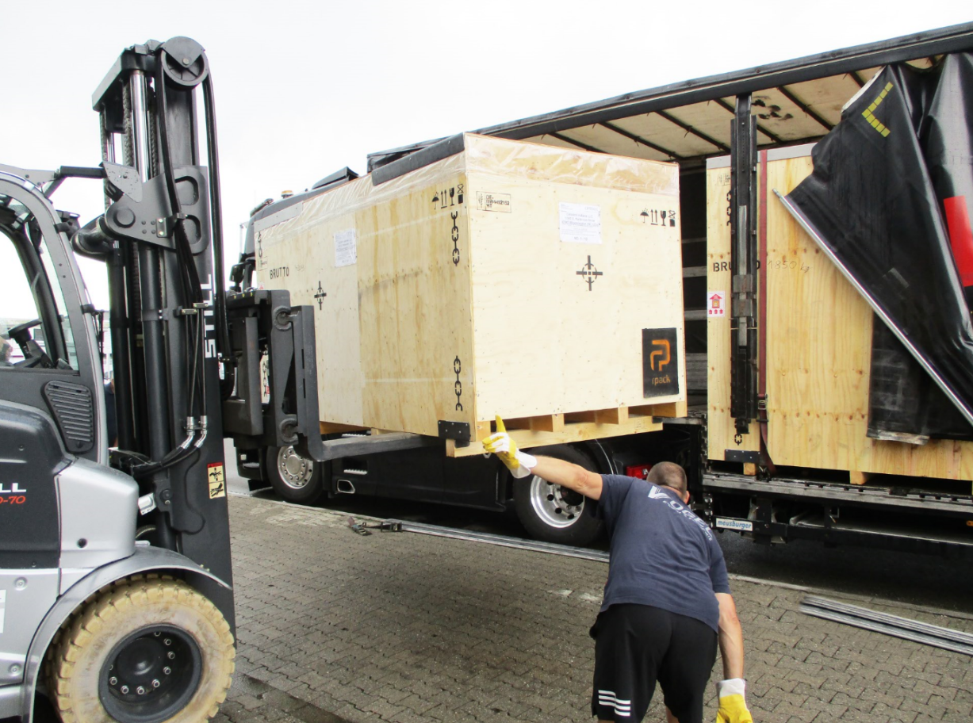
At Metall+Plastic in Radolfzell, the isolator technology required is loaded, and at Liège airport it is consolidated with Optima's shipment. (Source: Optima)

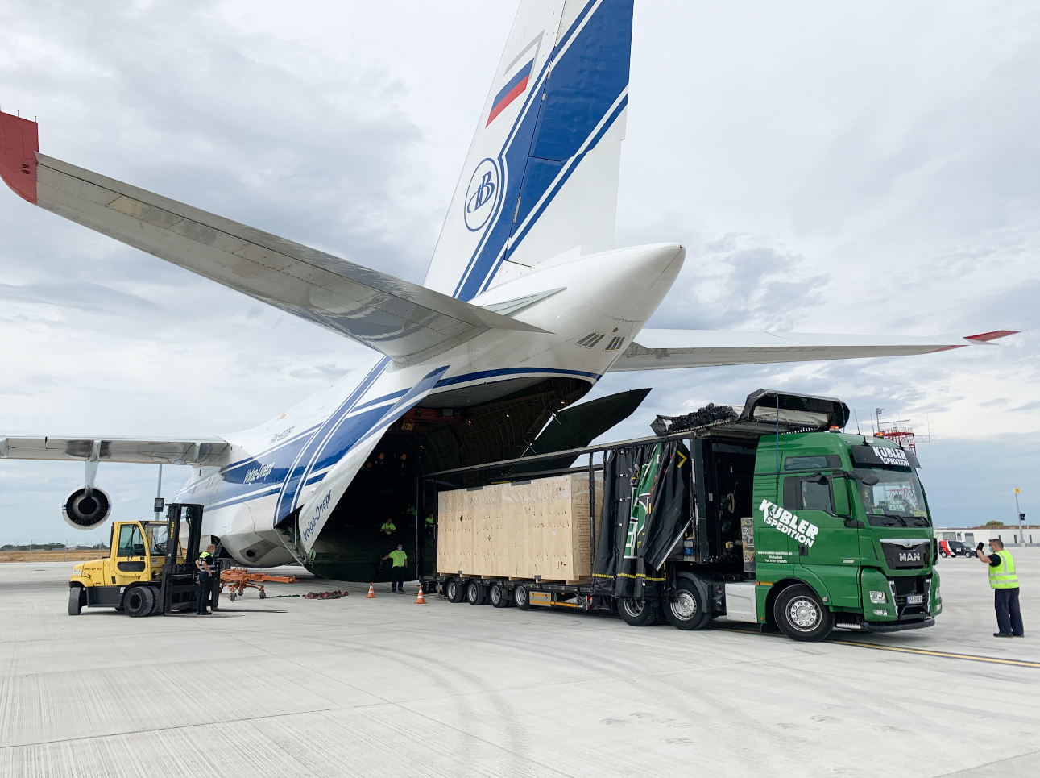
The system is loaded onto the Antonov An-124 at Liège airport. (Source: Spedition Kuebler)

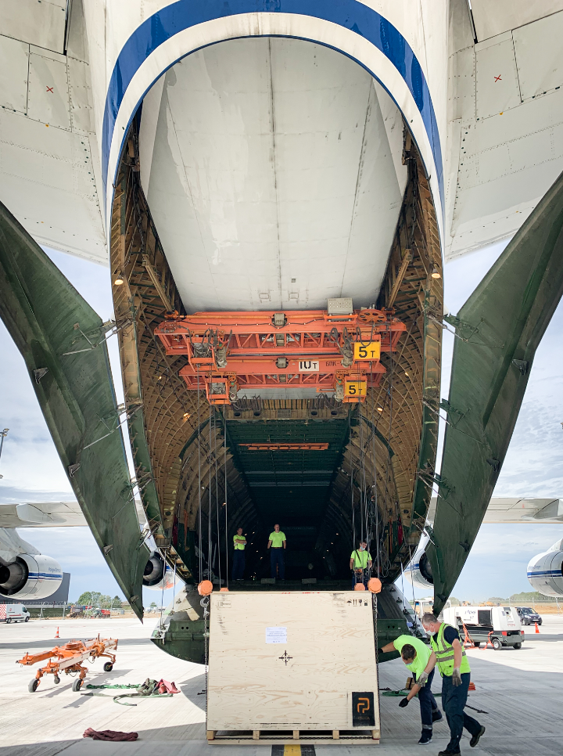
The Antonov An-124 is one of the largest cargo aircraft in the world. (Source: Spedition Kuebler)

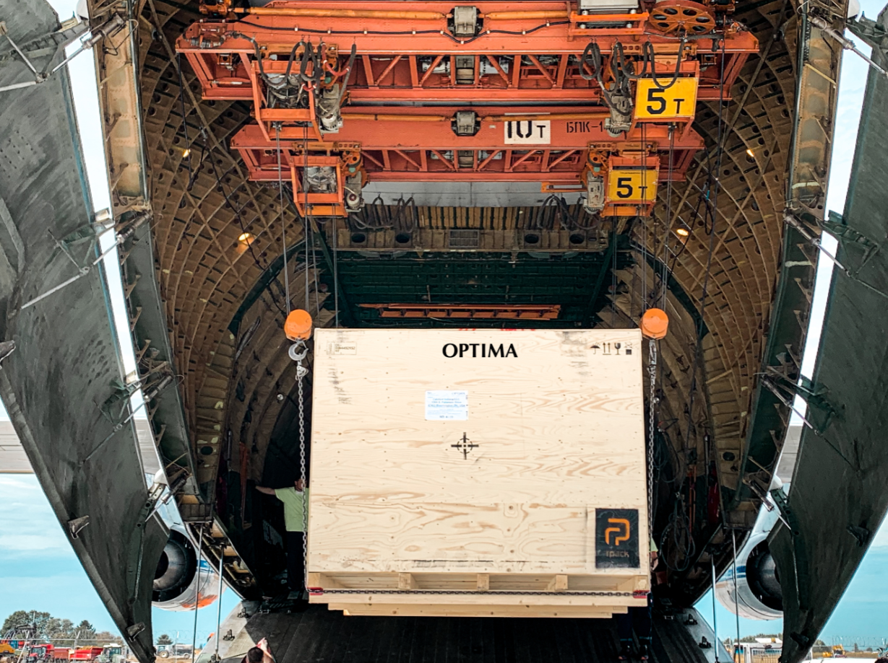
The system components weigh 38,000 kilograms and they were packed into 15 crates. (Source: Spedition Kuebler)

Characters (incl. spaces): 2,071

Press contact:
OPTIMA packaging group GmbH
Jan Deininger
Editor
+49 (0)791 / 506-1472
jan.deininger@optima-packaging.com
www.optima-packaging.com

About OPTIMA
Optima supports companies worldwide with flexible and customer-specific filling and packaging machines for pharmaceuticals, consumer goods, paper hygiene and medical devices markets. As a provider of solutions and systems, Optima accompanies these companies from the product idea through to successful production and throughout the entire machine life cycle. 2,450 experts around the globe contribute to Optima's success. 19 locations in Germany and abroad ensure the worldwide availability of services.

Thank you very much for your publication. We look forward to receiving a specimen copy.

