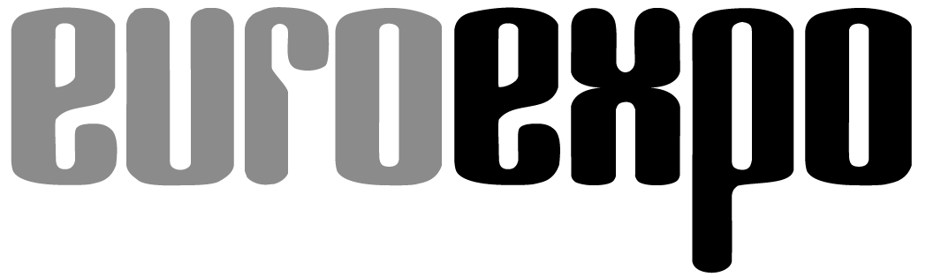
Messe- und Kongress-GmbH
Joseph-Dollinger-Bogen 7
D-80807 Munich, Germany
Phone: +49 89 32 391 259
Fax: +49 89 32 391 246
www.euroexpo.de/en
www.logimat-messe.de/en

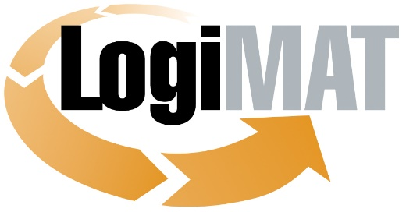

International Trade Show for
Intralogistics Solutions and Process Management
March 16–18, 2027 | Messe Stuttgart

Munich, June 17, 2026

Press Release

LogiMAT 2027 in Stuttgart

New event theme “MIND MEETS MACHINE – What’s next?”

Munich, June 17, 2026 – LogiMAT, the International Trade Show for Intralogistics Solutions and Process Management, is sending a clear message in 2027 about the future of the industry. The new theme of “MIND MEETS MACHINE – What's next?” puts the event’s focus squarely on the smart fusion of human expertise and technological prowess.

The intralogistics industry is undergoing profound change. Artificial intelligence (AI), autonomous mobile robots (AMRs), humanoid robots, and smart automation solutions are evolving at a dizzying pace, transforming processes along the entire value chain. At the same time, however, there remains a vital need for human experience, creativity, judgment, and accountability. The key question today is no longer which steps can be automated, it’s how humans and technology can collaborate successfully to tap into new potential. LogiMAT’s theme “MIND MEETS MACHINE – What's next?” addresses precisely this evolution, examining the intersection of human intelligence and technological innovation – the very partnership that will define the future of intralogistics.

LogiMAT as a forum for innovation

The theme also describes LogiMAT itself: the primary industry meetup where innovators and practitioners come together, where ideas find solutions, and where investment decisions take shape.
“LogiMAT lets people see and experience the technologies of tomorrow,” explains Exhibition Director Michael Ruchty from event organizer EUROEXPO Messe- und Kongress-GmbH. “Our new theme of ‘MIND MEETS MACHINE – What's next?’ underscores how closely enmeshed human expertise and technological innovation have become. The ‘MEETS’ aspect also stands for LogiMAT itself – the platform where people can see hardware, software, and systems in action and hear bold new ideas.” The term ‘MACHINE’ here covers the entire spectrum of intralogistics, from AI applications, robotics, and autonomous vehicles to industrial trucks, material handling systems, shelving and warehouse management solutions, packaging equipment, software solutions, and any number of other technologies that deliver efficiency and resilience in today’s supply chains.

From AI to humanoid robotics: futuristic visions become reality

This trend will be most evident in the areas where technological development is focused in the coming years. AI has taken the leap from visionary concept to industry practice and is already helping businesses plan, execute, and optimize their logistical processes. AMRs are rapidly becoming a mainstay of integrated material flow systems, working more and more closely with warehouse management and control systems.
Humanoid robotics is also attracting more attention as advances in sensor and gripping technologies and motion coordination pave the way for new applications in areas where traditional automation is reaching its limits. Although many use cases are still in the early stages of development, the direction is clear: The collaboration between humans and intelligent machines will become increasingly important as the technology leaps forward.
LogiMAT 2027 shines a spotlight on these trends, giving visitors a comprehensive overview of state-of-the-art technologies, specific use cases, and innovative solutions for the challenges of today’s intralogistics.

Dialog, networking, orientation

Exhibitors are invited to present their ideas, innovations, and new products in the context of the theme of “MIND MEETS MACHINE – What's next?” The campaign creates a space for dialog about how humans and machines can work together to boost the performance of logistical processes.
LogiMAT offers industry professionals unique added value: a roadmap for navigating an increasingly complex market and an opportunity to compare competing solutions side by side – from traditional intralogistics systems to robotics, automation, and smart software.
All this makes LogiMAT 2027 once again the must-attend industry meetup – where ideas find technologies, where innovations respond to customer needs, and where mind meets machine to deliver the solutions of tomorrow.

4.121 characters (with spaces)

Munich, June 17, 2027 – This text may be reprinted free of charge, but please send a copy to EUROEXPO Messe- und Kongress-GmbH, Press and Public Relations Department, 80912 Munich.

About LogiMAT

LogiMAT, the International Trade Show for Intralogistics Solutions and Process Management, will return next year to the Messe Stuttgart convention center, directly adjacent to Stuttgart International Airport, March 16–18, 2027. Presented by EUROEXPO Messe- und Kongress-GmbH, LogiMAT ranks as the world’s largest trade show for intralogistics solutions with a complete market overview of everything driving the intralogistics industry, from procurement to production to shipping. International exhibitors showcase innovative technologies, products, systems, and solutions for streamlining operations, optimizing processes, and cutting costs in a company’s internal logistics. Beyond the exhibitor booths, visitors can also experience a different program of presentations each day plus live events covering a wide range of topics.
LogiMAT also has a presence in various international markets. Upcoming events:
LogiMAT India: February 8–10, 2027 | Bombay Convention & Exhibition Centre, Mumbai
LogiMAT China: April 21–23, 2027 | SZCEC, Shenzhen

