PRESS RELEASE
Schwaebisch Hall, April 30, 2019

Simple, flexible machine solutions for quick entry into the market
OPTIMA will be showcasing entry level machinery for the consumer industry at Expo Pack in Mexico

The Optima Group will be exhibiting two machines at Expo Pack. The international trade show for the packaging industry will be held from June 11 to 13 in Guadalajara, Mexico. Visitors can get an impression of the company’s expertise from the machines on display: the OPTIMA FM1 and the SD €co. Optima experts will also be on hand with information about the Group's entire portfolio.
The OPTIMA FM1 filling machine and the OPTIMA CM1 closing machine enable quick entry into the cosmetics, food, and chemicals markets. This is made possible by the machines’ short delivery time, plug-and-play design, and low space requirement. The devices are ideal for filling glass and plastic containers. The OPTIMA FM1 can be combined with the OPTIMA CM1 closing machine. The OPTIMA CM1 can be used to place stoppers, screw caps, and press-on caps onto containers. Both machines offer up to 100 different formats.
Optima will also present details of the OPTIMA CFR rotary machine for coffee. The machine concept allows capsules to be launched onto the market faster and more safely. Its modular, configurable construction enables OPTIMA CFR to be up and running in just a few months. The “balcony design” makes it really easy to access for cleaning and maintenance. All functional units can be arranged easily in line with changing requirements. The integrated control cabinet also gives the machine a small footprint overall. The OPTIMA CFR can handle up to 220 capsules a minute.
With the OPTIMA SD €co, Optima is also showcasing a servo-controlled auger filler with a dispensing range of up to 30 kilograms, allowing food, cosmetics, and chemical products to be precisely and easily dispensed. The SD €co is simple to clean and stands out thanks to its ease of use and straight-forward self-assembly. Compact dimensions make installation easier in confined spaces.
Optima offers local service support through its subsidiary in Mexico City. Customers thus benefit from a local presence, quick response times, and highly qualified experts who are in regular contact and communication with Optima's German engineers.
Optima at Expo Pack in Guadalajara, Mexico: June 11-13, 2019: Expo Guadalajara, booth no. 1528

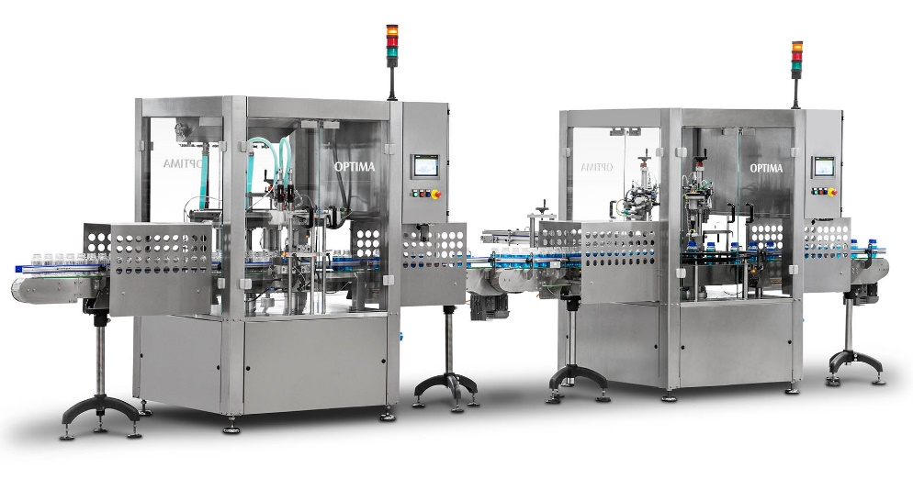
Quick, easy, flexible. Three words that could describe the OPTIMA FM1 and CM1. The machines are set apart by their quick format changes, compact dimensions, and good accessibility. The OPTIMA FM1 and OPTIMA CM1 can either be operated individually or in coordination with each other.

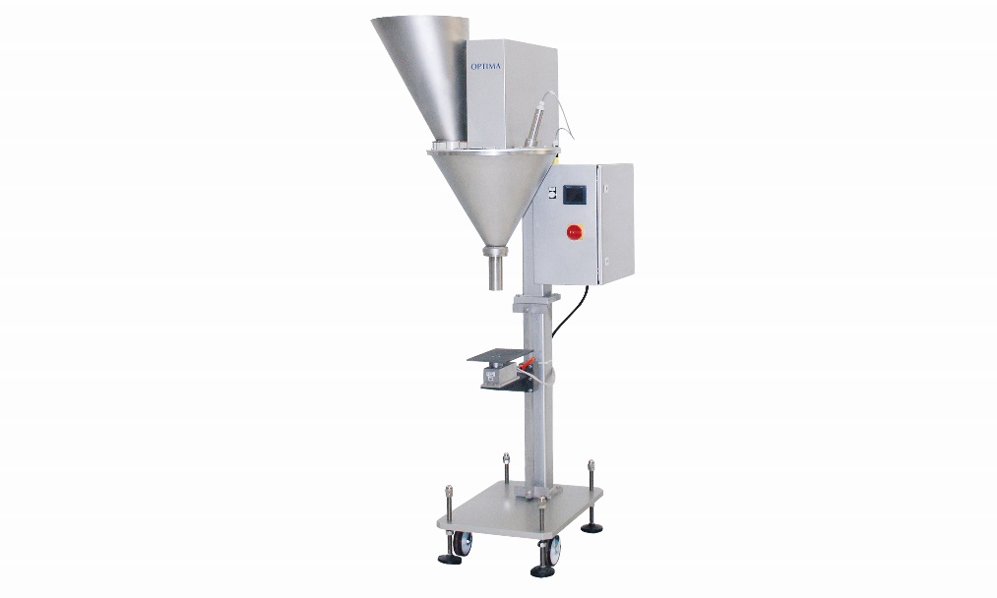
The simple plug-and-play design is also a hallmark of OPTIMA SD auger filler.

Characters (incl. spaces): 2,361

Press contact:
OPTIMA packaging group GmbH
Jan Deininger
Editor
+49 (0)791 / 506-1472
jan.deininger@optima-packaging.com
www.optima-packaging.com
Thank you very much for your publication. We look forward to receiving a specimen copy.

