PRESS RELEASE
Schwaebisch Hall, November 3, 2021

Cybersecurity at the highest level
OPTIMA collaborates with LANCOM Systems to develop a novel VPN solution for machines

The Optima Group from Schwaebisch Hall, Germany, has joined forces with cybersecurity specialist LANCOM Systems to develop a new type of VPN solution for machines and systems. As a result, it is now possible to establish an even more secure connection with the systems installed at the customer's site and maintain them remotely. The solution, which is the only one of its kind on the market, allows for VPN connections monitoring, protects the machine network at the customer's site with a firewall and is particularly user-friendly.
"With LANCOM Systems, we have found the ideal partner to take our cybersecurity to the next level," says Dr. Eng. Benjamin Haefner, Group Leader Industrial IT at Optima. In the future, every machine built by the special-purpose machine manufacturer will be equipped with an edge firewall from LANCOM that has been specially developed for Optima. "In addition to the highest security VPN routing functionality, the edge firewall functions as a kind of central doorman in the machine. As a result, uncoordinated data flows with potential risks can be systematically reduced and controlled," explains Haefner.

Unparalleled functionalities for maximum security

In addition, the VPN connection between Optima and the machines at the customer's site can be permanently monitored with what is known as a central firewall. "These functionalities are one-of-a-kind on the market and ensure maximum IT security," says Haefner. The structure of the entire VPN solution is strictly aligned with standards relevant to cybersecurity, such as IEC 62443 or CPwE reference architecture.

User friendliness increases IT security

The LANCOM solution is also user-friendly and easy to operate. In addition, the automated solution can be configured for the customer's network faster than previous applications. There is plenty of freedom for making flexible adjustments to the customer's individual IT infrastructure, which facilitates harmonious integration. Retrofitting can be carried out on existing machines at any time. "Usability is a particularly important issue for us," adds Markus Irle, Vice President Firewall & Security at LANCOM Systems. "This is because a large proportion of cybersecurity incidents are due to errors in use, not the security technologies themselves." Such a challenge can be overcome by making the system less complex. The development partnership with LANCOM Systems is part of an extensive series of measures Optima has taken to further enhance cybersecurity.

Highly respected manufacturer of secure, reliable and future-proof network and security solutions

Based in Wuerselen, Germany, LANCOM Systems is a highly respected manufacturer of secure, reliable and future-proof network and security solutions (WAN, LAN, WLAN & firewalls) for business and government. For the fifth time in a row, the German network infrastructure provider has topped the Professional User Rating Security Solutions (PUR-S) user survey conducted by the analyst firm techconsult and boasts an excellent reputation among experts. LANCOM Systems is a wholly owned subsidiary of the Rohde & Schwarz technology group.

More information: www.optima-packaging.com/cybersecurity

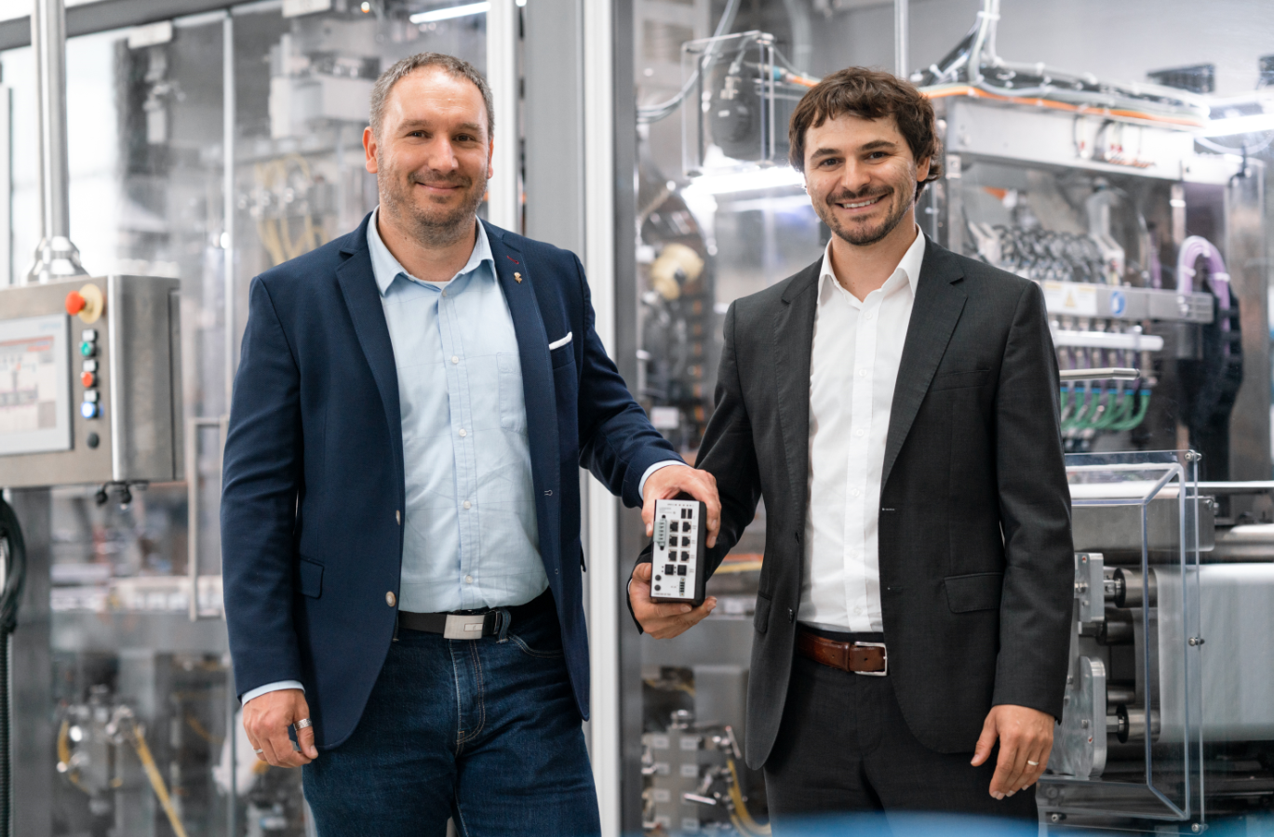Markus Irle, Vice President Firewall & Security at LANCOM Systems, and Dr. Eng. Benjamin Haefner, Group Leader Industrial IT at Optima, presenting the new VPN solution. (Source: Optima. All photos were taken in compliance with the strictest infection control measures.)

The solution, which is the only one of its kind on the market, allows for VPN connections monitoring, protects the machine network at the customer's site with a firewall and is particularly user-friendly. (Source: Optima)

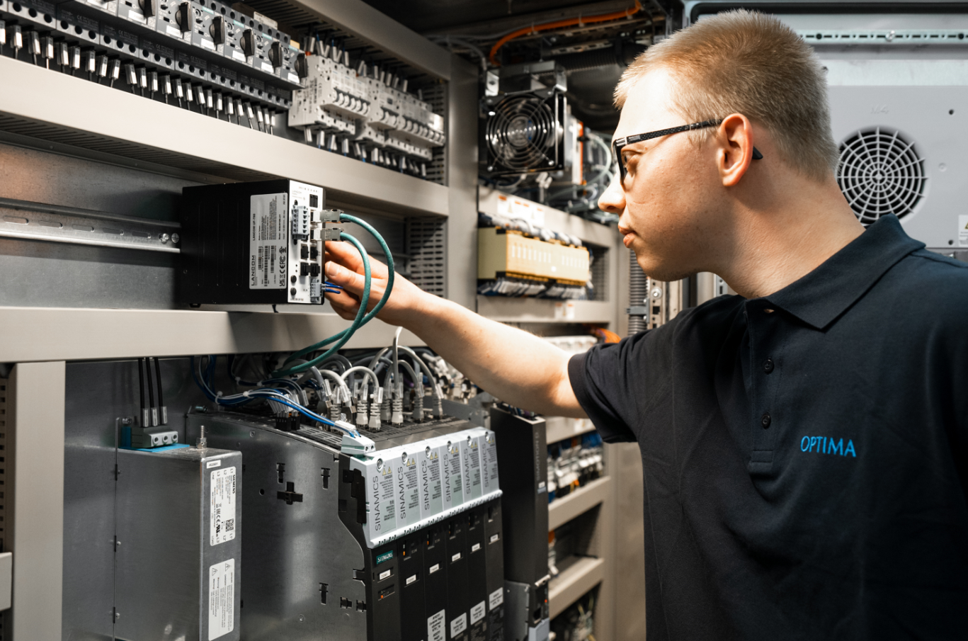
With the new VPN connection and its special security features, Optima and LANCOM Systems offer Optima’s customers a particularly secure and user-friendly solution. In the future, every machine manufactured by this special-purpose machine builder will be equipped with it. (Source: Optima)

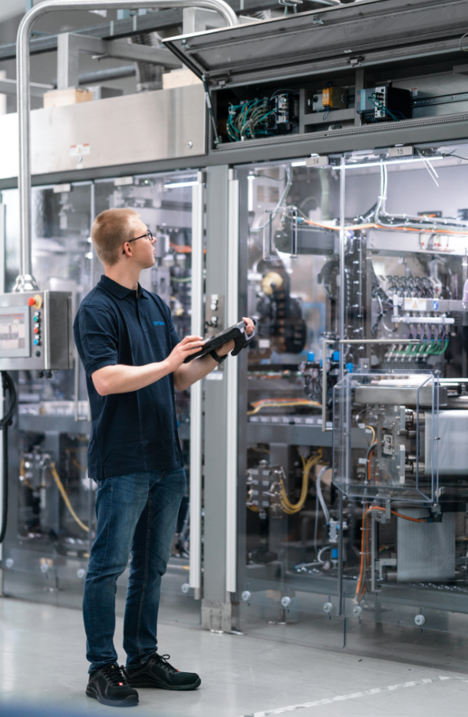
High-tech in action: An Optima employee checks the correct configuration of the VPN solution using a tablet. (Source: Optima)

Characters (incl. spaces): 3,252

Press contacts:
OPTIMA packaging group GmbH
Jan Deininger
Group Communications Manager
+49 (0)791 / 506-1472
jan.deininger@optima-packaging.com
www.optima-packaging.com

LANCOM Systems GmbH
André Faßbender
Senior Manager Corporate Communications
+49 (0)2405 49936-336
andre.fassbender@lancom.de
www.lancom-systems.de

About OPTIMA
Optima supports companies worldwide with flexible and customer-specific filling and packaging machines for pharmaceuticals, consumer goods, paper hygiene and medical devices markets. As a provider of solutions and systems, Optima accompanies these companies from the product idea through to successful production and throughout the entire machine life cycle. Over 2,650 experts around the globe contribute to Optima's success. 19 locations in Germany and abroad ensure the worldwide availability of services.

Thank you very much for your publication. We look forward to receiving a digital specimen copy.

