Bakery technology

# GEA launches new high-speed bake extruder

# A new standard in industrial baking flexibility and performance

Düsseldorf (Germany), June 16, 2025 – GEA has introduced its latest innovation for the baking industry: the new GEA Bake Extruder at IBA in Düsseldorf (Germany), a precision-engineered system designed to meet the evolving demands of medium to large-scale biscuit manufacturers, developed for high-volume and high-speed applications. The extruder delivers high flexibility, productivity, and hygienic operation, whether deployed as a stand-alone unit or integrated with downstream oven systems.

The new GEA Bake Extruder has been developed to address a range of industrial baking needs, supporting various production styles including wirecut, co-extruded, filled, continuous extruded, and like-deposited products. These formats are commonly used in the production of cookies, bars, and biscuits with varied textures, fillings, and inclusions.

“GEA identified current needs in a customer survey and aligned its engineering accordingly,” said Matteo Pasquali, Application Manager Soft Dough at GEA. “From customer interviews, we learned that the industry demands higher performance, greater flexibility, easier cleaning, and enhanced product variety. The Bake Extruder is our response to those requests.”

**Modular versatility with advanced features**

The system offers full modularity with interchangeable dies and cutting mechanisms, including a fully redesigned wirecut system that can nominally operate at speeds of up to 350 strokes per minute across a maximum working width of 1,700 millimeters. For specific product formats, the machine delivers a performance of 130 cuts per minute when producing encapsulated cookies, and up to 250 cuts per minute for continuous extruded products.

To further enhance versatility, the extruder is equipped with customizable filler blocks and can be configured with optional lobe pumps. These lobe pumps are particularly well suited for processing aerated and softer doughs that may contain inclusions such as chocolate chips or dried fruits, ensuring accurate dosing and maintaining product integrity.

**Precision and Control**

The GEA Bake Extruder is powered by **brushless motors**, enabling refined control over extrusion speed and cut timing. **Servo-driven axes** ensure high repeatability and minimal variance in product size and shape, essential for maintaining consistent quality in high-throughput environments. The option to integrate **lobe pumps** – which provide gentle and accurate dosing for delicate or aerated doughs – adds another level of precision, particularly for filled or layered products.

**Operator-Friendly and Hygienic Design**

The GEA Bake Extruder introduces a newly developed **HMI (Human Machine Interface)** with an independent control box, offering intuitive operation, multi-level access, and improved recipe management. The system is also compatible with ERP integration for streamlined data exchange and **predictive maintenance** via performance analysis tools.

Hygienic design principles have been applied throughout. Key components, including **servo motors, shafts, and supports**, are easily accessible for inspection and cleaning. A **removable hopper**, **open-head configuration**, and **photoelectric safety barriers** enable fast, safe sanitation while maintaining compliance with food safety standards. Stainless steel elements near the nip point also contribute to reduced component wear.

[gea.com](https://www.gea.com/en/)

Picture Overview

Ein Bild, das Maschine, Drucker, Kopierer, Im Haus enthält.
Pic. 1: GEA launches new high-speed bake extruder, GEA Bake Extruder. Source: GEA

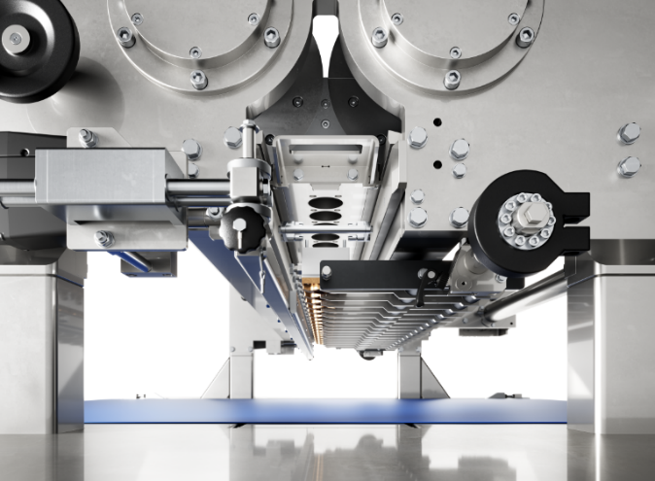**Pic. 2:** The fully redesigned wirecut system in the new GEA Bake Extruder that can operate at speeds of up to 350 strokes per minute across a maximum working width of 1,700 millimeters. Source: GEA

Ein Bild, das Snack, Backwaren, Kekse und Gebäck, Kekse enthält.

Pic. 3: Cookies with chocolate chips – produced with the new GEA Bake Extruder (source: Getty Images)

NOTES TO THE EDITORS

* Further [information](https://www.gea.com/en/index.jsp) about GEA
* To the GEA [Media Library](https://www.gea.com/en/company/media/media-center/index.jsp)
* [**Features**](https://www.gea.com/en/company/media/features/index.jsp) on current topics
* Overview [press events](https://www.gea.com/en/company/media/events/index.jsp)
* Follow GEA on [](https://www.linkedin.com/company/geagroup/) [](http://www.youtube.com/user/TheGEAGroup)

Media Relations

GEA Group Aktiengesellschaft

Nicole Hoffmann

Peter-Müller-Str. 12, 40468 Düsseldorf, Germany

Phone +49 211 9136-1503

nicole.hoffmann@gea.com

**About GEA**

GEA is one of the world’s largest suppliers of systems and components to the food, beverage and pharmaceutical industries. The international technology group, founded in 1881, focuses on machinery and plants, as well as advanced process technology, components and comprehensive services. For instance, every second pharma separator for essential healthcare products such as vaccines or novel biopharmaceuticals is produced by GEA. In food, every fourth package of pasta or every third chicken nugget are processed with GEA technology. With more than 18,000 employees, the group generated revenues of about EUR 5.5 billion in more than 150 countries in the 2024 fiscal year. GEA plants, processes, components and services enhance the efficiency and sustainability of customers’ production. They contribute significantly to the reduction of CO2 emissions, plastic usage and food waste. In doing so, GEA makes a key contribution toward a sustainable future, in line with the company’s purpose: ”Engineering for a better world.”

GEA is listed on the German MDAX, the European STOXX® Europe 600 Index and is also a constituent of the leading sustainability indices DAX 50 ESG, MSCI Global Sustainability and Dow Jones Best-in-Class World.

More information can be found online at **gea.com**.  
If you do not want to receive any further information from GEA, please send an e-mail to **pr@gea.com**.