PRESS RELEASE
Schwaebisch Hall, June 4, 2019

Entry-level solutions, turnkey projects, and competent on-site service
OPTIMA at Propak China 2019

Optima will be represented at Propak China as a provider of leading “made in Germany” packaging technology with a strong presence in China. Optima’s subsidiary in Shanghai offers services ranging from extensive customer care through to project development and servicing. At Propak China, Optima will be primarily focusing on packaging solutions for infant powdered milk, capsule portion packaging, and cosmetic products. Optima offers a wide spectrum of entry-level solutions through to fully automated lines, including end packaging if required, for all areas.
The OPTIMA CFR for capsule portion packaging will be showcased at Propak China. For example, the machine doses coffee into capsules which are compatible with Nespresso, Dolce Gusto, Lavazza and many more, and seals them with foil. The OPTIMA CFR is perfectly suitable for entry into this market and wins customers over with features such as its highly precise dosage system coordinated to the filler product or the sealing process under protective gas. The OPTIMA CFR fills up to 220 capsules a minute. A modular-built machine, it can be fitted out with up to twelve work stations. The OPTIMA CFR is very compact, with its integrated control cabinet. High-performance machines like the OPTIMA CFL-40 achieve an output of up to 1,500 portion packages per minute, while accomplishing highly precise dosing and carrying out various process controls.
Even processing infant powder milk requires special solutions. In order to meet the high product value of milk powder, Optima machines doses into the containers with maximum precision, using either gravimetric or volumetric methods to do so. The filling parameters on machines like the OPTIMA FS can be adjusted to comply with the legal requirements prescribed by different countries. Combined with sealing modules, this results in very compact, efficient lines. The OPTIMA FS is easy to clean thanks to its hygienic design, which safely prevents contamination when changing products. Last but not least, the traceability of the containers that is possible with the OPTIMA FS guarantees maximum product safety.
When it comes to cosmetic products, flexibility is a key criterion for Optima machines, and this is required even in entry-level solutions such as the OPTIMA FM1 and CM1. To ensure the quickest and highly flexible processes, filling and sealing machines such as the OPTIMA Moduline are fitted out with robotics, format parts that can be changed without tools, and even clean-in-place functions. The range for the cosmetic industry is complemented by systems that process various types of containers and viscosities and installation functions.
Optima offers cartoners that can be integrated in line for both cosmetic products and portion packaging. The cartoners produce high-grade sales packaging which impresses customers at the point of sale. Optima can expand the process chain right through to in-line palletizing as a complete turnkey solution.
It attaches utmost importance to servicing, which is available in no time at all from the site in Shanghai. At the company’s headquarters in Germany, Chinese employees are trained on a regular basis so that they stay on the ball in terms of technology and can master the latest Optima technologies. The installation of the systems in Germany is also carried out together with the Chinese service employees. Chinese customers can thus benefit from the fact that the experts at Optima Shanghai know every detail of the installed systems and are also native speakers. As well as China, Optima has sites in Japan, Malaysia, India and South Korea.
OPTIMA at Propak China, Shanghai (China): June 19 to 21, 2019, booth no. 5N70

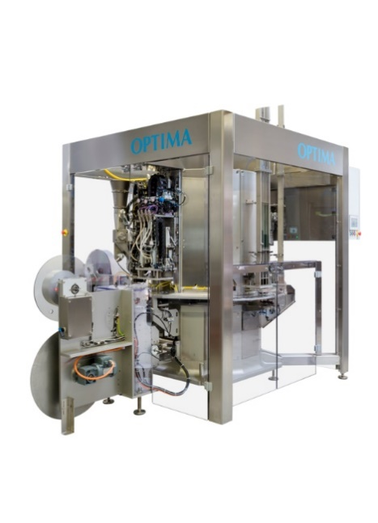
Portion packaging is still a trend. The OPTIMA CFR ensures successful market entry. Delicate products such as coffee are packed under protective gas, the dosage systems being coordinated to the filler.

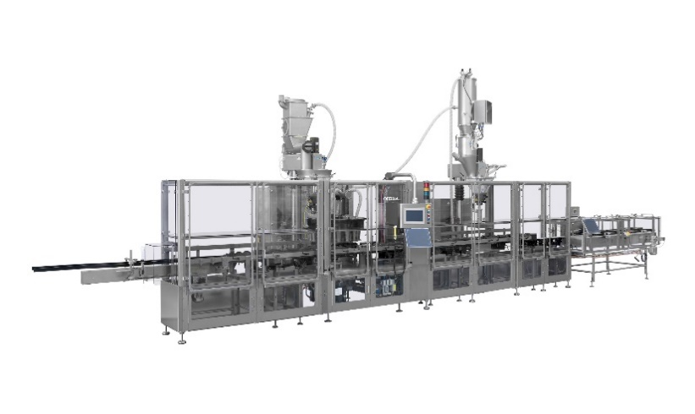
For milk powder: The OPTIMA FS doses this valuable product in a highly precise and time-efficient manner. It has an output of up to 300 containers per minute. The format scope ranges from 40 to 2,000g.

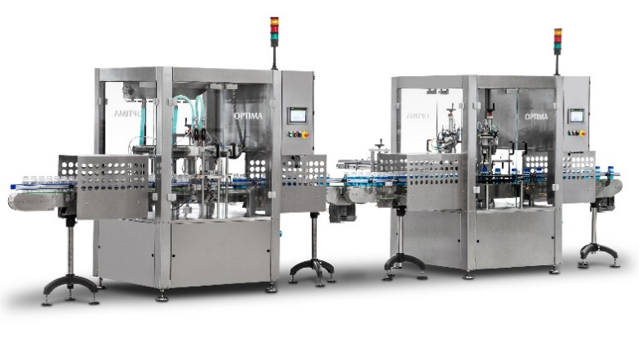
OPTIMA FM1 and CM1 – the flexible entry-level solutions for filling and sealing cosmetic products – can be operated as standalone systems or in line.

Characters (incl. spaces): 3,711

Press contact:
OPTIMA packaging group GmbH
Jan Deininger
Editor
+49 (0)791 / 506-1472
jan.deininger@optima-packaging.com
www.optima-packaging.com
Thank you very much for your publication. We look forward to receiving a specimen copy.

