Messe- und Kongress-GmbH
Joseph-Dollinger-Bogen 7
D-80807 Munich, Germany
Phone: +49 89 32 391 259
Fax: +49 89 32 391 246
www.euroexpo.de/en
www.logimat-messe.de/en
www.tradeworld.de/en

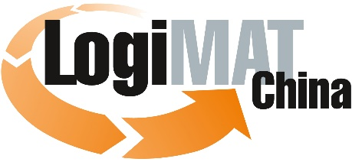

International Trade Show for Intralogistics
Solutions & Process Management

Munich, April 16, 2020

LogiMAT China 2020 postponed due to Covid 19 pandemic

Scheduled to be held in Shanghai in June 2020, LogiMAT China as well as transport logistic China 2020 will be cancelled due to the dynamically developing Covid 19 pandemic worldwide. At this time, the local government in Shanghai cannot guarantee to release the Fairground for major events in June. The health of visitors and exhibitors must take priority. The organizers had to take this decision now, to avoid exhibitors and visitors taking efforts and risk a last minute cancellation ordered by the government.
LogiMAT China has rapidly developed since its 2014 launch in China. After four years in Nanjing, LogiMAT China moved to Shanghai in 2019 and collocated with transport logistic China, organized by Messe Muenchen Shanghai. LogiMAT China developed to be a high-level international information platform and attracted more than 25,000 trade visitors in April 2019.

“Based on China’s State Council announcement to postpone all events until further notice on April 7, we believe it is not in the interest of our exhibitors, partners, and professional visitors, to pursue this year’s show,” explains Larry Chen, Project Director of LogiMAT China from Nanjing Stuttgart Joint Exhibitions in Shanghai. “We believe that postponement until next year is in the best interest for everyone.”

“We took this decision at this time, as we know companies and attendees invest tremendous efforts working in planning exhibitions,” states Peter Kazander, Managing Director of EUROEXPO Messe and Kongress GmbH, Munich, “Our exhibitors are going through difficult times right now and we hope that sharing this information in time could help all participants reschedule their plans more effectively.”

Next LogiMAT China will take place in Shanghai from June 16 to 18, 2021. We are looking forward to seeing our exhibitors, partners and visitors next March in Stuttgart or in June 2021 in Shanghai at the latest.

Organizer: EUROEXPO Messe- und Kongress-GmbH
Joseph-Dollinger-Bogen 7 | 80807 Munich, Germany
Phone: +49 89 32 391 259 | Fax: +49 89 32 391 246
www.logimat-international.com
1,960 characters (with spaces)

This text may be reprinted free of charge, but please send a copy to EUROEXPO Messe- und Kongress-GmbH, Press and Public Relations Department, 80912 Munich.

