PRESS RELEASE
Schwaebisch Hall, July 23, 2020

Getting to know each other in a virtual world
OPTIMA gives its new apprentices and students a digital welcome during a live stream

At the beginning of July, Optima gave a "Digital Welcome" to the new apprentices and students at the Digital Innovation Center. The COVID-19 pandemic meant that it was not possible for the customary afternoon of getting to known each other to take place in person. 45 trainees and students starting at Optima in September and October respectively, and their parents followed the virtual event. The concept was very well received by the professionals of the future.
The Digital Welcome was on 3 July and ran for an hour. Sebastian Henke, Director Human Resources, welcomed the trainees on behalf of the Optima management, and gave a short presentation of the company with the aid of a corporate film. Volker Freisinger, the Head of OPTIMA manufacturing GmbH, provided information about the training center and gave some interesting facts about the training at Optima. An informative video provided by the training center offered interesting insights into the vocational training. The webinar was made more accessible and personalized with interviews with trainers and apprentices, with humorous anecdotes and stories from daily training, and information about their professional careers. Trainees Erik Wurst, Niklas Bareiss, Florian Bruder and Leon Simon presented their apprenticeships as a mechatronics technician, an industrial mechanic, a cutting machine operator and an automation electronics technician. The trainees used standard tools such as what are known as wire end ferrule crimping tools and demonstrated standard work processes to show what is awaiting their future co-workers. Of course, it was also a vital chance to gain an insight into Optima's hotbeds of innovation – the Digital Innovation Center and the Additive Innovation Center. Verena Konz from Optima Human Resources Development and a project team made up of trainees, who working together had built a miniature trade show machine using Lego-Technic, self-designed 3D printed parts and stainless steel elements using the Scrum method, demonstrated the level of responsibility that can be taken on in the training phase at Optima.

Digital information package for the summer holidays

The new apprentices can find lots of useful information in the cloud to help them prepare for their arrival in September. A chat function during the livestream made it possible to communicate with the viewing public. To conclude, there was an opportunity to clarify any outstanding questions and to download a link to a recording of the event. "A lot of interesting, important information", "very informative and professional", "a company with the best in technical setup", "you can tell that you are welcome at Optima" – this was the feedback on the first Digital Welcome from the new trainees and dual curriculum students.

"We wanted to present Optima to the new trainees and students using modern technology, despite the restrictions on contact imposed by the COVID-19 pandemic”, said Sebastian Henke, Optima's Director Human Resources, “for us, just canceling the event was never an option.”

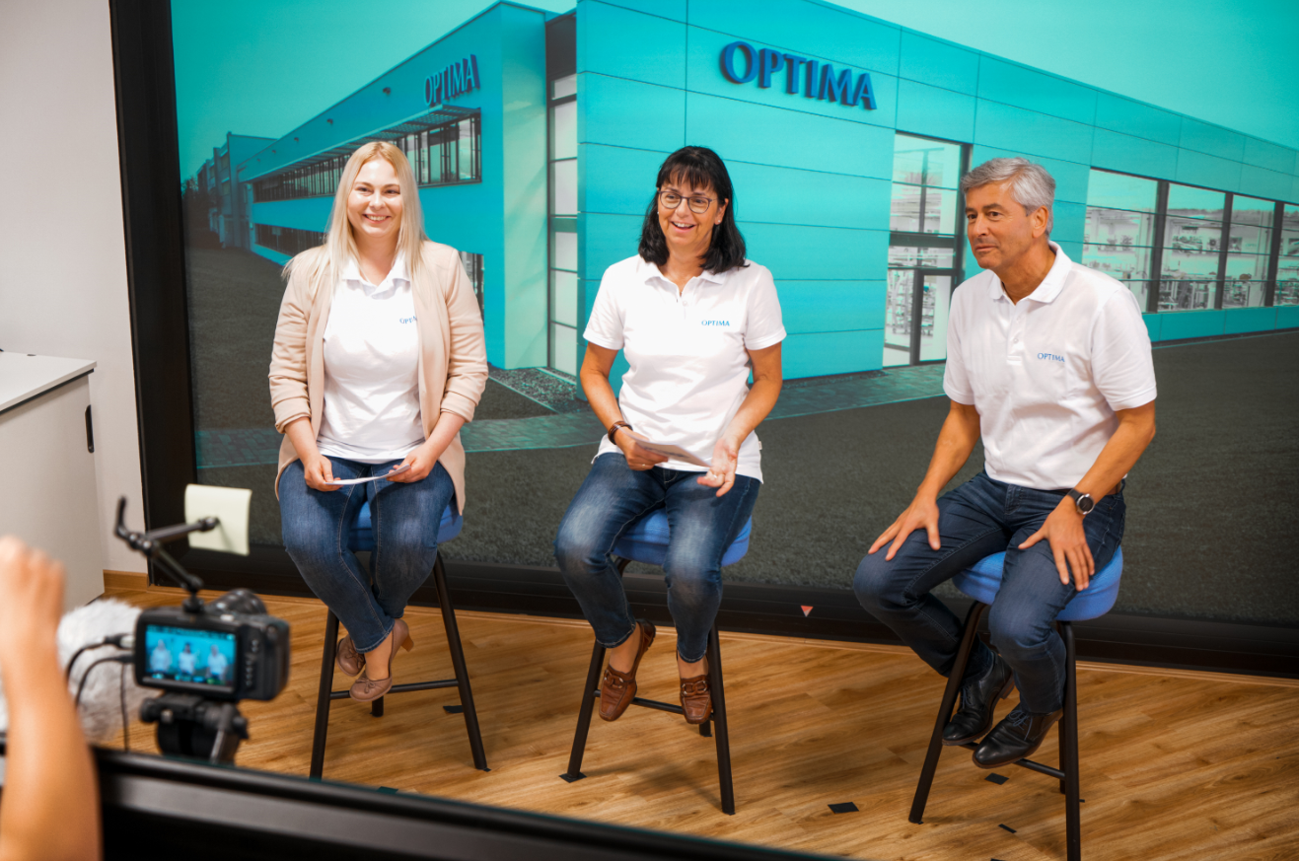
Sarah Wahl (HR Development Manager), Heike Brenner (Apprenticeship Coordinator) and Volker Freisinger (Head of OPTIMA manufacturing GmbH) give valuable tips on safety at work, codes of conduct and infection control measures. (Source: Optima)

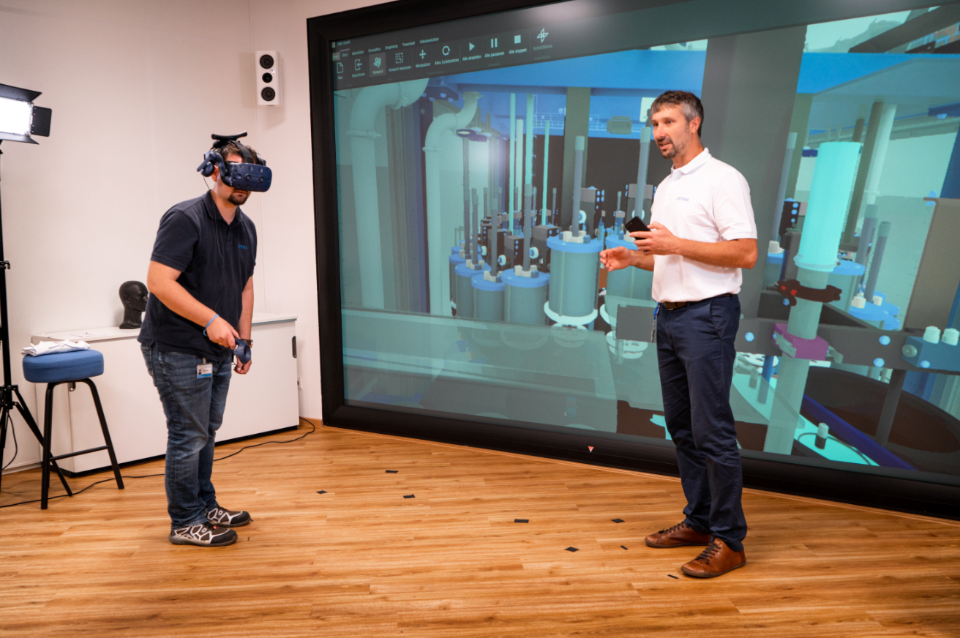
Volker Frey (Team Leader, Smart Services) and Tobias Augsten (Technical Support Specialist) provide an insight into augmented and virtual reality technologies that the apprentices and students at Optima will be working with. (Source: Optima)

Characters (incl. spaces): 3,212

Press contact:
OPTIMA packaging group GmbH
Jan Deininger
Editor
+49 (0)791 / 506-1472
jan.deininger@optima-packaging.com
www.optima-packaging.com
Thank you very much for your publication. We look forward to receiving a specimen copy.

