LAUDA Honors Jürgen Walz for 45 Years of Service

A Strong Backbone in Plant Engineering

Lauda-Königshofen, June 10, 2026 – An extraordinary anniversary took center stage at a ceremony held at LAUDA DR. R. WOBSER GMBH & CO. KG: Jürgen Walz, a welder in plant engineering, was honored by the management team and executive leadership for 45 years with the company – a testament to loyalty, professional expertise, and a deeply felt connection to the family business.

Jürgen Walz began his career on September 3, 1979, with an apprenticeship as a mechanic at LAUDA, which he successfully completed in January 1983. After a brief professional stint outside the company, he returned in May 1984 as a mechanic in the OEM Devices division – then known as Leitz-Bau. After completing his military service, which coincided with the fall of the Berlin Wall, he rejoined LAUDA in September 1989. Since July 1998, Jürgen Walz has worked as a welder in plant engineering, where he has established himself as an indispensable expert. Over more than four decades, he completed numerous welding and brazing certifications as well as additional qualifications, including a crane and forklift operator's license.

Dr. Gunther Wobser, President & CEO, paid tribute to the honoree in his laudatory speech with personal words: “Jürgen Walz works very well and reliably under pressure. As a welder, he literally stands at the seam of the department – a demanding job in which every clean weld determines the safety of our systems. With energy and backbone, he has always contributed critical feedback and suggestions for improvement. An anniversary as long as this one is something special, especially because the recognition originally planned for his 40th anniversary could not take place in the usual setting during the coronavirus period.” In recognition of his contributions, Dr. Wobser presented the LAUDA certificate of honor to Jürgen Walz.

On behalf of plant engineering, its manager Thorsten Schyle paid tribute to the honoree and emphasized that such a long tenure with the company is anything but a given today. Machines, processes, and technology have changed fundamentally over the past decades, he noted. What has remained unchanged, however, is the honoree’s humor, sociability, and constructive criticism. His passion for travel – which has taken him all the way to Australia – and his strong sense of camaraderie have also shaped the team spirit.

The Works Council Chairman Uwe Stastny spoke on behalf of the workforce. He looked back at the year 1979 from an economic and political perspective and acknowledged Jürgen Walz’s 28-year membership in the IG Metall trade union as well as his eight years of involvement in works council activities. The countless welding training courses, he said, are an expression of exemplary willingness to learn. For the future, he wished the honoree good health and fulfilling travels, which he will be able to pursue more intensively from the start of the release phase of his partial retirement on November 1, 2026.
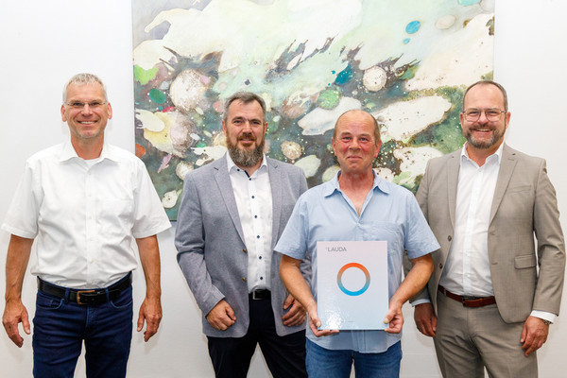

Picture (from right to left): Dr. Gunther Wobser (President & CEO of LAUDA), Jürgen Walz, Thorsten Schyle (Manager Production Plant Engineering), and Uwe Stastny (Works Council Chairman) paid tribute to the honoree in their speeches marking the 45th anniversary of his service. © LAUDA

We are LAUDA – the world leader in precise temperature control. Our constant temperature equipment and systems are at the heart of important applications, contributing to a better future. As a complete one-stop supplier, we guarantee the optimum temperature in research, production and quality control. We are the reliable partner for Aerospace, Electromobility, Hydrogen, Chemistry, Pharmaceuticals/Biotech, Semiconductors and Medtech. We have been inspiring our customers for over 70 years with our expert mentoring and innovative solutions – every day anew and all over the world.

In our company, we always go one step further. We support our employees’ development and are constantly developing ourselves: to create a better future together.

Press contact
We are more than happy to make prepared information about our company, the LAUDA Factory Gallery and our projects in the area of innovation promotion, digitalization and idea management available to the press. We look forward to hearing from you – just give us a call!

CHRISTOPH MUHR
Director Corporate Communications
T + 49 (0) 9343 503-349
christoph.muhr@lauda.de

LAUDA DR. R. WOBSER GMBH & CO. KG, Laudaplatz 1, 97922 Lauda-Königshofen, Deutschland/Germany. Limited partnership: Headquarters Lauda-Königshofen, Registration court Mannheim HRA 560069. General partner: LAUDA DR. R. WOBSER Verwaltungs-GmbH, Headquarters Lauda-Königshofen, Registration court Mannheim HRB 560226. Managing Directors: Dr. Gunther Wobser (President & CEO), Dr. Mario Englert (CFO), Dr. Marc Stricker (COO)

