PRESS RELEASE
Schwaebisch Hall, October 17, 2019

Perfecting aseptic processes
OPTIMA pharma at the P-MEC, India

At the P-MEC India, Optima Pharma will be providing in-depth insights into our extensive portfolio for the aseptic processing of pharmaceutical drugs. Using a 360° application, we will be presenting in detail highly flexible machines for filling and sealing liquids, through to turnkey solutions including isolator technology and pharmaceutical freeze drying. Another focus will be on machines to automate auto-injector assembly. Optima Pharma will also be exhibiting Smart Glasses and other digital innovations at P-MEC India from November 26 to 28, 2019.
At the P-MEC, experts from Optima Pharma will be presenting information about their latest projects and technologies. A total of four machines and lines will be presented in a 360° application. One of these is the OPTIMA MultiUse Filler. This type of machine is particularly suitable for efficiently and safely processing small to medium-sized batches and, where required, high potency drugs. Vials, pre-filled syringes and cartridges are processed without format parts, using the highly flexible machine platform and robot technology. The MultiUse systems have already been designed for the use of isolators and for connecting freeze drying systems.
Optima Pharma's turnkey solutions are increasingly in demand. At P-MEC, the company will be presenting a project for filling and sealing vials, including isolator technology and freeze drying. Optima Pharma has been primarily responsible for this project from the designing of all systems to site management and site acceptance tests (SATs).
Another project presented in a 360° application at the P-MEC is the high-speed processing of syringes. The OPTIMA SV125 offers the perfect entry-level solution for the fully automated filling and sealing of syringes. Its modular design means that the machine can be enhanced with additional functions or its output can be boosted. Different dosing systems can be used to meet specific requirements. There are many additional functions available.
Turnkey solutions with isolators, freeze drying and assembly functions
Devices for medical administration such as automatic or pen injectors are being increasingly used. At P-MEC, Optima Automation will be providing information on assembly machines for the injectors, which can initially be operated semi-automatically and can later be upgraded to provide fully-automated solutions. Other benefits include the option of processing different injectors on a single machine system and integrated, comprehensive process controls. The assembly machines can also be combined with Optima Pharma's syringe filling machines to create integrated turnkey lines.
Today, isolator technology is the leading barrier system with automated bio-decontamination of filling and sealing processes. With the DECOpulse® System from Metall+Plastic, new time savings can be achieved in the decontamination cycle and the use of H₂O₂ can be reduced. The DECOpulse® System has been awarded the Biotech Innovation Award 2019. Other specific benefits of isolator technology from Metall+Plastic will be demonstrated by a model that will be exhibited at P-MEC.
Sterility tests are an important cornerstone of aseptic processing. This is where the STISO sterility test isolator from Metall+Plastic is the benchmark product. It offers extremely short decontamination cycle times, and together with the low-maintenance H₂O₂ flash evaporation, ensures exceptionally high machine availability. In operational terms, the ergonomic concept and its numerous details, such as the wireless glove test that can be carried out via the HMI, are particularly impressive. STISO has a modular construction and can be flexibly adapted to meet specific customer requirements. Two versions are available, for aseptic or aseptic high-potency applications.
Using digitalization effectively
At the P-MEC, Optima Pharma will be demonstrating the advantages of digitalization for the pharmaceutical industry, taking Smart Glasses as an example. These demonstrate just how proficient the service that can be provided is when Optima Pharma's experts provide real-time support troubleshooting without having to be physically present. Instructions for maintenance work and format changes are also available in the form of tutorials displayed on the Smart Glasses. Optima Pharma is offering the Smart Glasses as part of the IPAS (Intelligent Production Assistant System), offering many other digital features that are being continually expanded.
Optima Pharma at the P-MEC, India:
November 26 to 28, 2019, India Expo Mart, Delhi (India)

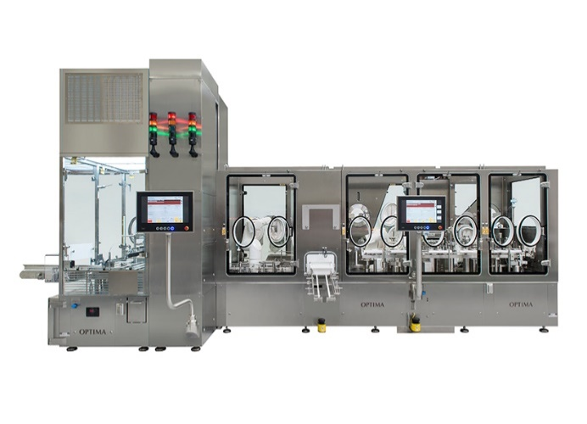
Optima Pharma's MultiUser Filler is perfectly suited to small batches, such as complex, highly potent drugs. Pre-filled syringes, cartridges and vials are processed without format parts.

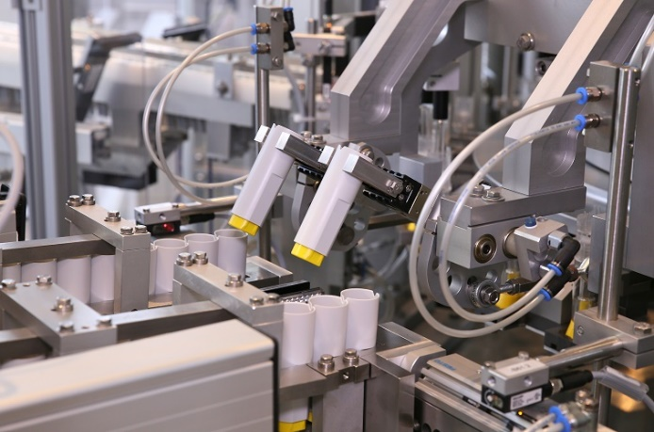
For the automated assembly of different injectors: Machine systems by Optima Automation. These can be upgraded to turnkey lines with Optima Pharma filling and sealing systems.

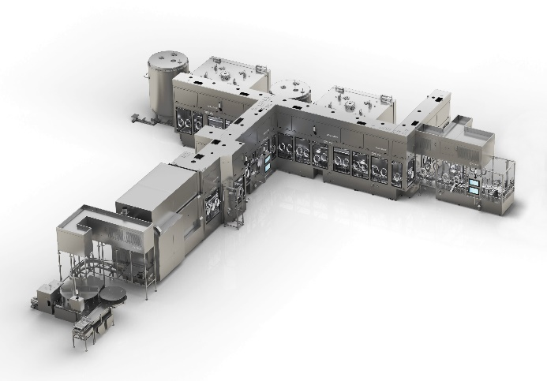
For many years, Optima Pharma has specialized in efficiently executing turnkey projects. For example, these include the filling and sealing of liquids, including upstream and downstream, isolator technology and freeze drying.

Characters (incl. spaces): 4,540

Press contact:
OPTIMA packaging group GmbH
Jan Deininger
Editor
+49 (0)791 / 506-1472
jan.deininger@optima-packaging.com
www.optima-packaging.com
Thank you very much for your publication. We look forward to receiving a specimen copy.

