GEA presents ConsiGma® FC Lab coater for small tablet batches
Duesseldorf (Germany), May 8, 2026 – GEA unveiled a new tablet coater, the ConsiGma® FC Lab, at the Interpack trade fair in Düsseldorf (May 7–13, Hall 6, C27). The coater is designed for small batches of 0.5 to 1.5 kg of tablets, complementing GEA’s ConsiGma® Coater range. With this launch, GEA adds to its industry-leading AirConnect platform with a coater module for pharmaceutical R&D. Like its sister device, the ConsiGma® Coater, the ConsiGma® FC Lab offers significant advantages for the industry, such as 360-degree spray application for a homogeneous coating, minimal wear, and higher efficiency (90% reduction in material consumption and development times). The new coater is optionally equipped with washing functions as well as containment solutions making it ideal for highly potent active ingredients. , Aesthetic, active and/or enteric coatings for controlled release can be applied to both standard tablets and mini tablets.

New module ensures greater precision and efficiency in small-scale tablet coating processes

Mark Rowland, Director of Product Management Pharma Solid Dosage at GEA, says: “Conventional tablet coaters run for extended periods with large batches of tablet cores. This can lead to abrasion of already applied coating, leading users to apply excessive coating material and thus costly waste. Furthermore, soft tablets can be damaged or broken due to the multiple impacts over this long process time. The ConsiGma coater solves both of these issues thanks to its unique coating concept.” GEA’s new scale-free coater, which integrates with AirConnect fluid bed systems, overcomes these issues and can coat products previously considered impossible, such as unusually shaped tablets. “The AirConnect was developed to meet the pharmaceutical industry’s requirements for flexibility in individual process steps and is based on the proven principle that a single core component can be used for numerous processes by swapping out a range of application-specific modules,” adds Mark Rowland. The new module ensures greater precision and efficiency in small-scale tablet coating processes for companies in the pharmaceutical, nutraceutical, animal health, and coated components sectors.

ConsiGma® FC Lab offers R&D teams the power of GEA’s rapid coating technology on a laboratory scale

The ConsiGma® FC Lab integrates seamlessly with GEA’s AirConnect technology and enables both drying and coating operations from a single base unit. This unified configuration simplifies laboratory workflows, accelerates operator training, and reduces the time required for qualification, maintenance, and calibration. Based on the principles of the ConsiGma® film coating concept and compatible with the AirConnect control module, the ConsiGma® FC Lab ensures precise, uniform, and rapid application of aesthetic and functional coatings to tablets of all shapes and sizes. The ConsiGma® FC Lab offers R&D teams the power of GEA’s rapid coating technology on a laboratory scale, allowing formulation development to begin on the same coating platform used in commercial production. With a process duration of just 6 minutes, development teams can conduct a complete Design of Experiments (statistical experimental design), a method for efficient process optimization, in a single day.
Since the FC-Lab offers the same micro-layer coating approach as the production-scale ConsiGma® Coater, process parameters can be linearly transferred from the lab to mass production. This eliminates the need for upscaling or revalidations, which significantly shortens time-to-market and substantially reduces API consumption (Active Pharmaceutical Ingredients, essential active ingredients in medications responsible for the therapeutic effect).

Photo:

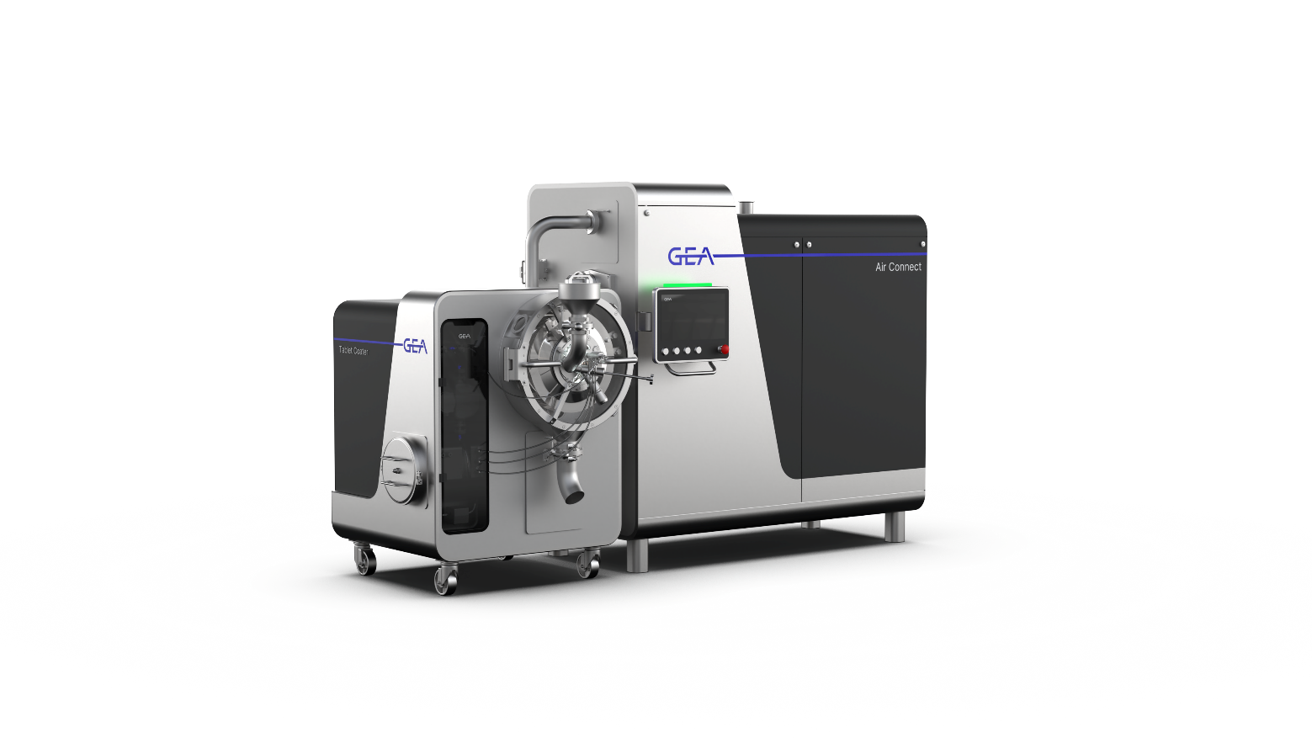
Photo, caption: GEA unveiled the new ConsiGma® FC Lab tablet coater at Interpack 2026 in Düsseldorf. The coater is designed for small batches of 0.5 to 1.5 kg of tablets and complements the ConsiGma® coater series by GEA. (Photo: GEA)

About GEA

GEA is one of the world’s largest suppliers of systems and components to the food, beverage and pharmaceutical industries. The international technology group, founded in 1881, focuses on machinery and plants, as well as advanced process technology, components and comprehensive services. For instance, every second pharma separator for essential healthcare products such as vaccines or novel biopharmaceuticals is produced by GEA. In food, every fourth package of pasta or every third chicken nugget are processed with GEA technology.

With more than 18,000 employees, the group generated revenues of about EUR 5.5 billion in more than 150 countries in fiscal year 2025. GEA plants, processes, components and services enhance the efficiency and sustainability of customers’ production. They contribute significantly to the reduction of CO2 emissions, plastic usage and food waste. In doing so, GEA makes a key contribution toward a sustainable future, in line with the company’s purpose: ”Engineering for a better world.”

GEA is listed on the DAX, the STOXX® Europe 600 Index and is also a constituent of the leading sustainability indices DAX 50 ESG, MSCI Global Sustainability and Dow Jones Best-in-Class World.

More information can be found online at gea.com.

NOTE TO EDITORS

- Further information about GEA
- To the GEA Press page
- To the GEA Media Center
- Background information on current topics can be found at Features
- Follow GEA on  

GEA
Media Relations GEA
Dr. Michael Golek
Ulmenstraße 99, 40478 Düsseldorf
Phone +49 211 91361505
Tel. +491736205746
michael.golek@gea.com

