GEA helps Betko extend fruit storage to 14 months while cutting peak power demand by 20 percent

Düsseldorf (Germany), July 21, 2026 – Betko Fresh Produce Pty (Ltd), a South African producer of apples and pears that also operates packing facilities, has expanded its cold storage capabilities with a new GEA-equipped controlled-atmosphere facility. The upgrade extends fruit storage to up to 14 months and enables Betko to process approximately 50,000 additional fruit bins annually. Already in the first season, more than 37,000 bins were processed through the facility, exceeding the original design capacity. As a result of the facility’s energy-optimized building and refrigeration design, peak power demand is reduced by 20 percent. The new facility, featuring 24 controlled-atmosphere chambers, combines an energy-optimized building design with GEA's “Adaptive Suction Set Point Control”, which recalculates the optimal operating point for each individual chamber every 60 seconds. The project is the latest chapter in a partnership that has run continuously since 1992.

A business built on cold
Betko is one of South Africa’s leading producers of apples and pears, operating farms and packing facilities in the Western Cape. The company farms 1,000 hectares in the Western Cape and supplies approximately 65,000 metric tons of fruit annually to markets across Africa, Asia, the European Union and the United Kingdom. The company handles 16 apple and 8 pear varieties, distributing a third of its volume to each of its three main market regions. “Without cold storage, we do not have a business,” says Roux Groenewald, Managing Director of Betko. “We need cold storage through the year to have this business.”
As Betko’s own production grew and new farms were acquired, the existing facility ran out of both space and power. The solution was to build a new, standalone complex at a farm the company had acquired in Sunnyside, closer to the orchards, where grid capacity was available.

Energy optimization from the ground up
From the outset, the project was shaped by a key constraint: South Africa’s electricity grid is under sustained pressure, meaning Betko could not simply increase its power consumption. GEA faced the challenge of enabling Betko to expand its storage capacity while reducing peak power consumption by 20 percent.
“The starting point of this project was energy optimization,” explains Shaun Kleb, Head of Project Sales Southern and Eastern Africa at GEA. “We examined every part of the operation for potential energy savings and challenged conventional assumptions about the facility design.”
The creative part of GEA’s approach lay in treating the building, storage layout and refrigeration system as one integrated design challenge rather than optimizing the refrigeration plant in isolation. By considering the facility as a whole, the team identified savings across the building envelope, storage configuration and refrigeration technology while still increasing Betko’s available capacity. The facility was designed for 24 controlled atmosphere (CA) stores, each holding 1,200 bins. Bins are stacked 11 high rather than the industry standard of 10, giving Betko more capacity for the same 5,000 square meter footprint. The floors were insulated, which is standard practice in freezer facilities but a first for a CA store of this kind. “We did some high-level calculations, and the payback was within a year,” says Kleb.

Compressors designed for a constrained grid
At the heart of the system are three GEA Grasso V series reciprocating compressors, with a fourth identical unit in standby. Variable frequency drives control the operating speed between 500 and 1,500 RPM, allowing the plant to ramp up smoothly without power spikes and to run at lower speeds and higher efficiency during the quieter winter months.
Together with high-pressure liquid subcooling, the compressor setup delivered the targeted 20 percent reduction in peak power consumption. “In practical terms, this reduction means the customer can increase production by another 20 percent without requiring additional power from the local grid,” says Hannes Steyn, Senior Director Country Manager Southern and Eastern Africa at GEA.

Control that optimizes every 60 seconds
The GEA Omni system with Adaptive Suction Set Point Control ties the facility together, collecting data from every room, analyzing it in real time and recalculating the optimal operating point every 60 seconds. Data flows to the GEA cloud, giving Betko’s refrigeration manager remote visibility and control across all 24 rooms via mobile phone.
The system also supports Dynamic Controlled Atmosphere storage, in which oxygen setpoints are lowered to extend storage duration further, with sensors monitoring fruit stress levels continuously.
Storage extended to 14 months
The commercial impact of extending storage is significant. Alan Salonika, who has advised Betko’s refrigeration operations for more than 30 years, is direct about what the previous constraint meant in practice: “Before, to a degreewe often had to bring fruit to market earlier than we would have preferred because of the lack of cold storage space. With this new project, we’re pushing our storage toward 12, even 14 months, which allows for more flexibility in our distribution worldwide.”
Thirty years of continuous partnership
“We’ve been doing business with GEA for more than 30 years,” says Groenewald. “We gave them carte blanche in terms of energy optimization because we trusted the GEA team to optimize the design.” Construction began in March 2024. By 17 February 2025, the first fruit went into CA storage. “In less than a year, the project was completely finished,” says Groenewald. “When the first fruit came out of storage in September 2025, it was perfect.” “As a multinational company, GEA has global experience and best-practice examples from all around the world,” says Steyn. “But we match it through our local organizations. Every customer is unique. We really try to understand that and optimize the design so that the customer gets the greatest value out of his facility.”

Learn more about GEA heating & cooling solutions for cold storage at www.GEA.com/coldstorage

Photos:

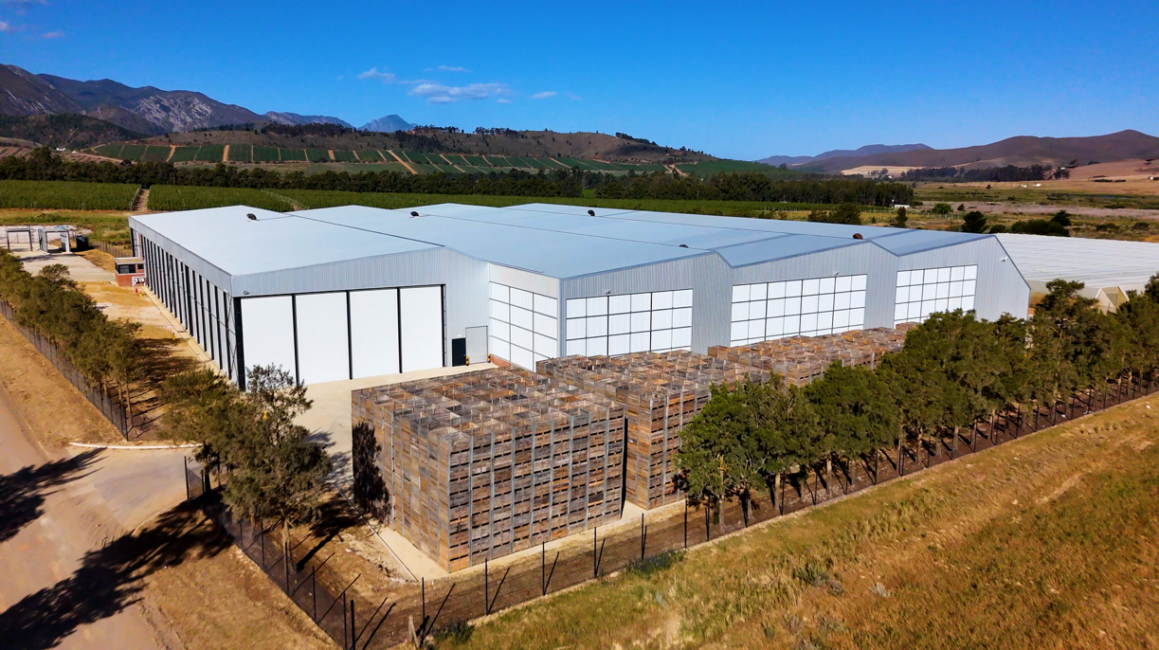

The new Betko Sunnyside facility in the Western Cape, South Africa, houses 24 controlled atmosphere stores with capacity for a second phase of another 24. (Photo: GEA)

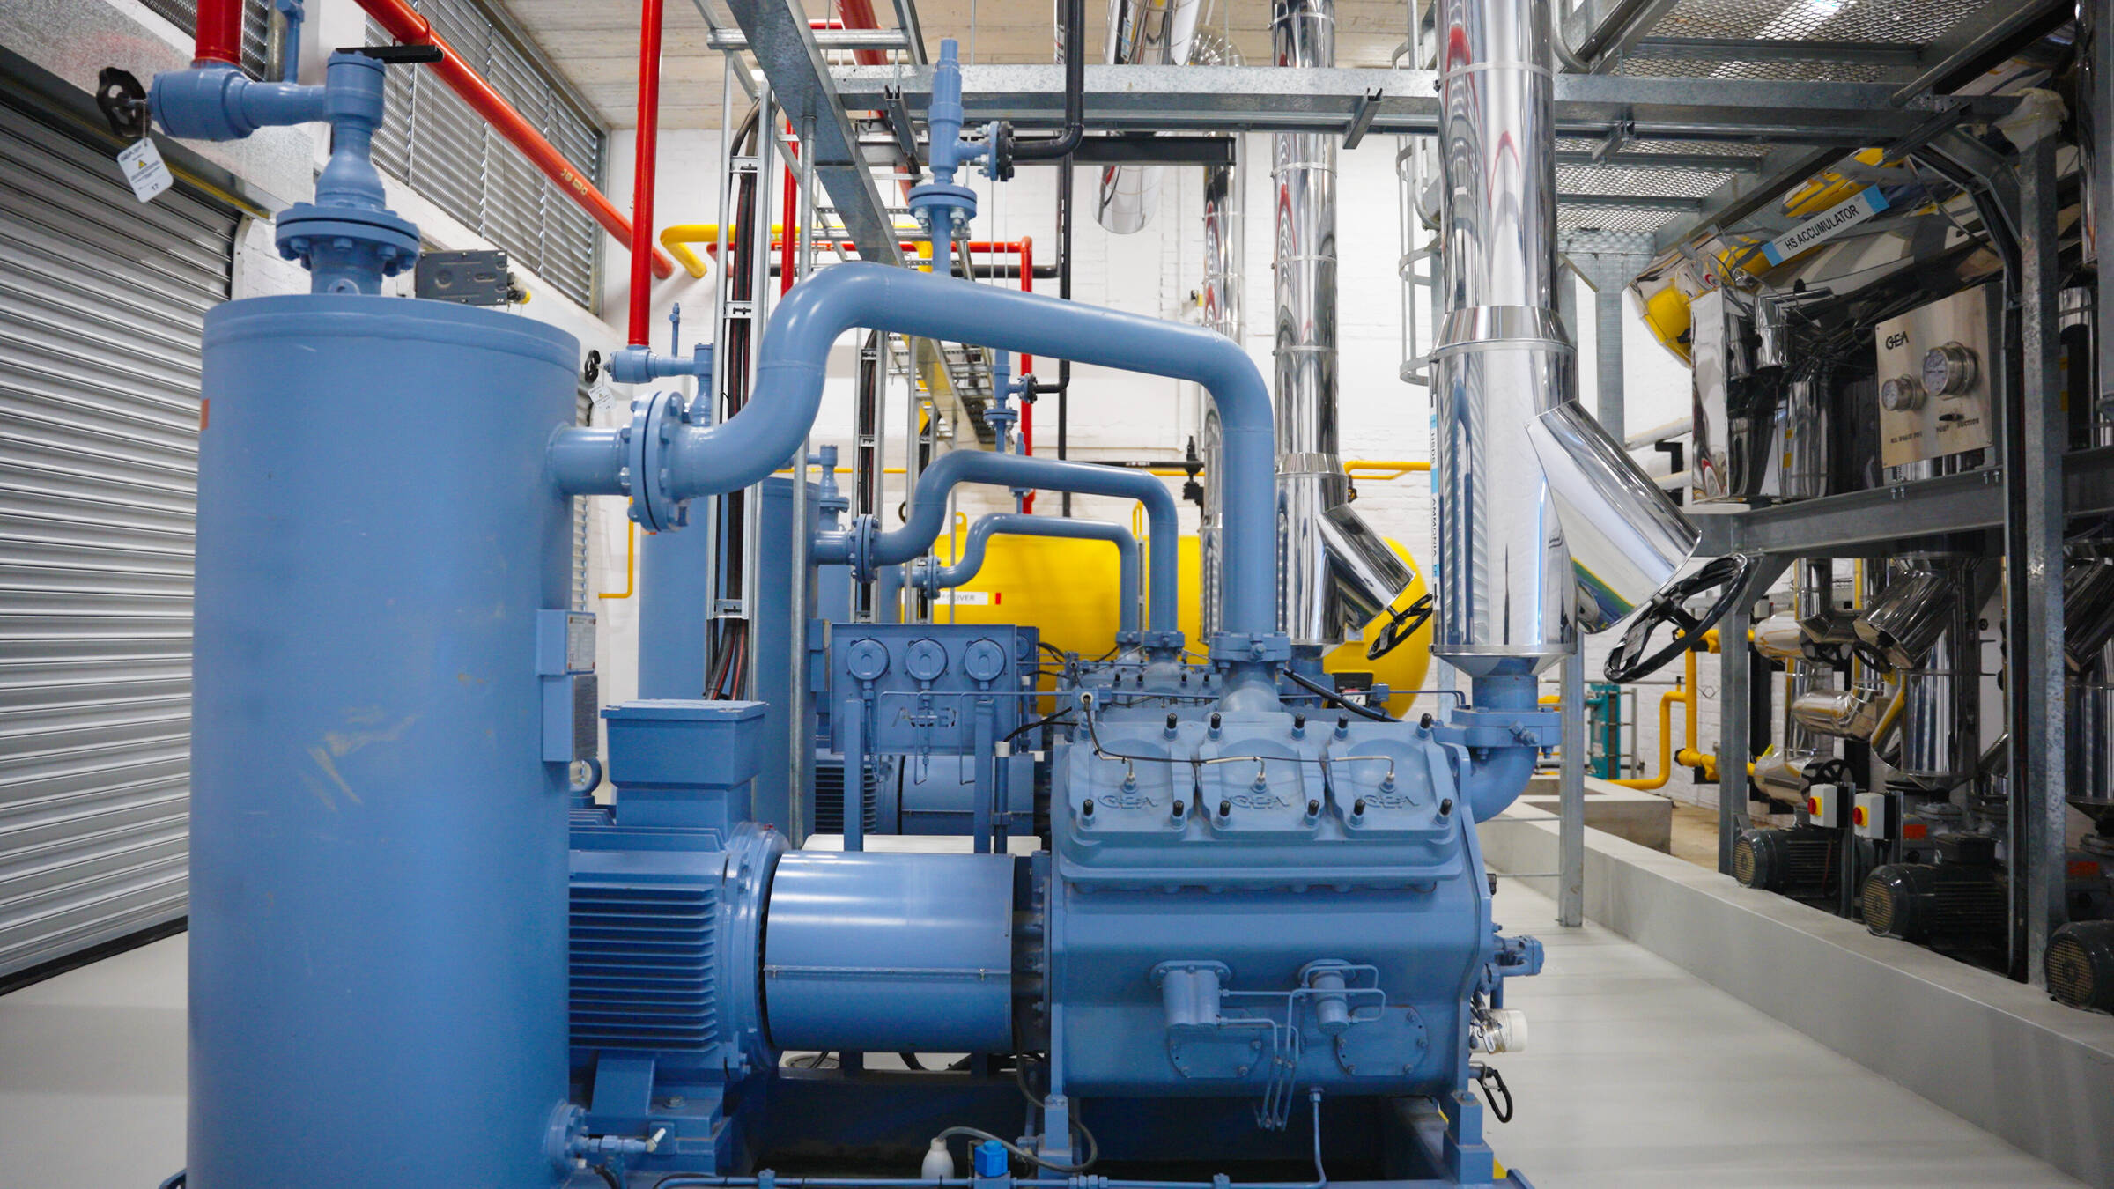

GEA Grasso V series reciprocating compressors at the heart of Betko’s new refrigeration plant, Sunnyside, South Africa. (Photo: GEA)
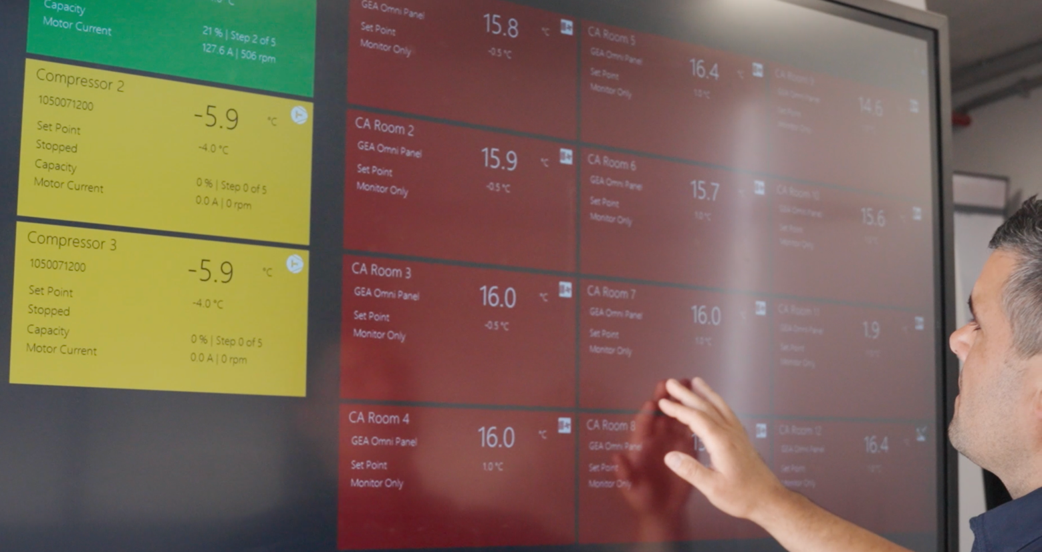
The Adaptive Suction Set Point Control collects data from every room, analyzing it in real time and recalculating the optimal operating point every 60 seconds. (Photo: GEA)

NOTES TO EDITORS
- Further information about GEA
- To the GEA Media Library
- Features on current topics
- Overview press events
- Follow GEA on  

About GEA
GEA is one of the world’s largest suppliers of systems and components to the food, beverage and pharmaceutical industries. The international technology group, founded in 1881, focuses on machinery and plants, as well as advanced process technology, components and comprehensive services. For instance, every second pharma separator for essential healthcare products such as vaccines or novel biopharmaceuticals is produced by GEA. In food, every fourth package of pasta or every third chicken nugget are processed with GEA technology.

With more than 18,000 employees, the group generated revenues of about EUR 5.5 billion in more than 150 countries in fiscal year 2025. GEA plants, processes, components and services enhance the efficiency and sustainability of customers’ production. They contribute significantly to the reduction of CO2 emissions, plastic usage and food waste. In doing so, GEA makes a key contribution toward a sustainable future, in line with the company’s purpose: “Engineering for a better world.”

GEA is listed on the DAX, the STOXX® Europe 600 Index and is also a constituent of the leading sustainability indices DAX 50 ESG, MSCI Global Sustainability and Dow Jones Best-in-Class World.

More information can be found online at gea.com.
If you do not want to receive any further information from GEA, please send an e-mail to pr@gea.com.

Media Relations
GEA Group Aktiengesellschaft
Dr. Michael Golek
Ulmenstraße 99, 40476 Düsseldorf, Germany
Phone +49 211 9136-1505
michael.golek@gea.com

