PRESS RELEASE
Schwaebisch Hall, August 28, 2019

The complete package for diagnostic companies
OPTIMA life science at MEDICA 2019

Filling, coating and packaging diagnostic products – this is all handled by the Optima Life Science division of the Optima Group based in Schwaebisch Hall (Germany). The OPTIMA ImmuPouch®, the OPTIMA ImmuCoat® and the OPTIMA ImmuFill® range offer diagnostic companies every machine solution for the automated production of ELISA test kits from a single source. Optima will be showcasing the newest member of the “diagnostics family” at MEDICA 2019 – the OPTIMA ImmuFill®.
“Optima Life Science is able to cover a broad range of solutions required for diagnostics,” says Frank Wenmakers, Director Diagnostics at Optima Life Science. With the new OPTIMA ImmuFill® Optima Life Science offers the full range of solutions for the production of ELISA test kits. The system will be on display at MEDICA 2019. The new rotary transfer machine means the reagents for the microtiter plates can be dispensed in bottles of varying diameter and depth. The machine controls the sorting, filling, weighing, closing and labeling of bottles.
Compact, low cost and time saving when changing formats
Because small batches are often produced in the diagnostics industry, it is essential that formats can be changed quickly. The machine only requires very few format parts, allowing a changeover in under 30 minutes. The OPTIMA ImmuFill® consists largely of aluminum components and is overall considerably less expensive than machines from the pharmaceutical sector, in which stainless steel is predominantly used. Making the machine compact was also a key consideration. Occupying an area of three square meters, the machine is perfect for both smaller production spaces and for laboratories.
From the individual solution to a fully automated production line
The system complements the modular OPTIMA ImmuCoat® machine platform, which covers the entire process of coating microtiter plates. Every required process step can be integrated into this platform. For example, it includes incubators in which the microtiter plates are stored between the individual process steps. Also in the portfolio is the OPTIMA ImmuPouch® machine, which packages the plates in three-side pouches and seals them. All Optima systems can be networked with the OPAL line management software, which among other things improves effectiveness and produces all kinds of batch reports. This helps product traceability.
Optima Life Science at MEDICA 2019: November 18 to 21, 2019, hall 1, booth no. B17

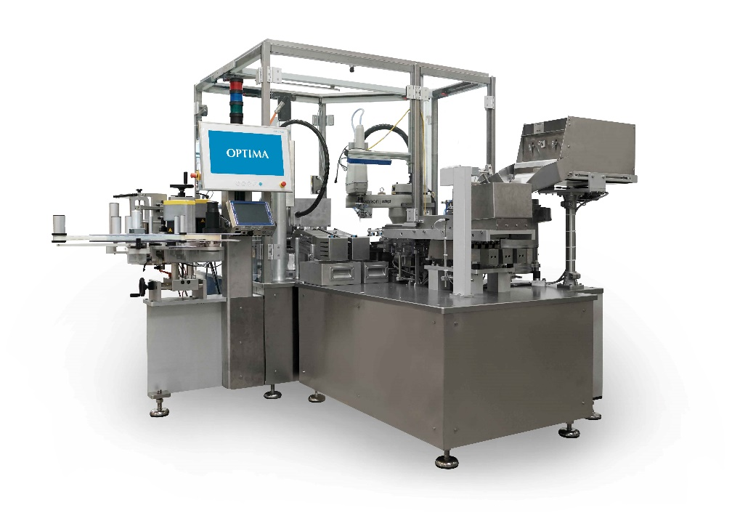
The OPTIMA ImmuFill® tops off Optima Life Science’s diagnostics machine family. It is used to dispense (ancillary) reagents.

Characters (incl. spaces): 2,443

Press contact:
OPTIMA packaging group GmbH
Jan Deininger
Editor
+49 (0)791 / 506-1472
jan.deininger@optima-packaging.com
www.optima-packaging.com
Thank you very much for your publication. We look forward to receiving a specimen copy.

