Forward-looking strategies, innovative processes & healthy corporate culture
LAMILUX wins Best Managed Companies Award
From the development of forward-looking strategies and innovative processes to corporate governance structures and a healthy corporate culture: the Rehau-based family business LAMILUX beat off strong competition to win the Axia Best Managed Companies Award 2021, impressing the top-class jury with its entrepreneurial excellence. This award honours LAMILUX as a pioneer in all key areas of corporate management.
The specialist in daylight systems and fibre-reinforced plastics LAMILUX is a fourth-generation family business that has grown sustainably over the years and generations to become one of the world market leaders in its sectors. As a medium-sized, continuously growing company, LAMILUX is thus one of the central driving forces of the German economy. The top-class jury of the Axia Best Managed is also enthusiastic about the unique LAMILUX corporate culture and philosophy and has chosen LAMILUX as a Best Managed Company 2021.

LAMILUX convinces in all criteria
In a multi-stage application process, the companies were put through their paces. The focus was on strengths, potential and challenges in the four areas of strategy, productivity and innovation, culture and commitment as well as governance and finance. LAMILUX convinced the renowned representatives from business, science and media in all four core areas.
"The German SME sector is characterized by a globally unique diversity of sustainably grown family businesses and hidden champions. The LAMILUX Heinrich Strunz Group stands out once again as a Best Managed Company due to its outstanding corporate management and thus takes on a role model - a particularly important signal to the entire market in times of pandemic" adds Markus Seiz, Best Managed Company Programme Manager and Director at Deloitte Private.
Additional requirements for the application were a minimum annual turnover of 150 million euros and headquarters in Germany. Furthermore, the companies had to be medium-sized or family-owned and show a successful economic development in the past years.

About the Best Managed Companies Award
The Axia Best Managed Companies (BMC) programme is a competition and seal of quality for successful medium-sized companies run by Deloitte Private, WirtschaftsWoche, Credit Suisse and BDI in Germany. The vision: to build a national and global ecosystem of excellently managed medium-sized companies. A key unique selling point of BMC is its internationality: BMC was launched by Deloitte in Canada in the 1990s and has since been successfully introduced in more than 30 countries.

Customized Intelligence - serving the customer as a programme
LAMILUX stands out among the competitors for its CI philosophy "Customized Intelligence - serving the customer as a programme". For LAMILUX this means top performance in all areas relevant to the customer, in particular as a leader in quality, innovation, service, competence and problem-solving. By striving for technologically innovative, user-oriented and customized solutions, LAMILUX aims to inspire above all committed, creative and technophile people to develop tomorrow's innovations.
But the LAMILUX corporate culture is also increasingly becoming a distinguishing feature and a success factor for the family-owned company. It is the "spirit" of LAMILUX. Because the technology and knowledge of market participants are becoming more and more similar - all the more important is how a company acts, which values are lived in the company and how it masters challenges.

Family-like cooperation leads to success
One of the most important guiding principles of LAMILUX is "We are family". Because: employees are the strength of a company and thus the central key to its aspiring success. This is why LAMILUX lives a culture of mutual appreciation, respect and trust as well as an "open door" culture.
"We attribute our success in the AXIA Best Managed Companies Award 2021 to our lived corporate culture and philosophy. This puts people at the centre of all considerations. This includes customers and suppliers as well as employees", says Dr. Heinrich Strunz, Managing Partner of the LAMILUX Heinrich Strunz Group.

About the LAMILUX Heinrich Strunz Group
Continuous roof lights, glass roofs or skylight domes: the LAMILUX Heinrich Strunz Group is one of the leading manufacturers of daylight systems in Europe. The skylights ensure efficient use of natural daylight in a wide variety of buildings. In addition, special smoke and heat extraction systems provide safety in the event of fire and are thus essential components of fire protection concepts. LAMILUX is also known for its solutions for building smoke extraction. Furthermore, the medium-sized family business founded in 1909 is one of the world's largest producers of carbon and glass fibre reinforced plastics. These composite materials provide stability, lightweight construction and impact resistance for roof, wall and floor linings in commercial vehicles, for example. The company currently employs around 1200 people and achieved a turnover of around 293 million euros in 2020.
…
www.lamilux.com
Caption:
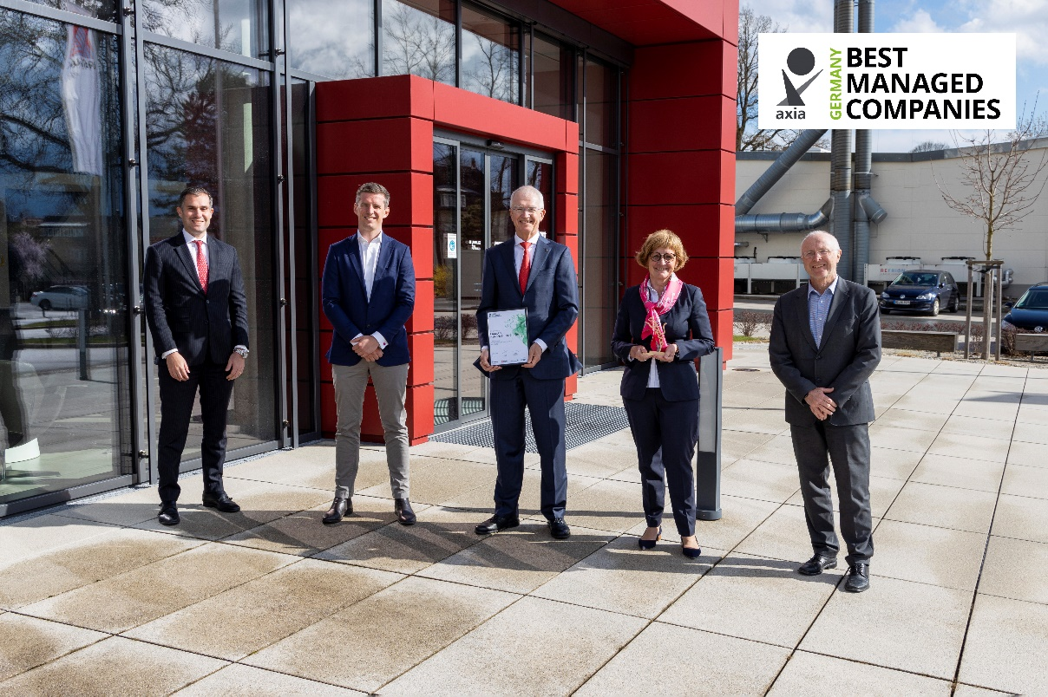

Representatives of the AXIA Best Managed Company Award personally presented the LAMILUX management with the award prize and certificate in Rehau.

From left to right: Senior Relationship Manager at Credit Suisse, Dr Thomas Krause, Managing Partners of LAMILUX, Mr Alexander Strunz, Dr Heinrich Strunz and Dr Dorothee Strunz and Head of Assurance at Deloitte, Martin Thiermann. Missing from this picture is managing partner Johanna Strunz.

