PRESS RELEASE
Schwaebisch Hall, August 10, 2020

The flexible way to complete automation
OPTIMA at CIDPEX 2020

At CIDPEX, Optima is presenting the new OPTIMA FS1, a machine for packaging feminine hygiene products. It is one of an entire range of machines that has been specially designed for companies in Asia. What makes this machine special is that semi-automatic packaging systems can be gradually upgraded to become fully automated processes. The OPTIMA Pearl is also a machine especially designed for the Asian market. Its design combines high performance with low entry prices.
At CIDPEX, Optima is presenting a complete range of machines that have been specially designed for the Asian market. It has focused on flexible upgrade options that are particularly suited to the growing demands of many Asian paper hygiene manufacturers. The OPTIMA FS1 for feminine hygiene products is part of this range. Per minute, the OPTIMA FS1 in-feed can handle a maximum of 1,000 products and outputs up to 100 packs. Additional features include high-quality packaging and all-round format flexibility. The OPTIMA FS1 machine has a sturdy design and is a very cost-effective investment.
Flexible upgrades possible
The OPTIMA DS1 was the first model in the series for the baby diaper packaging industry. Since then, it has proven its worth many times over day to day in numerous companies in Asia. Models such as the OPTIMA Lophura and the OPTIMA Good are flexible and easy to upgrade. Companies can start with a basic closing machine, then integrate a bag filling function and finally add an automatic product stacking function. This means that the user has the fully automated OPTIMA DS1 system after they have completed the final upgrade phase. Additional versions such as the OPTIMA Midnight are available. This is ideal for packaging adult diapers, for example.
The OPTIMA Pearl will also be presented at CIDPEX, and is aimed at Asian customers who demand exceptionally high performance at a competitive price. This packaging system is the only one on the market, and offers good standard equipment with fewer options but which include all the important functions.
The OPTIMA Pearl packaging system is specially designed for sanitary napkins. The balance has been achieved by concentrating on the characteristically smaller package sizes that are standard in Asia, and the fact that the OPTIMA Pearl was able to be developed without incurring additional development costs for new technology. The system is based on tried and tested components and high-performance processes. This makes the price-performance ratio compelling, as does its small footprint.
Local presence
Optima is well aware of the enormous significance of the Asian market. This is reflected in the make-up of its teams, which include both local and international experts. The largest Optima Group field service team is currently operating out of Optima China in Shanghai.
As the world market leader for paper hygiene product packaging, Optima will also be informing CIDPEX attendees about its comprehensive range of packaging machines. High performance, top packaging quality, innovative services, and extensive machine flexibility are all key features of our machines.
Optima at CIDPEX, Nanjing (China), September 24 to 26, 2020: Hall 8, booth no. 8H14

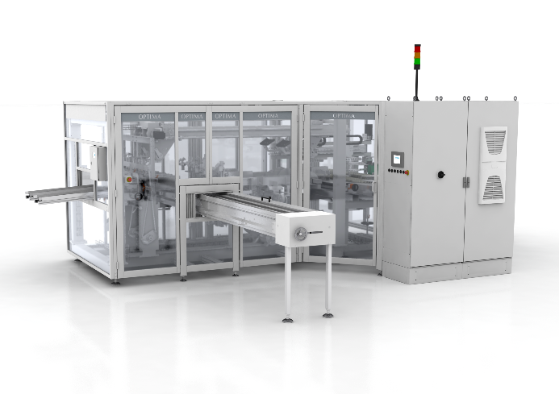

The new OPTIMA FS1 packages feminine hygiene products. Up to 1,000 products can be fed in per minute. (Source: Optima)

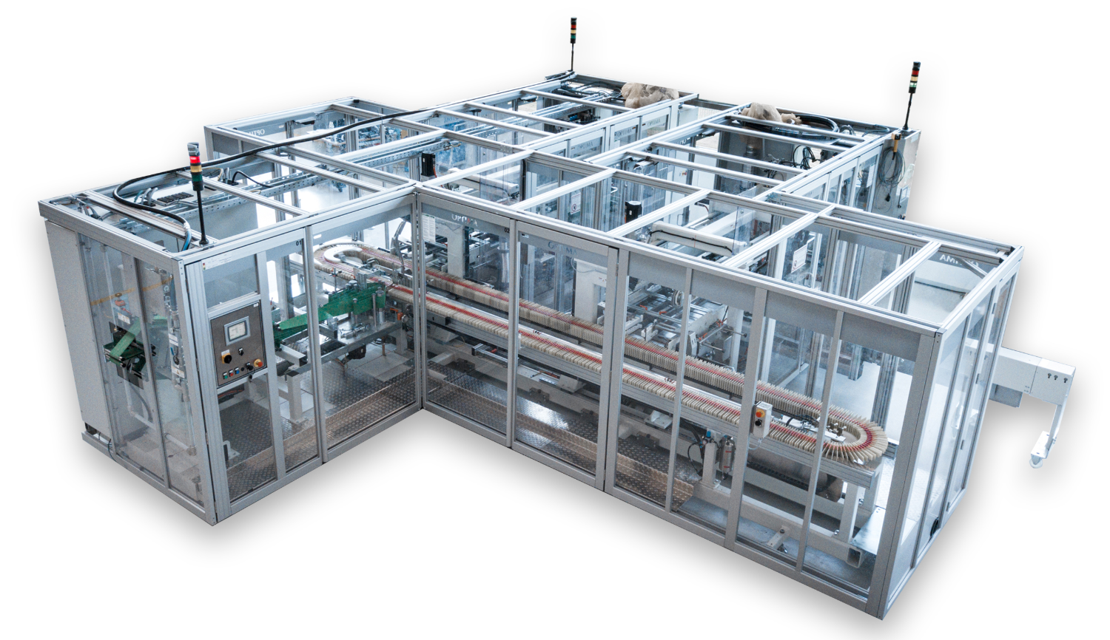
The OPTIMA Pearl offers high levels of performance and many of the frequently requested functions as standard, all at an affordable price. (Source: Optima)

Characters (incl. spaces): 3,181

Press contact:
OPTIMA packaging group GmbH
Jan Deininger
Editor
+49 (0)791 / 506-1472
jan.deininger@optima-packaging.com
www.optima-packaging.com

About OPTIMA

Whether for pharmaceuticals, consumer goods, paper hygiene or medical devices: With flexible and customer-specific filling and assembly systems as well as production and packaging machines, Optima supports companies worldwide and accompanies them as a solution and system provider from the product idea to successful production. With the life cycle management program OPTIMA Total Care, Optima is at the customer's side throughout the entire machine life cycle. The family-owned company has been delighting its customers since 1922. 2,450 experts around the globe contribute to Optima's success. 19 locations in Germany and abroad ensure the worldwide availability of services. The company generates more than 85 percent of its sales abroad. Further information: www.optima-packaging.com.

Thank you very much for your publication. We look forward to receiving a specimen copy.

