marce norbert hörler  slant  November 1, 2025–May 3, 2026, Kunstmuseum St.Gallen  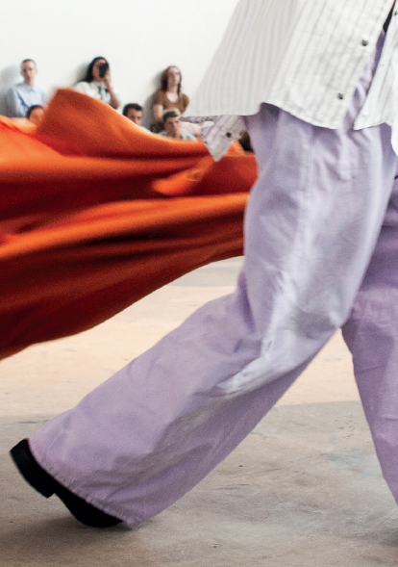  marce norbert hörler, for heat and fervor (2023), photo: Karin Salathé  marce norbert hörler – Between Space, Meaning, and Embodiment  The Kunstmuseum St.Gallen presents the 2025 winner of the Manor Art Prize for St.Gallen, marce norbert hörler, with a multifaceted exhibition that combines performance, poetry, scent, and architecture, challenging our perceptions of space and identity.  What criteria shape our perception of a space? What traces do bodies leave in the spaces they pass through? How does our sense of orientation shift when a space does not follow a straight line? For marce norbert hörler, these are the central questions explored in the exhibition slant.  Three types of spaces intersect in the exhibition: the physical exhibition space, the imaginary space of stories and meanings (as explored, for instance, through tarot and its symbols), and the personal space of queer experiences. Spatial interventions create semi-transparent, labyrinth-like pathways in which live actions unfold. Texts on the walls, drawn from tarot cards, recall topographic contour lines while offering glimpses into a world beyond the visible space.  A corridor connecting two rooms has been subtly altered to produce a shift in perspective, so that walking through it evokes a feeling of imbalance or disorientation. Cast aluminum panels bear poetic phrases; tarot card motifs are present only as distant resonances. The faintly floral scent of the molecule Hedione permeates the space, expanding it with a sensual impulse that has the potential to influence our emotions.  The exhibition space simultaneously serves as a stage for a newly developed performance featuring three performers. In this staged exploration, wayfinding, orientation, and the interweaving of the exhibition’s three spatial dimensions are made tangible through voice and body.  marce norbert hörler lives between Switzerland and Berlin and holds an MA in Art Praxis from the Dutch Art Institute in Arnhem (NL) and a BA in Fine Arts from the Institute Art Gender Nature at the Academy of Art and Design FHNW, Basel.  A Commitment to the Young Swiss Art Scene  The Manor Art Prize, one of the most important awards supporting contemporary art in Switzerland, was initiated in 1982 by Philippe Nordmann to provide a platform for emerging artists. Each year, it is awarded by a professional jury in six Swiss cities, with Aarau, Basel, Biel, Chur, Geneva, Lausanne, Lucerne, Lugano, Schaffhausen, Sion, St. Gallen, and Winterthur alternating in participation on a biennial cycle. Over the years, the prize has accompanied numerous artists on their path to international recognition. | Exhibition Dates  Nov 1, 2025–May 3, 2026 Kunstmuseum St. Gallen  Press Conference  Oct 31, 2025  11:00 a.m.  Exhibition Opening  Oct 31, 2025  6:30 p.m.  Opening Hours  Tue – Sun: 10:00 a.m. – 5:00 p.m.  Thu: 10:00 a.m. – 8:00 p.m.
Press Contact

Nadine Sakotic
Head of Communications
Museumstrasse 32
9000 St. Gallen
T +41 71 242 06 84

kommunikation@kunstmuseumsg.ch
kunstmuseumsg.ch

Fact Sheet
marce norbert hörler
slant

Exhibition Dates | November 1, 2025 – May 3, 2026
Exhibition Venue | Kunstmuseum St.Gallen
Press Conference | October 31, 2025, 11 a.m., Kunstmuseum St.Gallen
Exhibition Opening | October 31, 2025, 6:30 p.m., Kunstmuseum St.Gallen  Vernissage with award presentation by Pierre-André Maus,  Member of the Board of Directors of Maus Frères SA,  Representative of the Manor Art Prize
Curator | Nadia Veronese
Opening Hours | Tue – Sun: 10:00 a.m. – 5:00 p.m.  Thu: 10:00 a.m. – 8:00 p.m.
Press Contact | Nadine Sakotic  T +41 71 242 06 84  kommunikation@kunstmuseumsg.ch
Website | kunstmuseumsg.ch

