PRESS RELEASE
Schwaebisch Hall, September 27, 2021

Green Packaging: New solution for the
paper hygiene market
OPTIMA has co-developed the first paper packaging
for feminine hygiene products

The Optima Group has developed a paper packaging for sanitary napkins in collaboration with a global consumer goods group. This is the first paper packaging to be used in this market segment, and it has received the German Packaging Award 2021.
Sustainability is a future-oriented issue. The way forward is being set today, and it requires interdisciplinary strategies. It is not always necessary to reinvent the wheel. The sustainable packaging solution that was co-developed at Optima is proof of this. “We are receiving more and more requests for the flexible processing of different packaging materials right from the outset,” reports Markus Urich, Key Account Manager at Optima Nonwovens. In a project concerned with the packaging of feminine hygiene products, fully recyclable paper was used as packaging material for the first time in the world. This case demonstrated that paper with reduced printing and without any plastic coating for hygiene products can definitely be an alternative to plastic.

Widespread use in the retail industry

The packaging will soon be available in retail outlets everywhere and has even received the German Packaging Award 2021. The jury comments: “Paper is not always an appropriate substitute for plastic when it comes to FMCG packaging (FMCG: Fast Moving Consumer Goods). Here, paper is a sustainable alternative that can easily be recycled.”

Development partnership with Voith Paper

The development partnership with Voith Paper gives Optima the ideal conditions to develop other packaging for products for which paper packaging previously seemed unthinkable. “Whether paper, film or other packaging materials – it is essential to integrate product protection, sustainability and marketing successfully with one another,” says Dominik Broellochs, Group Sustainability Manager at Optima. There is no one right packaging material, it always depends on the application. Design for recycling of course applies to all packaging and materials. The machine technologies required for this are available at Optima. This ensures the new packaging solutions have a successful future.

More about this topic:
https://www.verpackung.org/events/deutscher-verpackungspreis-2021/auszeichnungen/always-cotton-protection

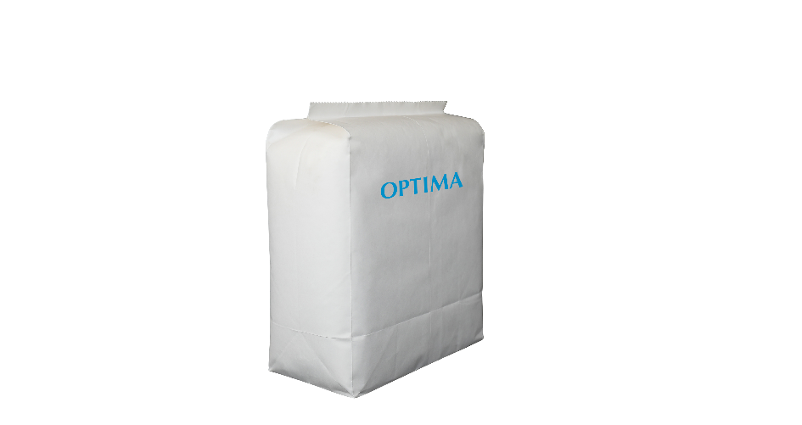
The Optima Group has developed the world's first paper packaging for sanitary napkins in collaboration with a consumer goods group. (Source: Optima)

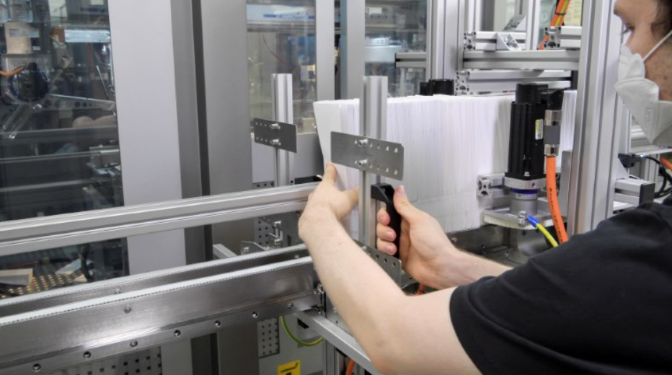
The paper bags are added to the packaging process. (Source: Optima)

Characters (incl. spaces): 2.252

Press contact:
OPTIMA packaging group GmbH
Jan Deininger
Group Communications Manager
+49 (0)791 / 506-1472
jan.deininger@optima-packaging.com
www.optima-packaging.com

About OPTIMA
Optima supports companies worldwide with flexible and customer-specific filling and packaging machines for pharmaceuticals, consumer goods, paper hygiene and medical devices markets. As a provider of solutions and systems, Optima accompanies these companies from the product idea through to successful production and throughout the entire machine life cycle. Over 2,650 experts around the globe contribute to Optima's success. 19 locations in Germany and abroad ensure the worldwide availability of services.

Thank you very much for your publication. We look forward to receiving a specimen copy.

