PRESS RELEASE
Schwaebisch Hall, September 27, 2019

What moves the industry
Insights and prospects impress participants at the OPTIMA Pharma Forum 2019

That discussions are necessary and good for the pharmaceutical industry was once again demonstrated by the Pharma Forum organized by Optima Pharma, the most recent installment of which took place in Schwaebisch Hall on September 18 and 19. In a nutshell, the Pharma Forum comprised 200 participants from 25 countries, nine speakers, a podium discussion, and a tour of the latest machine technology.
Sharing experiences, learning from one another, networking, and getting to know new trends and developments – these are the characteristics of the Pharma Forum. Biotechnologically produced drugs, in particular, proved to be a major topic of conversation because their special properties and potential are truly shaking up the industry like never before. Sanofi’s Yatin Gokarn (USA) reported that more than 50 percent of research and development is now in the field of biotechnology drugs. This dawn of a new era could be clearly felt and experienced at the Pharma Forum.
Alexander Haig (Catalent) and other speakers agreed that today multiproduct-capable systems for the often sensitive biopharmaceutical drugs are therefore needed. Due to the all-round complexity, sound plant engineering today can only succeed with close collaboration between customer and supplier, whereby the challenges virtually always differ from project to project. Special robot and transport systems are therefore increasingly deployed in aseptic processes. Many of the new drugs are highly potent, which means they are extremely effective even in very small quantities. Topics of discussion ranged from the necessary protective mechanisms, such as specific pressure zone concepts or the ideal placement of special filters in the plant, to the logistics for the pharmaceuticals and treatment of consumables with product contact. Rainer Glöckler presented the strategies of the specialized CMO (contract manufacturing organization) service provider Swissfillon.
Just how important technical innovations ultimately are for patients was made clear several times. The audience was particularly touched by the contribution of Dr. Annette Künkele, senior physician at the Berlin Charité hospital, who talked about a case of a child suffering from leukemia, where all known therapies had failed. Thanks to a new type of therapy (CAR T-cell therapy), the girl’s tumor cells have disappeared and not returned for seven years now. This is a therapeutic approach with a very high success rate, which can now be statistically demonstrated as well. However, this therapy is still immensely expensive and elaborate, and the drug is extremely sensitive. In order to make such therapies widely available, technology needs to step up to the task – with highly flexible solutions starting with diagnostics and spanning the entire production chain.
Time and again, with real-life conditions in mind, the focus of the Pharma Forum returned to the cost aspect – right up to the question from which batch sizes it pays to invest in equipment to sterilize the containers, or when the presterilized ready-to-use (RTU) components are an advantage. It is certain that with the advent of biotechnological drugs even small batches must be processed safely and highly efficiently. Galina Hesse (Sanofi, Germany) had no doubt that digitalization will play an important role here in the near future. Not only in the form of complete process automation, which is already virtually the norm today; rather, it is about avoiding predictable problems in systems, for example, by means of data analysis.
Biosimilars are on an exciting path. Similar to generics for chemically produced drugs, they promise cheaper patient care but with biopharmaceutical drugs whose patent protection will expire. This is where the technical requirements for market entry are just as high as for the biological originals, explained Javier Camposano (Celltrion). At the same time, the relevant international regulations are still far from harmonized, which is currently still negatively influencing market entry and costs.
This example also shows how much the pharmaceutical industry is on the move, even though it describes itself as conservative – not least due to the stringent regulatory requirements of the health authorities. One aspect that became clear at the Pharma Forum is that although innovations are demanded and desired by health authorities, their introduction is often faced with major bureaucratic hurdles – both in drug development and in the manufacturing processes of the ready-to-use product. Still, pharmaceutical safety is and will remain the highest priority – something else all speakers and participants unanimously agreed on. The requirements and paths to this goal are more diverse than ever. Ultimately, the panel discussion also focused on the question of what the future of aseptic production looks like.
Several answers to this question were presented during a tour of a section of the production and the new Optima Pharma CSPE (Comprehensive Scientific Engineering) Center. Participants enjoyed a firsthand look at new handling and transport systems, robotics in various applications, entire turnkey lines including for highly potent drugs, innovative sterility test isolators, new highly efficient isolator decontamination systems, insights into freeze-drying technologies from Optima Pharma, and digitalization strategies. The pharmaceutical experts were even impressed with the special building technology of the CSPE Center, which is a prerequisite for integrated factory acceptance tests (iFATs). Supply lines for all required media were unobtrusively integrated into the hall floor. The extended hall height means that the HVAC (heating, ventilation, air-conditioning) components of isolators can now also be accommodated. Complex lines can now already be coordinated and tested in the factory instead of later at the customer’s site. All in all, visitor feedback about the Pharma Forum and about Optima as organizers was very positive: “We knew after the very first lecture that it was worth attending,” noted one participant.
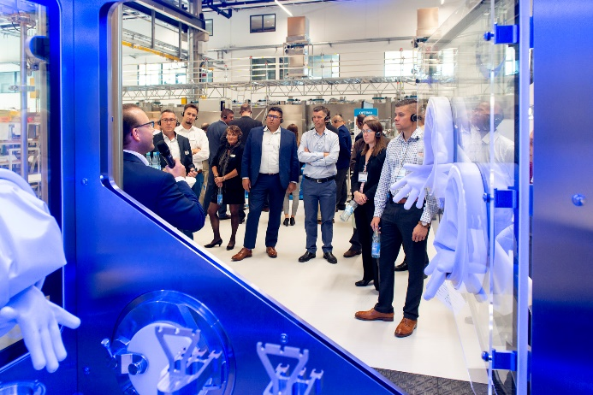
The pharmaceutical challenges of the future require new technical concepts, and Optima Pharma has responded with an immense variety of new solutions. These include robotics for a wide range of applications as well as highly efficient fumigation systems (pictured) for decontamination.

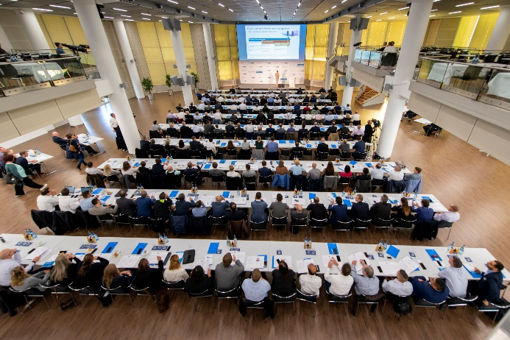
Over two days, the Pharma Forum 2019 offered a wealth of valuable information: from digitalization and plant flexibility to the successful management of complex technology and projects.

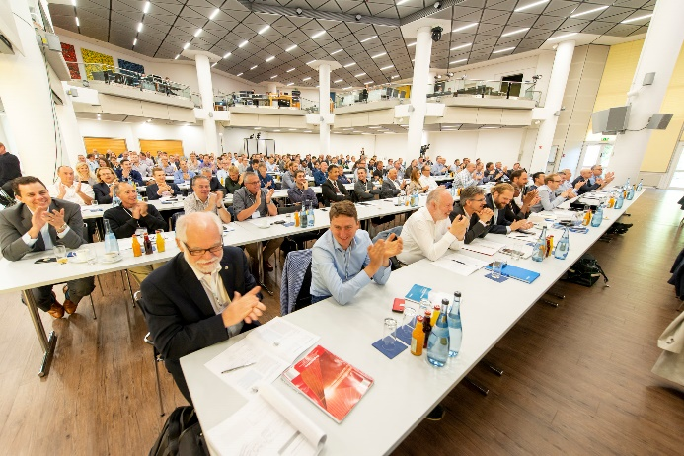
Now in its seventh installment, the Pharma Forum 2019 attracted 200 visitors from 25 countries to Schwaebisch Hall.

Characters (incl. spaces): 6,186

Press contact:
OPTIMA packaging group GmbH
Jan Deininger
Editor
+49 (0)791 / 506-1472
jan.deininger@optima-packaging.com
www.optima-packaging.com
Thank you very much for your publication. We look forward to receiving a specimen copy.

