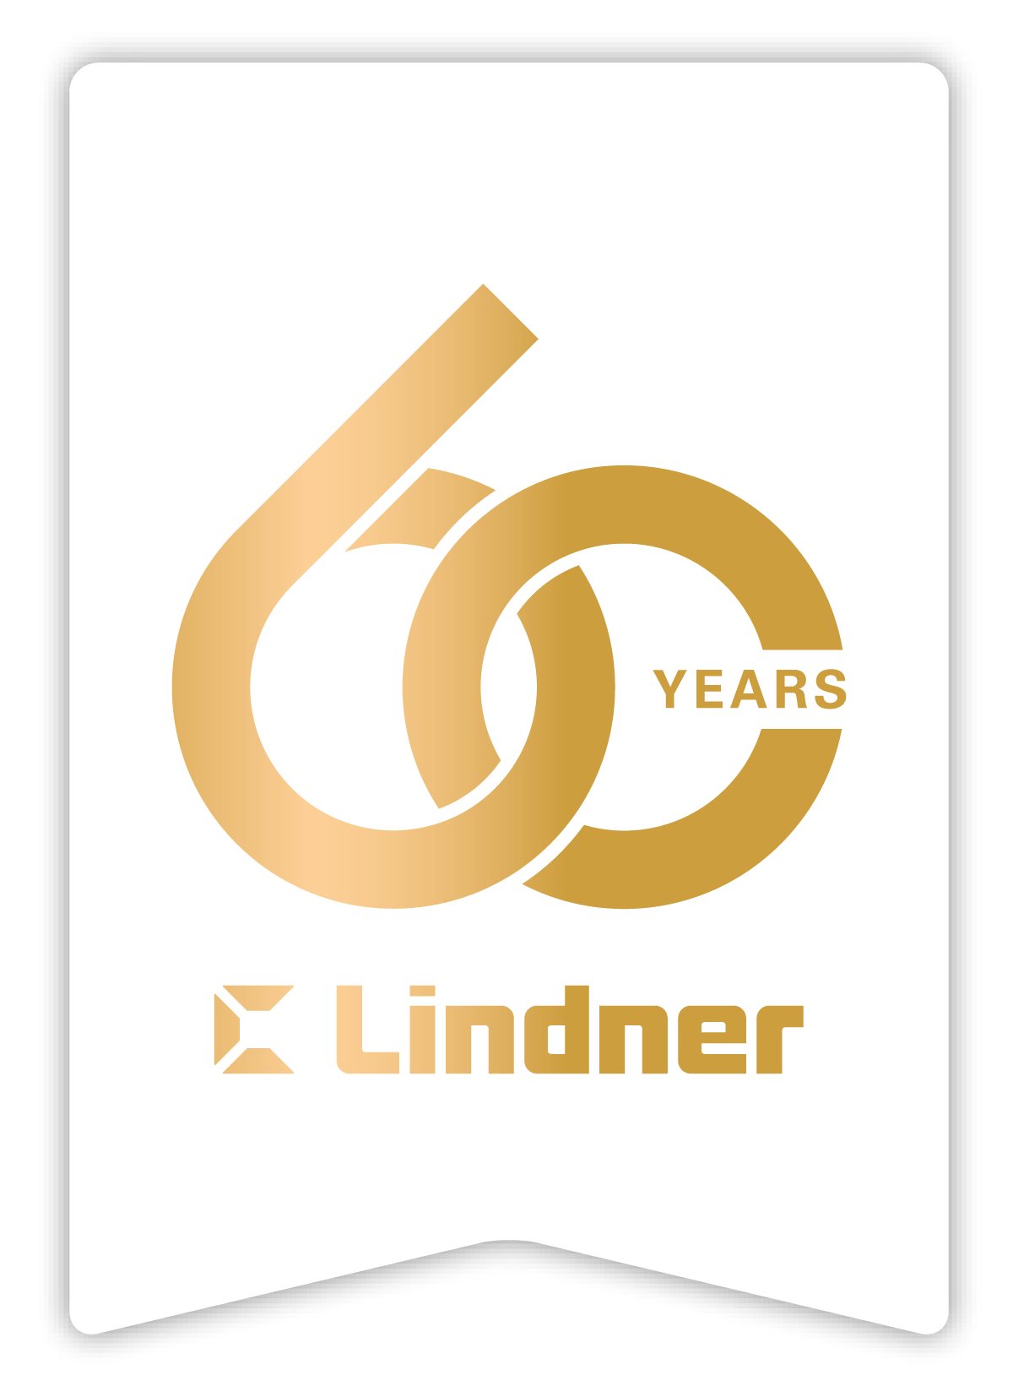

EXPO REAL 2025 – Successful Start to Trade Fair for the Lindner Group

From 6 to 8 October, the Lindner Group exhibited at EXPO REAL in Munich for the first time. As Europe's largest trade fair for real estate and investment, it is the ideal platform for presenting the Lindner Group's SMART Solutions to an international audience.

**Holistic, sustainable, efficient**  
Under the motto ‘Turning Ideas Into Impact – with SMART Solutions by Lindner’, the Lindner Group presented holistic approaches to construction projects. At Lindner, SMART Solutions stands for:

S = Sustainable |Secure | Strategic

M = Modular | Measurable | Methodical

A = Agile | Advanced | Adaptive

R = Results-driven | Resilient | Reliable

T = Transformative | Transparent | Time-efficient

SMART Solutions thus cover all phases of a project – from planning and execution to project management – and combine functionality, cost-effectiveness and sustainability. Practical examples illustrated how construction projects can be implemented systematically and in a results-oriented manner with SMART Solutions.

**Circular economy and value retention**

A key component of the trade fair presentation was the exchange of ideas on circular construction and sustainable material strategies. On 6 October, Madaster hosted an exclusive Madaster get-together at the Lindner Group stand. Together, they discussed value retention, material data and recyclable planning – a valuable exchange between existing and new customers as well as industry experts.

This was followed on 8 October by a panel discussion with the German Sustainable Building Council (DGNB) on the topic of ‘Circular construction: Where is the industry on its way from buzzword to real practice?’. Together with experts, topics such as building resource passports, material registers and Cradle to Cradle were examined. Visitors gained practical insights into how circular construction can already be successfully implemented today.

**Successful premiere**  
Participation in EXPO REAL 2025 was a resounding success for the Lindner Group. ‘EXPO REAL offered us a great amount of added value, and having our own exhibition stand allowed us to showcase the full strength of Lindner in one place and engage even more intensively with our clients about future projects and relevant industry topics,’ said Heinrich Büchner, Managing Director of the Lindner Group.

The considerable interest in the solutions presented, numerous technical discussions with existing and new customers, and industry representatives once again highlighted the relevance of sustainable and holistic construction concepts.

**Pictures**

Bildverweise: © [www.Lindner-Group.com](http://www.Lindner-Group.com)

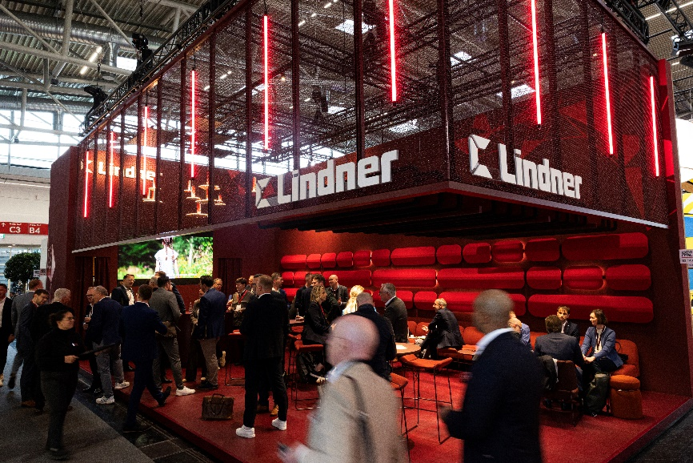

**Lindner_img-de-expo-real-muenchen-2025 (4).jpg**

**Lindner Group**

The Lindner Group is Europe's leading specialist in interior fit-out, facades, building services engineering and insulation technology. The family business has 60 years experience in “Building New Solutions”, the development and execution of individual and advanced project solutions that provide Add.Vantage. With 8,000 employees worldwide, Lindner operates production sites and subsidiaries in more than 40 countries from its headquarters in Arnstorf, Bavaria.

**Lindner Group**

Press Contact: Christina Rieger

Bahnhofstraße 29, 94424 Arnstorf, Germany

Phone +49 8723 20-3148

Christina.Rieger@Lindner-Group.com

**More Information on** [www.Lindner-Group.com](http://www.Lindner-Group.com)

[LinkedIn](http://www.linkedin.com/company/lindner-group) | [Instagram](http://www.instagram.com/lindner_group) | [Facebook](https://www.facebook.com/LindnerGroup.Karriere) | [Pinterest](http://www.pinterest.de/lindnergroup) | [YouTube](https://www.youtube.com/user/LindnerGroup)