PRESS RELEASE
Schwaebisch Hall, November 21, 2019

Tailored flexibility for sustainable packaging

Looking back: AMOTEK at the K 2019

The newest AMOTEK R168 is a technically advanced machine model that has a lot to offer. Its live demonstrations inspired the visitors at Amotek's booth during the K 2019 in October. The improved compact design impresses with its maximum versatility. It is also suitable to process compostable and recycled materials.

The plastic market is on the move, evolving to consider the ecological world tendencies. Energy and material savings are demanded for sustainable packaging, so the curiosity and the need for information at the Amotek stand with regard to processing solutions was correspondingly high. Amotek answered by presenting the tightest package ever performed by its AMOTEK R168 machine, demonstrating, live on the exhibition floor, a real material savings.

In addition to the plastic material, Amotek is able to grant the use of recycled and compostable materials to satisfy the request of a minor group of producers, mainly European, that are currently adopting the use of these bio-plastic materials.

Amotek confirmed once again, its innovative flexibility by presenting at the show a live visually appealing Mater-Bi packaging with garbage rolls. Mater-Bi is now undoubtedly the leader of biodegradable and compostable film packaging material whose destiny is still under evaluation.

Another topic together with packaging tightness, is surely the new machine frame design, in which Amotek has also succeeded in making the machine even more compact. These features paired with the smart control of the machine, which can be done in parallel via external devices such as tablets or smart phones, as well as the simplified human/machine interfaces and an easier customer care interaction through the teleservice, captured a lot of attention among the visitors. The AMOTEK R168’s product versatility has again been underlined. Projects for freezer bags, table covers, toothbrushes, disposable gloves, small paper hygiene packaging and other products were also discussed at the show.

Compared to the previous K trade editions, Amotek registered a constant number of visitors with an above-average number of project inquiries. This means that the show was able to meet expectations fully. As the world's leading trade show for the plastics industry, K 2019 attracted many international visitors to Amotek's stand. Most of them came from Europe, followed by the Middle East. Delegation from Asia, Africa, and South America were also strongly represented.

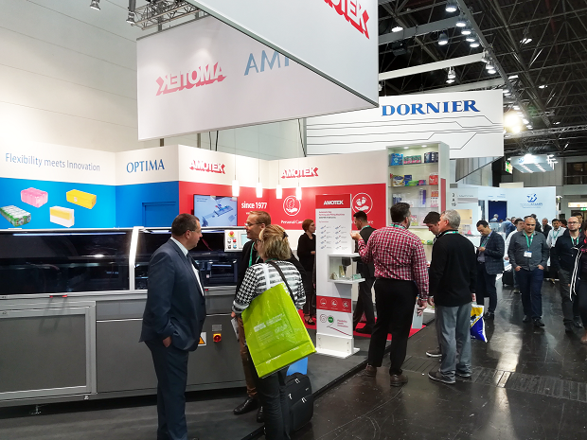
Environmental aspects come to the fore in the packaging of a wide variety of products. Amotek presented solutions for this at the K show.

Characters (incl. spaces): 2,540

Press contact:
OPTIMA packaging group GmbH
Jan Deininger
Editor
+49 (0)791 / 506-1472
jan.deininger@optima-packaging.com
www.optima-packaging.com
Thank you very much for your publication. We look forward to receiving a specimen copy.

