LAUDA expands into India

Temperature control specialist opens sales company
Degree LAUDA Precision in Pune

Lauda-Königshofen, November 28, 2025 – LAUDA DR. R. WOBSER GMBH & CO. KG, the global market leader for temperature control devices and systems, has officially opened its new Indian sales company, Degree LAUDA Precision Pvt. Ltd., in Pune. With this strategic expansion, the family-owned company is strengthening its position in the world's most populous country with over 1.4 billion people and tapping into new growth markets in South Asia. The tenth foreign subsidiary of LAUDA is operating as a joint venture with its long-standing partner, Sawant Process Solutions, and is serving customers in India, Bangladesh, and Sri Lanka.

High-ranking guests from business and politics accepted the invitation to the opening ceremony, which was hosted by Indian actress and TV presenter Anushrii Bathla Oza. Dr. Gunther Wobser, President & CEO of LAUDA, traveled to India together with Felix Heinrich-Bignasse, Director Global Sales. Among the guests of honor were Kalpesh Saraf, Regional Director of the Indo-German Chamber of Commerce in Pune, and representatives of Rödl & Partner, who supported LAUDA in the founding process.

“India is developing into one of the most important future markets for LAUDA,” explains Dr. Gunther Wobser. “The World Bank forecasts economic growth of 6.7 percent for the next two years. We want to make the most of these exceptional market opportunities with our local presence.” Pune in the state of Maharashtra offers excellent conditions as a location. The metropolitan region, with a population of around five million, is located 150 kilometers southeast of Mumbai. Major German companies such as Liebherr, Volkswagen, and Mercedes-Benz India, as well as larger medium-sized companies such as Marquardt, have already settled in the region. The final location was chosen after Dr. Wobser participated in a successful delegation trip organized by the Baden-Württemberg Ministry of Economic Affairs in February 2025.

The structure of Degree LAUDA Precision is based on the successful cooperation with the Indian representative Sawant Process Solutions Pvt. Ltd., which has been a distributor for LAUDA for 17 years and will take a 25 percent stake in the new sales company. Devaki Sawant will join Managing Director Marco Hauser and Dr. Gunther Wobser as a member of the board of directors. The entire Sawant family, including Sandeep Sawant, Managing Director & CEO, his wife Gauri Sawant, Member of the Board of Directors, as well as Devaki and her sister Deveshree Sawant, attended the opening ceremony.

“We rely on proven partnerships and combine these with the advantages of our own company,” explains Dr. Wobser. “Sawant Process Solutions is much more than a successful distributor. As a partner in our joint venture, they have demonstrated trust, reliability, and competence over many years and opened the doors to the Indian market for us.”

In addition to the joint venture with Sawant Process Solutions, LAUDA has already gained three further sales partners for the region: S.V. Scientific and APP Systems, with whom LAUDA already works successfully in Singapore, will also be active in India. Nuventa Limited acts as a partner in Bangladesh. Further distributors are to follow. “With new sales partners, we are gaining access to additional customer groups such as automotive and semiconductors,” emphasizes Dr. Wobser.

LAUDA is sending experienced sales specialist Marco Hauser to Pune to set up and manage the new subsidiary. He has been living in the Indian metropolis with his family since the beginning of August 2025. “Having our own sales office enables us to improve intercultural exchange, obtain first-hand market information, and coordinate local sales activities much more closely,” emphasizes Dr. Wobser.

“We are not only bringing our products and technologies to India, but also our values such as quality, reliability, and innovation,” said Dr. Wobser in his opening speech. With Degree LAUDA Precision, the family-owned company is planning double-digit growth rates per year in the coming years. The investment in the Indian sales company underscores the long-term commitment of LAUDA to one of the most dynamic economic regions in the world and its conviction that local presence is the key to sustainable success in this promising market.

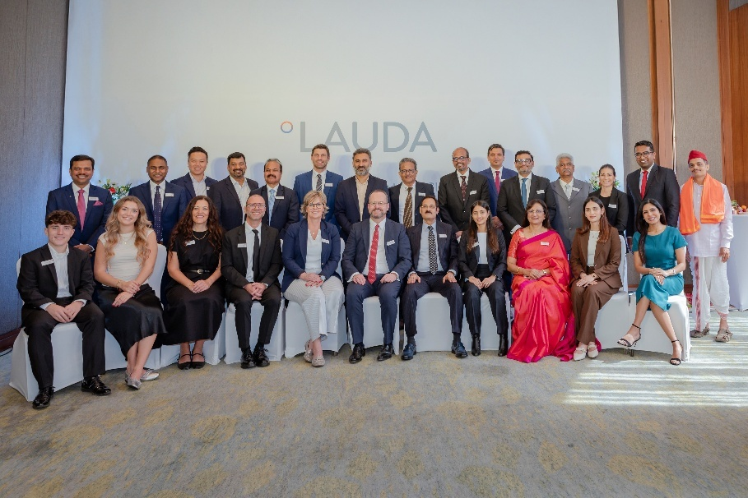
Picture 1: High-ranking guests from business and politics as well as partner companies celebrate the opening of Degree LAUDA Precision in Pune, India – a milestone for the expansion of the global market leader LAUDA into one of the most dynamic future markets worldwide. © LAUDA

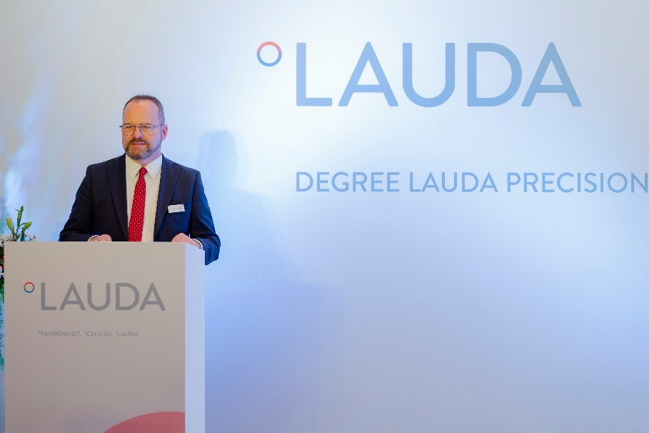
Picture 2: In his welcome speech at the opening ceremony of Degree LAUDA Precision in Pune, Dr. Gunther Wobser, President & CEO of LAUDA, emphasizes the importance of proven partnerships and the value of local presence for sustainable success in the growing Indian market. © LAUDA

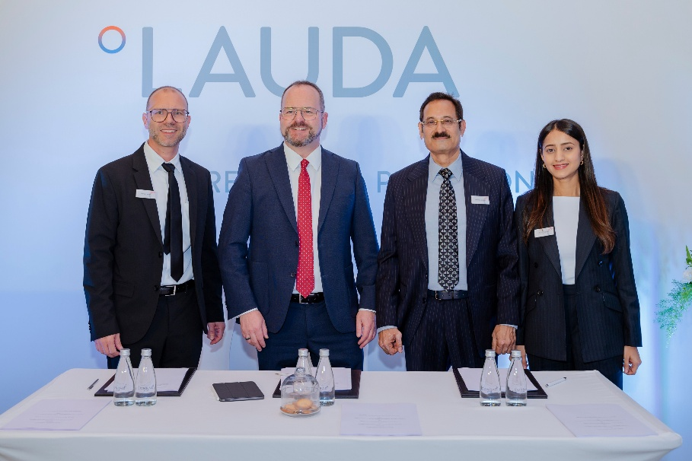
Picture 3: Laying the foundation for a successful future: From left to right: Marco Hauser (Managing Director of Degree LAUDA Precision), Dr. Gunther Wobser (President & CEO of LAUDA), Sandeep Sawant (Managing Director & CEO of Sawant Process Solutions) and Devaki Sawant (Associate Director, Member of the Board of Directors) at the signing ceremony for the joint venture agreement. © LAUDA

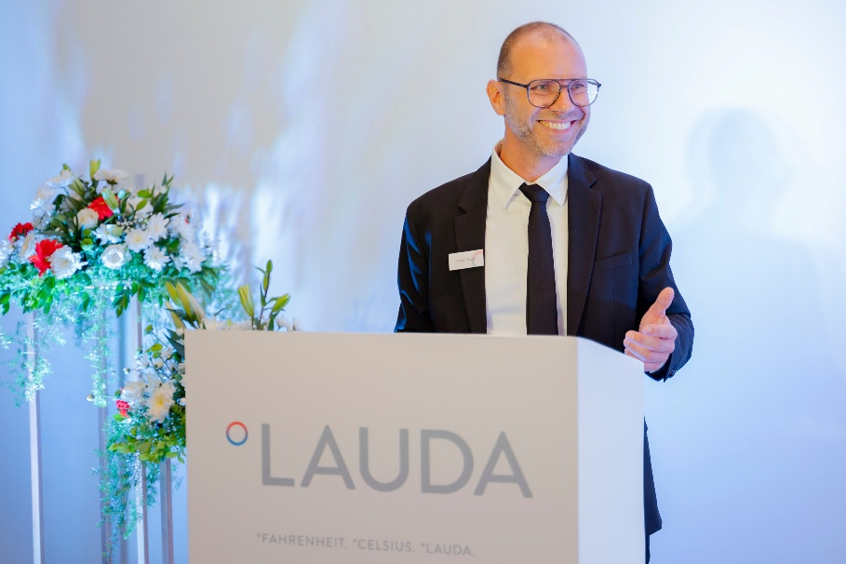
Picture 4: Marco Hauser, Managing Director of Degree LAUDA Precision, explains the goals of the new sales company at the opening ceremony in Pune, which aims to achieve double-digit growth rates through better intercultural exchange and closer coordination. © LAUDA

We are LAUDA – the world leader in precise temperature control. Our constant temperature equipment and systems are at the heart of important applications, contributing to a better future. As a complete one-stop supplier, we guarantee the optimum temperature in research, production and quality control. We are the reliable partner for Aerospace, Electromobility, Hydrogen, Chemistry, Pharmaceuticals/Biotech, Semiconductors and Medtech. We have been inspiring our customers for almost 70 years with our expert mentoring and innovative solutions – every day anew and all over the world.

In our company, we always go one step further. We support our employees’ development and are constantly developing ourselves: to create a better future together.

Press contact
We are more than happy to make prepared information about our company, the LAUDA Factory Gallery and our projects in the area of innovation promotion, digitalization and idea management available to the press. We look forward to hearing from you – just give us a call!

CHRISTOPH MUHR
Director Corporate Communications
T + 49 (0) 9343 503-349
christoph.muhr@lauda.de

LAUDA DR. R. WOBSER GMBH & CO. KG, Laudaplatz 1, 97922 Lauda-Königshofen, Deutschland/Germany. Limited partnership: Headquarters Lauda-Königshofen, Registration court Mannheim HRA 560069. General partner: LAUDA DR. R. WOBSER Verwaltungs-GmbH, Headquarters Lauda-Königshofen, Registration court Mannheim HRB 560226. Managing Directors: Dr. Gunther Wobser (President & CEO), Dr. Mario Englert (CFO), Dr. Marc Stricker (COO)

