PRESS RELEASE
Schwaebisch Hall, February 9, 2021

Dr. Stefan Koenig becomes Managing Director at OPTIMA packaging group

On March 1, 2021, Dr. Stefan Koenig will become Managing Director at OPTIMA packaging group GmbH. Together with Hans Buehler (Managing Director/CEO), Gerhard Breu (Chairman, Optima Pharma Division) and Jan Glass (CFO), Koenig will be responsible for continuing the development of the Optima Group. The primary focus will be on products and markets. He will also be tasked with the strategic development and increased internationalization of the Optima Consumer Division and other subsidiaries.
The Optima Group is on a growth trajectory. The company, in line with its positive business development, has been able to gain a top manager from the packaging machinery industry, who will oversee the company's continued growth. "We are delighted to have gained, in Dr. Stefan Koenig, such an experienced manager for Optima – one who brings with him a wealth of knowledge from the field of special machine construction and our target industries," says Buehler.
Koenig is especially familiar with the food and pharmaceutical industries and has extensive experience in series production. Before he joined Optima, 55-year-old Koenig had held senior management positions for over 20 years, including four years spent in Asia. Most recently, Koenig was CEO at Bosch Packaging Technology, which is now Syntegon Technology.
König holds a doctorate in mechanical engineering and describes himself as a "constructive team player, a forward and lateral thinker, as well as someone who drives intercultural and cross-functional cooperation with high expectations of results". The married father of three has a positive outlook on his new duties at the Schwaebisch Hall-based family group: "I am delighted to be part of a group of companies that is now undergoing such dynamic development and is at the forefront of technology in many areas."

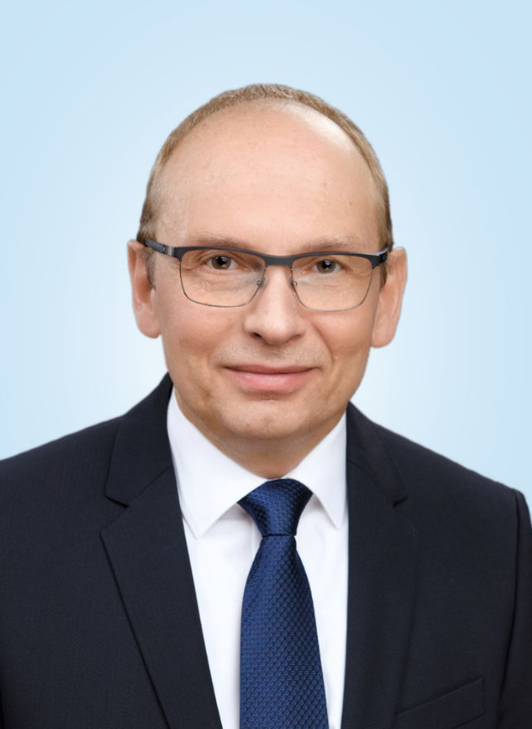
On March 1, 2021, Dr. Stefan Koenig will become Managing Director at OPTIMA packaging group GmbH. (Source: Optima)

Characters (incl. spaces): 1,894

Press contact:
OPTIMA packaging group GmbH
Jan Deininger
Group Communications Manager
+49 (0)791 / 506-1472
jan.deininger@optima-packaging.com
www.optima-packaging.com

About OPTIMA
Optima supports companies worldwide with flexible and customer-specific filling and packaging machines for pharmaceuticals, consumer goods, paper hygiene and medical devices markets. As a provider of solutions and systems, Optima accompanies these companies from the product idea through to successful production and throughout the entire machine life cycle. 2,450 experts around the globe contribute to Optima's success. 19 locations in Germany and abroad ensure the worldwide availability of services.

Thank you very much for your publication. We look forward to receiving a specimen copy.

