PRESS RELEASE
Schwaebisch Hall, November 24, 2022

Award for sustainability strategy
OPTIMA receives silver medal from EcoVadis

The EcoVadis rating agency has awarded Optima a silver medal for its core sustainability strategy "We care for tomorrow". This places the Optima Group in the top 25 percent of the companies rated by EcoVadis. The areas assessed were the environment, labor and human rights, ethics, and sustainable procurement. Optima's sustainability strategy is assessed annually by EcoVadis to identify new potential initiatives and promote existing activities.
"The jump from last year's bronze medal to this year’s silver medal demonstrates that we are on track with our sustainability strategy. We are looking to become outstanding across the board in the areas of environment, social responsibility and corporate governance", according to Dr. Stefan König, Managing Director at Optima.
Since May 2022, Optima's company-wide sustainability strategy "We care for tomorrow" has consisted of three pillars: circular packaging, sustainable technology and corporate sustainability. This means that Optima is targeting packaging solutions for a circular economy along with resource-saving production processes developed in partnership with customers. In addition, past activities are integrated into a comprehensive environmental and climate strategy. Specific goals for the next few years have been set as well as aspirations in the areas of social responsibility and sustainable corporate governance.
EcoVadis's regular assessment means that optimization processes can be identified at an early stage. The silver medal's status will remain effective for twelve months and then be re-evaluated.
The EcoVadis rating agency was founded in 2007 and has become the world's leading provider of sustainability ratings, with an international network of over 100,000 rated companies. The rating methodology is based on international sustainability standards such as the Global Reporting Initiative, the United Nations Global Compact and ISO 26000.
Through measures such as investing in photovoltaic systems, the Optima Group has already been able to reduce its climate footprint by 40 percent since 2009. A further package of measures will reduce this by an additional 25 percent by 2030. (Source: Optima)

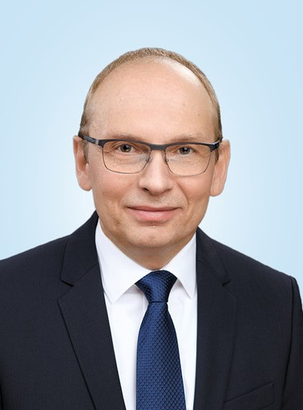
"The jump from last year's bronze medal to this year’s silver medal shows that we are on track with our sustainability strategy. We are looking to become outstanding across the board in the areas of environment, social responsibility and corporate governance", according to Dr. Stefan König, Managing Director at Optima. (Source: Optima)

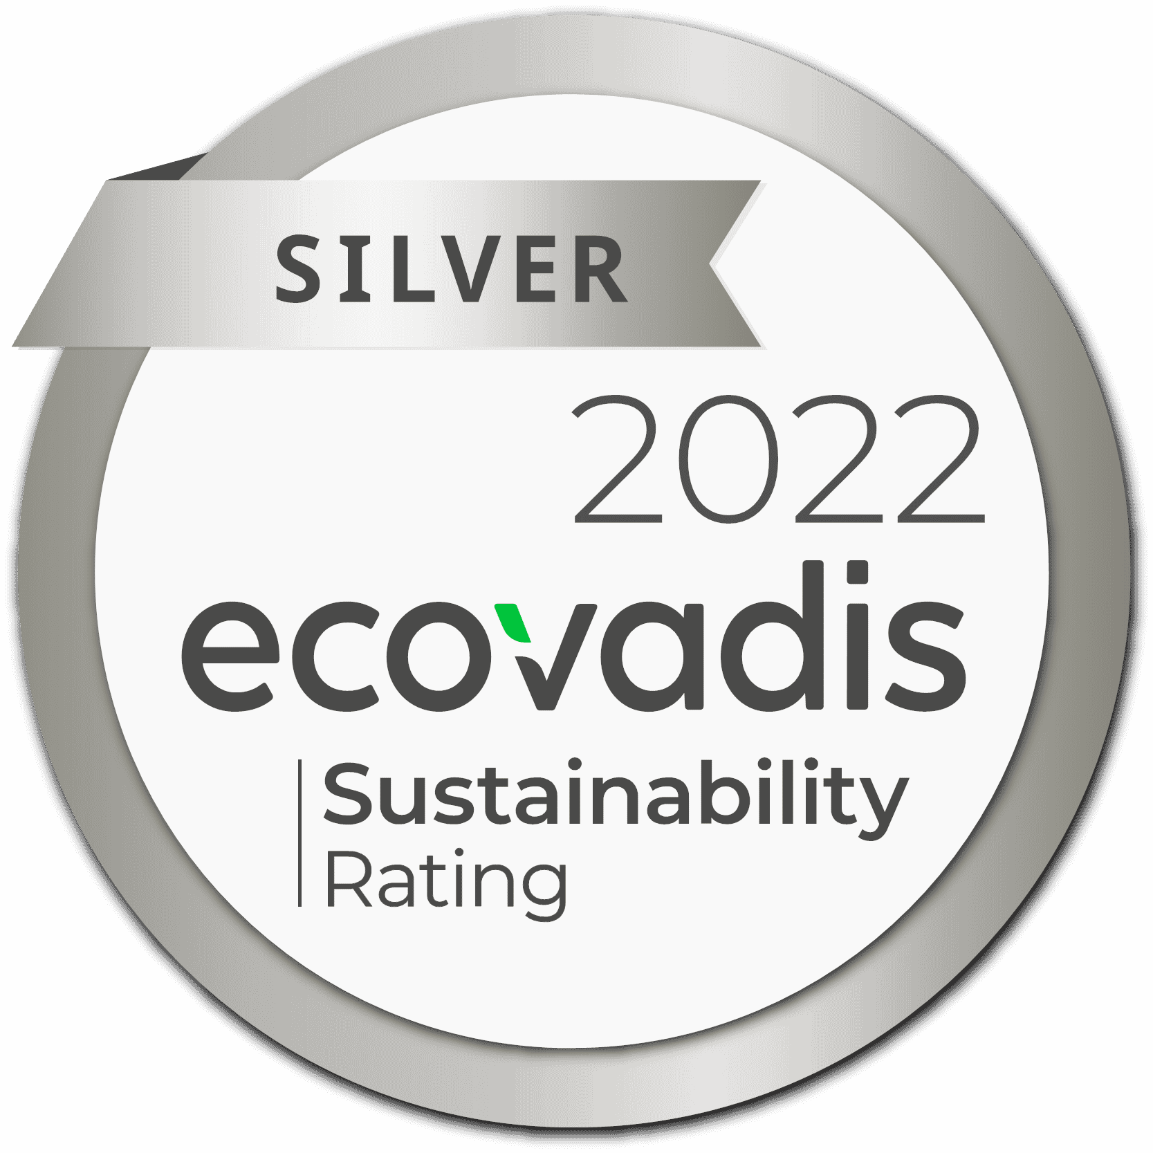
EcoVadis rating agency awards Optima with a silver medal for its sustainability strategy. (Source: EcoVadis)

Characters (incl. spaces): 1.996

Press contact:
OPTIMA packaging group GmbH
Jan Deininger
Group Communications Manager
+49 (0)791 / 506-1472
jan.deininger@optima-packaging.com
www.optima-packaging.com

About OPTIMA
Optima supports companies worldwide with flexible and customer-specific filling and packaging machines for pharmaceuticals, consumer goods, paper hygiene and medical devices markets. As a provider of solutions and systems, Optima accompanies these companies from the product idea through to successful production and throughout the entire machine life cycle. Over 3,000 experts around the globe contribute to Optima's success. 20 locations in Germany and abroad ensure the worldwide availability of services. In 2022, Optima celebrates the company's 100th anniversary.
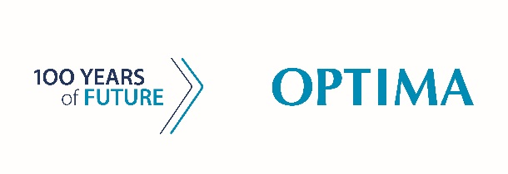
Exciting stories from 100 years of Optima: www.100-years-of-future.com

Thank you very much for your publication. We look forward to receiving a digital specimen copy.

