Alexander Hahn  Memory of Light, Light of Memory  29 October 2022 – 2 April 2023, Kunstmuseum St. Gallen  Alexander Hahn (*1954, Rapperswil) has worked in the electronic and digital media arts in Europe and America since 1981. He transforms events from his personal life, history, art, and science into video art, making use of the inner worlds of memories and dreams. After his solo exhibition The Bernoulli Itinerary in 1991, he will now present an overview of his work at the forefront of developments in new media.  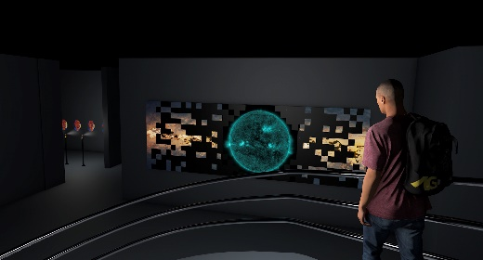  Alexander Hahn, computer-generated installation view, basement level of the Kunstmuseum St. Gallen with TRANSIT OF EARTH, 2022, © 2022, ProLitteris, Zurich  The artist completed his degree in art education at the Zurich University of the Arts in 1979 and took part in the Whitney Museum Independent Study Program in New York in 1981. He lives and works in Zurich and New York. Hahn’s works have been shown in numerous solo and group exhibitions and at film festivals in New York, Zurich, Sydney, Berlin, Beijing, and New Delhi, and has received numerous awards. He has had major retrospectives at the Kunstmuseum Solothurn in Switzerland, the Museum der Moderne in Salzburg, Austria, and the Padiglione d’Arte Moderna in Ferrara, Italy.  Curator: Roland Wäspe | Exhibition dates  29 October 2022 – 2 April 2023  Kunstmuseum St. Gallen  Press conference  28 October 2022  11 a.m.  Exhibition opening  28 October 2022  6:30 p.m.  Opening hours  Tuesday to Sunday, 10 a.m. to 5 p.m.,  Wednesday, 10 a.m. to 8 p.m.
Press contact

Gloria Weiss
Head of Communications
Museumstrasse 32
9000 St. Gallen
T +41 71 242 06 84

Sophie Lichtenstern
Communications
Museumstrasse 32
9000 St. Gallen
T +41 71 242 06 85

kommunikation@kunstmuseumsg.ch
www.kunstmuseumsg.ch

Fact sheet
Alexander Hahn
Memory of Light, Light of Memory

Exhibition dates | 29 October 2022 – 2 April 2023
Exhibition venue | Kunstmuseum St. Gallen
Press conference | 28 October 2022, 11 a.m., Kunstmuseum St. Gallen
Exhibition opening | 28 October 2022, 6:30 p.m., Kunstmuseum St. Gallen
Curator | Roland Wäspe
Opening hours | Tuesday – Sunday: 10 a.m. – 5 p.m.,  Wednesday: 10 a.m. – 8 p.m.
Admission | Single admission, regular price  Pensioners  Vocational, school, and university students  Members of the Kunstverein St. Gallen | CHF 12.00  CHF 10.00  CHF 6.00  Free
Press contact | Gloria Weiss  T +41 71 242 06 84  Sophie Lichtenstern  T +41 71 242 06 85  kommunikation@kunstmuseumsg.ch
Website | www.kunstmuseumsg.ch

Other exhibitions
Current  www.kunstmuseumsg.ch/en/ausstellungen | Upcoming  www.kunstmuseumsg.ch/en/our-program/preview

