Collection Fever  From August 26, 2023 | Kunstmuseum St. Gallen  With “Collection Fever”, Kunstmuseum St. Gallen is launching a new presentation of its extensive holdings, which span more than five centuries of artistic practice. The exhibition highlights the unique history of this museum; its origins in the 800-year-old tradition of textile production, the private collections that were assembled in St. Gallen, and the influence of the local and wider European art market on both the artists and collectors. The artworks will be presented according to a timeline which follows the different textiles manufactured in St. Gallen over the centuries—from early medieval linens to cotton, to lace, and today’s high tech fabrics. The display opens with a newly-commissioned work by Geneva-based artist Mathias C. Pfund (born 1992). Specifically produced for the context of the exhibition, Pfund’s installation refers to the history of collecting in the city.  “Collection Fever” provides an in-depth view of the collection at Kunstmuseum St. Gallen; showing how the museum was established in 1877 and how the collection has grown over the years. Through asking new questions, addressing contemporary themes and perspectives, the collection is being illuminated and interpreted in new ways.  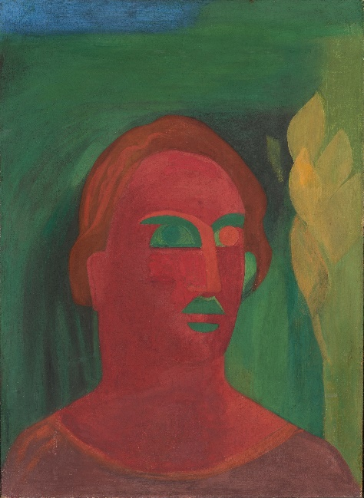  Ferdinand Gehr, Roter Kopf (Red Head), around 1926, Kunstmuseum St. Gallen.  Donation of the heirs in memory of Ferdinand Gehr 2014.  Photo: Sebastian Stadler, 2014 © Gehr-Stiftung, St. Gallen.  The title of the exhibition, “Collection Fever”, is derived from “Archive Fever,” the 1995 essay by Algerian-French philosopher Jacques Derrida (1930–2004). In this text, he defines fever as the opposing principle to order—ordering being traditionally associated with the concepts of collecting and archiving. At the same time, according to the philosopher, it is only through fever—underlying curiosity, tracking, and accumulation—that collections and archives are created. Derrida describes this as “to burn with a passion. It is never to rest, interminably, from searching for the archive right where it slips away. It is to run after the archive, even if there’s too much of it.”  It is precisely this feverish energy that has been the guiding principle for “Collection Fever”—leading to the new and the unexpected. Thinking of collecting as a feverish activity is to acknowledge that it has much to do with accumulating. It also raises questions around the connections between prestige, money, and art. In the case of St. Gallen, this then points to the relationship between textiles and art.  Curated by Melanie Bühler, Dorothee Haarer, Gianni Jetzer and Lorenz Wiederkehr | Exhibition Dates  From August 26, 2023  Kunstmuseum St. Gallen  Press Conference  August 25, 2023  11:00 a.m.  Exhibition Opening  August 25, 2023  6:30 p.m.  Opening Hours  Tue – Sun: 10:00 a.m. – 5:00 p.m.  Thu: 10:00 a.m. – 8:00 p.m.
Press Contact

Gloria Weiss
Head of Communications
Museumstrasse 32
9000 St. Gallen
T +41 71 242 06 84

kommunikation@kunstmuseumsg.ch
kunstmuseumsg.ch

Factsheet
Collection Fever

Exhibition Dates | From August 26, 2023
Exhibition Venue | Kunstmuseum St. Gallen
Press Conference | August 25, 2023, 11:00 a.m., Kunstmuseum St. Gallen
Exhibition Opening | August 25, 2023, 6:30 p.m., Kunstmuseum St. Gallen
Curated by | Melanie Bühler, Dorothee Haarer, Gianni Jetzer und Lorenz Wiederkehr
Opening Hours | Tuesday – Sunday: 10:00 a.m. – 5:00 p.m.  Thursday: 10:00 a.m. – 8:00 p.m.
Admission | Adults  Seniors  Students  Members of the Kunstverein St. Gallen | CHF 12.–  CHF 10.–  CHF 6.–  Free
Press Contact | Gloria Weiss  T +41 71 242 06 84  kommunikation@kunstmuseumsg.ch
Website | kunstmuseumsg.ch

Jacques Derrida, “Archive Fever: A Freudian Impression,” trans. Eric Prenowitz, Diacritics 25, no. 2 (Summer 1995): 9–63.

