GEA unveils the ConsiGma® FC Flex: production-scale film coating system

Düsseldorf, October 6, 2026 – GEA unveiled the ConsiGma® FC (CFC) Flex at CPHI Milan (October 6–8, 2026, Fiera Milano), a production-scale film coater that brings the process developed on the ConsiGma® FC Lab to commercial-scale volumes. This compact, high-throughput system is designed for use in the pharmaceutical, dietary supplement, and chemical industries. The primary function of the ConsiGma® FC (CFC) Flex is to automatically coat tablets, capsules, or pellets with an ultra-thin, uniform protective or functional film, processing small sub-batches in rapid sequence to achieve high throughput.
The CFC Flex features the same drum diameter as the laboratory unit. Only the wheel depth and number of nozzles change, allowing operators to work with the same process behavior from the laboratory through production – with no need for additional optimization or training. Safety containment is built into the design. Loading and unloading through the BUCK® split valve are intended to prevent dust exposure and eliminate the need for specialized personal protective equipment.
The system is designed for OEB4 as standard and, with the optional CIP upgrade, is compatible with OEB5–6. Integrated wash nozzles support fully automated cleaning cycles.
Sub-batches of about nine kilograms and a six-minute cycle keep work-in-process inventory low and workflows moving smoothly. The free-fall coating process gently handles soft, friable, and irregularly shaped tablets while reducing coating solution consumption by about one-third. Loading and unloading take place within the wall plate, and shallow drums help minimize the system’s footprint. “The FC Flex is precision tablet-coating technology designed around the people who operate it. Our philosophy is ‘scale out rather than scale up’: the drum stays the same, so teams can move seamlessly from the laboratory bench to full-scale production without having to learn anything new. For operators, that means faster, cleaner, and more cost-effective development, along with the same protection and simplicity they know from the laboratory, carried through into production,” said Mark Rowland, Strategic Business Director, Pharma Solid Dosage, GEA Pharma & Healthcare.
Visitors can meet the GEA team in Hall 9, Booth A66, or book a live demonstration or formulation trial at one of GEA’s pharmaceutical test centers.

ConsiGma® and BUCK® are registered trademarks of GEA in several countries.

Photo:
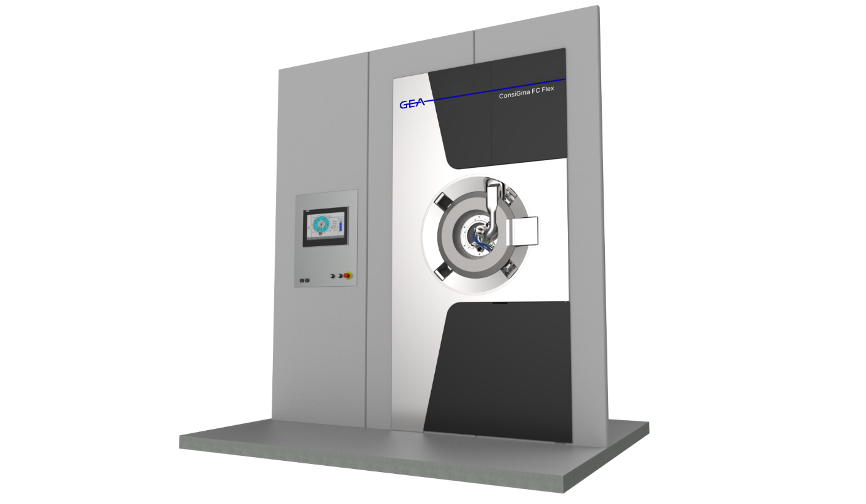
Photo: At CPHI Milan (October 6–8, 2026, Fiera Milano), GEA unveiled the ConsiGma® FC (CFC) Flex, a production-scale film coater that implements the process developed on the ConsiGma® FC Lab at commercial scales. (Illustration: GEA)

NOTES TO EDITORS
- Further information about GEA
- To the GEA Media Library
- Features on current topics
- Overview press events
- Follow GEA on  

About GEA
GEA is one of the world’s largest suppliers of systems and components to the food, beverage and pharmaceutical industries. The international technology group, founded in 1881, focuses on machinery and plants, as well as advanced process technology, components and comprehensive services. For instance, every second pharma separator for essential healthcare products such as vaccines or novel biopharmaceuticals is produced by GEA. In food, every fourth package of pasta or every third chicken nugget are processed with GEA technology.

With more than 18,000 employees, the group generated revenues of about EUR 5.5 billion in more than 150 countries in fiscal year 2025. GEA plants, processes, components and services enhance the efficiency and sustainability of customers’ production. They contribute significantly to the reduction of CO2 emissions, plastic usage and food waste. In doing so, GEA makes a key contribution toward a sustainable future, in line with the company’s purpose: “Engineering for a better world.”

GEA is listed on the DAX, the STOXX® Europe 600 Index and is also a constituent of the leading sustainability indices DAX 50 ESG, MSCI Global Sustainability and Dow Jones Best-in-Class World.

More information can be found online at gea.com.
If you do not want to receive any further information from GEA, please send an e-mail to pr@gea.com.

Media Relations
GEA Group Aktiengesellschaft
Dr. Michael Golek
Ulmenstraße 99, 40476 Düsseldorf
Telefon +4921191361505
michael.golek@gea.com

