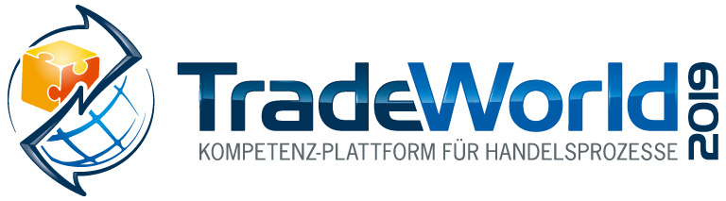
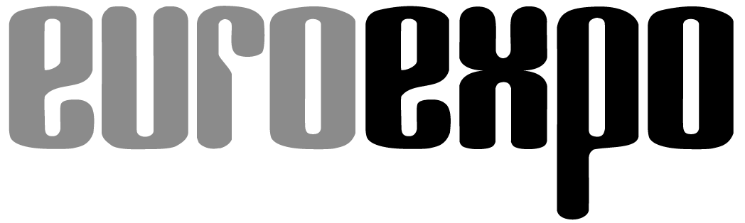
Messe- und Kongress-GmbH
Joseph-Dollinger-Bogen 7
D-80807 Munich, Germany
Phone: +49 89 323 91 259
Fax: +49 89 323 91 246
www.euroexpo.de/en
www.logimat-messe.de/en
www.tradeworld.de/en

February 19–21, 2019 | Messe Stuttgart

Presented at:

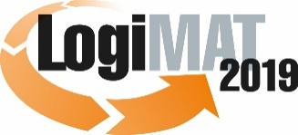

The 17th International Trade Show for
Intralogistics Solutions & Process Management
February 19 -21, 2019 | Messe Stuttgart

Munich, January 22, 2019

Press Release

TradeWorld at LogiMAT 2019 in Stuttgart
The power of the digital supply chain in commercial logistics

The effective application of new technologies such as smart data, artificial intelligence, blockchain, tracking & tracing, and electronic route management brings greater transparency to commercial logistics, which in turn helps optimize resources. Julia Miosga, Head of Retail and Logistics at Bitkom e.V., presents the expert forum “Digitization Brings Transparency to Commercial Logistics” on Tuesday, February 19, 2019. Miosga uses real-world examples to illustrate how digital technology is already helping businesses optimize their existing resources.

The digital revolution is changing more than just products and business models: It’s transforming entire organizational structures, bringing greater transparency not only to the companies themselves but to their value chains. One more reason why businesses should be open to the opportunities of digitization. This kind of transparency benefits management, employees, and customers alike. That's because it makes it possible for all authorized parties to simultaneously view, share, and create redundant backups of data anywhere, anytime– and now even allows data to be authenticated across the entire value chain.

But how exactly does digitization contribute to greater transparency for customers, businesses, and entire markets? Answers can be found at the expert forum “Digitization Brings Transparency to Commercial Logistics,” moderated by Julia Miosga, Head of Retail and Logistics at Bitkom e.V., taking place at TradeWorld in Hall 2, Forum T on Tuesday, February 19, 2:45–4:00 p.m. Here’s a sneak peek at two examples:

The platform economy in the supply chain

One trend in digital technology commonly associated with the retail sector is the “platform economy”– the bundling of buying and selling activities on platforms. The best known examples of this are probably Amazon and eBay, but the online realm is now populated by a variety of specialized digital platforms. Those who seek supply chain transparency can no longer afford to ignore this trend. Gone are the days when you simply offered goods and services in an online marketplace. Today’s providers must keep a watchful eye on demand and integrate it into their business processes. Data needs to be collected, thoroughly analyzed, and ultimately monetized. These are typical attributes of third-generation platforms.

Sensor technology: how smart data changes transport monitoring

Sensor technology has long been the basis for monitoring and evaluating such factors as environmental influences on goods in transit. Digital technologies make it possible to use sensors much more widely to monitor temperature, vibration, humidity, and much more. This opens the door to using sensor technologies to control the flow of goods within a company, identify and predict bottlenecks, reduce inventories, and automate processes – with a resulting increase in overall productivity.

More examples at the TradeWorld Forum

The above examples are only a small sample of what digital technologies can offer businesses today. Julia Miosga from Bitkom will talk with business leaders about how they are already using these technologies today. Anne Bernardy, Head of the Smart System Innovation Lab of FIR at RWTH Aachen University, presents “5G for the IoT in Logistics: a Use Case Study.” Udo Latino, Managing Director of brodos.net GmbH, speaks on “Reinventing Retail– Omnichannel Made Easy,” and Stephanie Less, Head of Marketing & PR at Agrand, presents “Greater Transparency in Agricultural Trade through Data Sharing.” The entire program is included in the registration price for LogiMAT.

Event organizer:
EUROEXPO Messe- und Kongress-GmbH | Joseph-Dollinger-Bogen 7 | 80807 Munich
Phone: +49 89 323 91 259 | Fax: +49 89 323 91 246

3, 691 characters (with spaces)

Munich, January 22, 2019 – This text may be reprinted free of charge, but please send a copy to EUROEXPO Messe- und Kongress-GmbH, Press and Public Relations Department, 80807 Munich.

About TradeWorld/LogiMAT

LogiMAT 2019, the 17th International Trade Show for Intralogistics Solutions and Process Management, will take place February 19–21 on the grounds of Messe Stuttgart, directly adjacent to Stuttgart International Airport. LogiMAT, now the world’s largest intralogistics trade show with over 1,600 exhibitors, offers a comprehensive overview of everything driving the intralogistics industry, from procurement to production to shipping. International exhibitors gather early in the year to showcase innovative technologies, products, systems, and solutions for streamlining operations, optimizing processes, and cutting costs in a company’s internal logistics.

LogiMAT includes the extra bonus of TradeWorld, a professional platform for trade processes, which showcases innovative e-commerce concepts for designing, managing, and integrating digital technology in the areas of procurement, online shops and marketing, software, fulfillment, parcel services, returns, and after-sales. The TradeWorld expert forum in Hall 2 rounds off the program with a new series of presentations each day covering the following themes: The B2B E-Commerce Challenge; Digitization Brings Transparency to Commercial Logistics; B2B Commerce in the Age of the Platform; From Fulfillment to Omnichannel Business; AI and Robotics in Logistics and Trade; and Making the Most of Returns.
TradeWorld’s exhibition area and expert forum are a special strategic component of LogiMAT.

For more information, please visit: www.tradeworld.de/en or www.logimat-messe.de/en.

