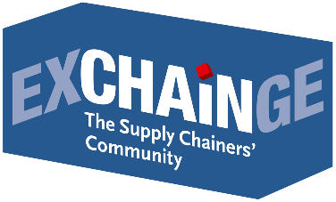
Press Release

The Digital Revolution Is Everyone’s Business –
Supply Chain Awards Presented to CEMEX and InstaFreight

Frankfurt am Main, November 22, 2018 - “We have an urgent need in Germany for more venture capital and a change in market conditions.” Dr. Patric Spethmann (presenter; COO, Gries Deco Company / DEPOT brand), speaking at the sixth EXCHAiNGE supply chain summit in Frankfurt, implored German businesses and policymakers to overcome their complacency and embrace the digital revolution. “We already have the talent, knowledge, and ideas. What we urgently need now is to finally implement a long-term roadmap for putting viable ideas into practice. We need to stop losing ground to the drivers in China, the United States, and elsewhere,” said Spethmann to the experts gathered at EXCHAiNGE. The technology is there: What’s lacking is the courage to try it out and the trust in people. This core argument was the common thread running through all the discussions at EXCHAiNGE.
Leaders in supply chain management, finance, logistics, and purchasing came together in Frankfurt on November 20 and 21, 2018, around the theme “Management 4.0 – New Work & Digital Business.” The Munich-based event organizer EUROEXPO Messe- und Kongress-Gesellschaft found a new home for the established conference at Hypermotion (November 20-22, 2018) in Frankfurt. The two-day EXCHAiNGE conference was filled with in-depth discussions of all things digital. The top themes in the spotlight included innovation and its drivers, the disruptive effects of big data and AI, the sustainability of supply chains, and the culture of digital transformation. “EXCHAiNGE focuses primarily on the necessary change process in the supply chain,” explains Dr. Petra Seebauer (Managing Director, EUROEXPO; Publisher, LOGISTIK HEUTE). “Digital transformation is on the mind of everyone here - every business and every individual. Global supply chains and the structures of new business models run smoothly only when we work together to develop a common understanding.”
EXCHAiNGE moderators Bettina Bohlmann (Managing Partner, 3p Procurement Branding) and Klaus Krumme (Managing Director, ZLV Center for Logistics and Traffic at the University of Duisburg-Essen) summed it up nicely: “It’s not easy to reconcile supply and demand,” remarked Krumme. And “trust is often more important that indicators,” added Bohlmann. Rainer Buchmann (CEO for Central Europe, Dematic) believes that digital transformation can succeed only if accompanied by “an appreciative corporate culture,” noting that this cannot be taken for granted, given the number of failed attempts. He pointed to many an attempt by “stodgy old parent companies” to burnish their image through the acquisition of a startup, only to see things go south if the different mentalities are not respected.
Johannes Giloth (Chief Procurement Officer and Senior Vice President of Global Operations, Nokia Solutions and Networks) believes that springboard innovations are possible only if the company management tolerates or actively promotes a bimodular approach. In other words: Employees with a traditional, conservative mindset of annual cycles (Mode 1) must be allowed to work as equal partners alongside those motivated by disruptive ideas (Mode 2). “If the respect is lacking, Mode 1 will consume Mode 2,” Giloth warned. His advice: “Create structures of innovation with teams of incubators, innovation funnels, and seed funding.”
Nicole Berger (Senior Sourcing Manager for Indirect Procurement, Zalando) pointed to the importance of network effects within a company: “Approach your colleagues, listen to what they have to say, and seize on new ideas.” Sometimes, that works better over coffee between meetings than during the meetings themselves. “Zalando has been in the market for ten years now, but we still consciously cultivate a startup mentality,” remarked Berger. “At Siemens we look systematically at the contribution that each and every individual wishes to make toward digital transformation,” reported Priska Göbel-Ralph (Director of Digitization, Siemens). The SCM Digital Network, with 40 core members organized across hierarchies and functional areas, “quickly and unbureaucratically adopts a genuine learning culture and consciously tolerate mistakes.” Employees have the opportunity to put forward their project ideas and receive support from Siemens in the form of money, expertise, and IT. Having trust in others and the courage to share knowledge and data - for Göbel-Ralph, this is essential.
Matthias Haubenreißer (Senior Manager for ECR & Supply Chain Management, GS1 Germany) also made a case for more trust: “We have lots of data, but every logistics service provider collects its own data. We need to open ourselves up to shared solutions. This is the only way to leverage the potential for consolidation.” Markus Klug (Leader of Data Science & Simulation, SSI Schäfer) also addressed trust in new technologies: “Amid the volatility in some areas of business - in light of the declining acceptance of warehouse stock and overcapacities, for example - we need to deploy learning systems.” Klug recommended starting with small AI projects, assessing data sovereignty, and keeping control over the process. Dr. Ulrich Franke (Managing Director, Institute for Supply Chain Security) argued for increased acceptance of blockchain, reporting “70 to 80 percent” cost savings through this new technology.
“We need to embrace data-sharing and collaboration - and this means trust,” warned Peter Trapp (Managing Director, startport). Without the right culture of innovation, no genuine innovation will emerge, he argued. “Investments in innovation are a tough sell when profit margins hover in the low single digits, and those who define themselves strictly by price have no wiggle room for innovation. The opaque, fragmented logistics market must become more open. Every new platform turns up the pressure on logistics professionals,” remarked Trapp. Dr. Thomas Wimmer (Chairman of the Executive Board, German Logistics Association BVL) believes that collaboration is a critical issue for the future: “Sometimes you also need to work with your competitors to satisfy demand and serve the markets.” Wimmer advised attendees to acquire experience in regional innovation hubs. “We invest a lot of money in incubator labs, in part to support them in the area of logistics,” explained Oliver Kaut (Vice President of Marketing & Sales for Germany, DHL Global Forwarding). “One aspect of collaboration is learning to differentiate ourselves from our competitors.”
Markus Ziegler (Division Manager, pakadoo/LGI Logistics Group International) noted that consolidation effects among service providers “saved up to 40 percent of last-mile costs.” This includes letting competitors use DHL packing stations. Ziegler reported that many customers already prioritize the quality of delivery services, putting “adherence to deadlines over speed.” Andreas R. Streubig (Director of Global Sustainability, Hugo Boss) underscored this point: “You can never automatically assume that all customers want to have their product delivered by tomorrow.” Streubig called for a “regulatory framework,” since competition is standing in the way of new shared solutions. He also pointed to the lack of clearly defined roles for customers and service providers in the context of sustainability. Practical solutions are imperative, he argued, given the high return rate of orders and the added expense of green certifications and shipping options. Streubig recommended arousing concern among customers by showing them how their consumer behavior impacts the environment.
Martine Bouman (Scientific Director, Center for Media & Health; Erasmus University Rotterdam) also recommended focusing on sharing information with customers and employees: “Behaviors don’t change overnight. People are capable of change only in response to new knowledge and insights.” “The issue of sustainability has not yet become a matter of course - not among businesses, and not among customers,” observed Klaus Krumme. “The effects of climate change and the long-neglected problems with the oceans will make themselves felt in the coming ten years.” Krumme called on institutions to act as well. “The public sector is still completely invisible as a partner in the larger issue of collaboration and startups, and that needs to change.”
That’s why the challenges of the future can only be met by a close-knit collaborative effort. Everyone needs to work together to create a robust, hybrid-integrated supply chain. The best examples of this came once more from the finalists in their pitches for the two awards presented to outstanding concepts along the supply chain. The Supply Chain Management Award was presented for the 13th time this year to CEMEX, a global manufacturer of building materials. The inaugural Smart Supply Chain Solution Award was awarded to InstaFreight, the digital freight forwarding company.
“In addition to the winners CEMEX and InstaFreight, the other finalists - BASF, Bossard, Schaeffler, and Synfioo/SAP - also presented innovative and outstanding solutions in their pitches,” noted Dr. Petra Seebauer during the awards ceremony. “All those taking part in this final round have already made a big splash and scored a real success,” emphasized Harald Geimer, a Partner at PwC Strategy&. Geimer and Seebauer represented the prestigious jury in presenting the awards alongside Johannes Giloth (2015 winner) and Dr. Patric Spethmann (2017 winner). In keeping with tradition, the live voting of the EXCHAiNGE conference delegates were considered in the jury deliberations.
In the interactive voting sessions, attendees were able to experience for themselves how collaboration and interdepartmental cooperation breed success. Participants had an hour to work on a supply chain simulation with EXCHAiNGE partners Andrea Walbert and Stefan Hoogervorst (both from the PMI Production Management Institute). The goal was to identify and address vulnerabilities in the value chain of an economically struggling fruit juice company and return it to profitability using expertise and teamwork.
“We took a bold initiative this year by joining forces with Hypermotion. We wanted to integrate our delegates and content with the Hypermotion audience and their focus on mobility and logistics. Both events stand for in-depth exchange in interactive formats. Now that it’s over, the task is to see how well the plan worked. We’re looking forward to EXCHAiNGE 2019,” concludes EXCHAiNGE initiator Petra Seebauer.

SAVE THE DATE
EXCHAiNGE—the Supply Chainers’ Community 2019 | November 26–27, 2019
Learn more: www.exchainge.de

About EXCHAiNGE
The “Supply Chainers’ Community” brings together movers and shakers from the worlds of SCM, finance, logistics, and purchasing. Representatives from businesses of all sizes - from startups to large enterprises - meet to talk about new business models, disruption, and approaches to successful integration.
EXCHAiNGE provides a roadmap for navigating such key issues of digital transformation as sustainability, culture and mindsets, blockchain, big data, and artificial intelligence. Finalists competing for the Supply Chain Awards offer profound insights into pre-eminent examples of best practice.
Visitors get valuable tips on repositioning their businesses to become drivers of innovation with the goal of generating a critical competitive advantage. EXCHAiNGE stands as an established networking platform that keeps visitors engaged through robust case studies and illuminating roundtables. The event is organized by EUROEXPO Messe- und Kongress-GmbH in Munich.

About HYPERMOTION
Mobility and logistics become one - at Hypermotion in Frankfurt am Main, November 20–22, 2018.
Following its successful debut in 2017, Hypermotion returns as a platform for forward-looking issues with a focus on smart systems and solutions for mobility, transport, logistics, and digital infrastructure and offering an innovative program for the mobility and logistics industries. Core questions: How will digitization and decarbonization transform transportation systems? How can we find unique, intermodal solutions for logistics and mobility chains in smart cities and digital regions?
The agenda blends seven interrelated topics: smart & digital regions, data analytics & security, synchronized & urban logistics, hypermodality (intermodal, multinational, digital), sustainability, monitoring & transparency, and connectivity. The event includes businesses of all sizes - from startups to large enterprises - together with researchers, policymakers, and representatives of professional associations. For the first time, the EXCHAiNGE conference is offered both as a part of Hypermotion 2018 and as a standalone event.
Learn more about Hypermotion.

About EUROEXPO Messe- und Kongress-GmbH
EUROEXPO Messe- und Kongress-GmbH was founded in 1996. Today, EUROEXPO organizes LogiMAT - the annual international trade show for intralogistics solutions and process management - as well as LogiMAT China and TradeWorld, the professional platform for trade processes.
EUROEXPO also organizes “EXCHAiNGE - the Supply Chainers’ Community.” The international business conference, now in its sixth year, targets leaders from the areas of SCM, finance, logistics, and purchasing at startups, small and medium-sized businesses, and large enterprises. EUROEXPO is also a service provider offering B2C and B2B event management services, such as the organization and implementation of the LOGISTIK HEUTE series.
For more information, please visit www.euroexpo.de.

Supply Chain Awards 2018
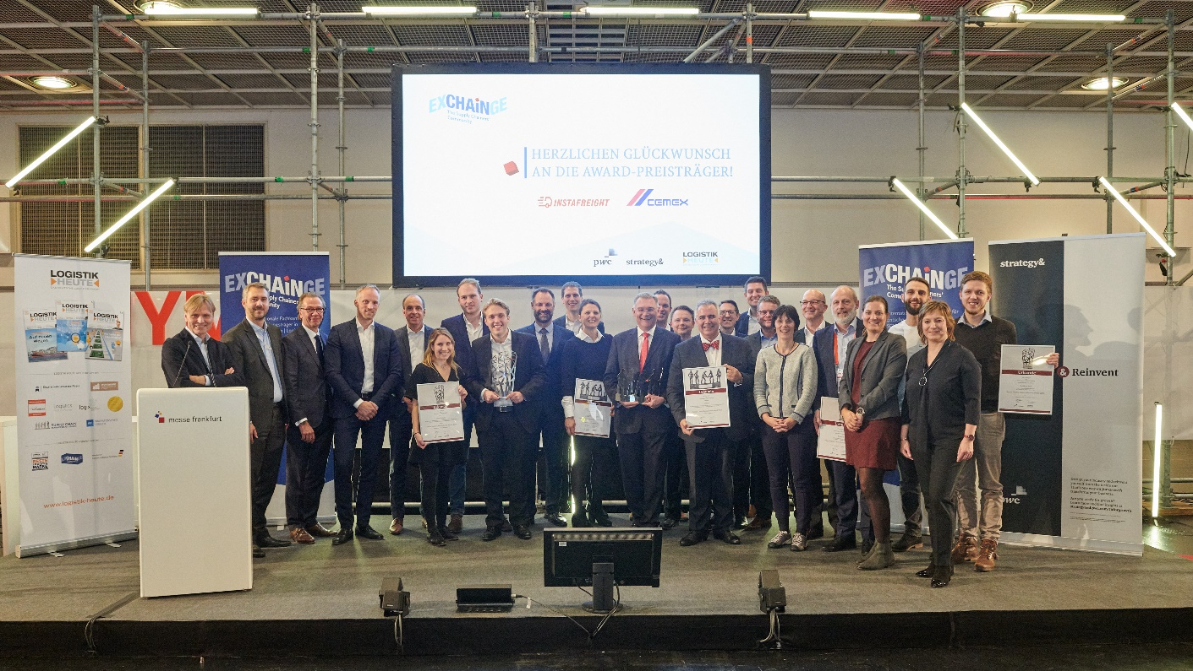

This year’s proud winners CEMEX and InstaFreight are joined by finalists BASF, Bossard, Schaeffler, and Synfioo/SAP and members of the jury at the ceremony to present the Supply Chain Awards 2018.
Photo credit: EUROEXPO Messe- und Kongress-GmbH

More images can be found here.

For more information, please contact:
Hendrikje Rother
Marketing/Press
EUROEXPO Messe- und Kongress-GmbH
Phone: +49 89 323 91 240
hendrikje.rother@euroexpo.de
www.exchainge.de/en

(Characters with spaces: 14,083)

EUROEXPO blog postings may be reprinted free of charge. Texts and images can be found at the EXCHAiNGE blog page under www.exchainge.de.
Please send a copy of any republication by email to hendrikje.rother@euroexpo.de or by postal mail to EUROEXPO Messe- und Kongress-GmbH | Presse- und Öffentlichkeitsarbeit | Joseph-Dollinger-Bogen 7 | 80807 München.

