PRESS RELEASE
Schwaebisch Hall, April 8, 2019

Complete solution for films with pharmaceutical ingredients receives ICE Award
Looking back – OPTIMA life science at ICE Munich 2019

An award in the bag and plenty of new contacts forged – now that ICE Europe in Munich has drawn to a close, Optima Life Science is taking a look back on a successful trade show. The films with pharmaceutical ingredients and the corresponding production and assembly technology from the COMEDCO alliance impressed industry experts. The COMEDCO complete solution for transdermal patches (TDPs) and orally disintegrating films (ODFs) received the ICE Award for “Special Film Innovations”, chosen by the trade show visitors through an online vote. The award ceremony was held on March 12 at ICE Europe in Munich.
Films with pharmaceutical ingredients that are used as transdermal patches or orally disintegrating films are attracting more and more attention in the industry. On the one hand this is reflected by the excellent visitor figures, but primarily by the many specific inquiries that alliance partners Coatema and Optima Life Science have received about the COMEDCO machine system. Visitors to ICE Europe in Munich were also very enthusiastic about Optima Life Science’s flexible and high-speed converting systems, which can be used to manufacture and package modern wound dressings, for example.
The COMEDCO machine solution was presented with the ICE Award for “Special Film Innovations”. The ICE Award commends exhibiting companies from the converting industry for best practice, innovation, excellence, and outstanding achievement. Numerous companies from various countries submitted their entries in four categories and the winners were decided by an online vote by the trade show visitors.
The two companies Coatema and Optima Life Science have combined their expertise in coating, converting and services to found the COMEDCO alliance. COMEDCO also acts as a development and technology partner for pharmaceutical companies wishing to market TDS and ODF products more efficiently. For this, the alliance can offer many years of experience and provide advice, as TDP and ODF products require a certain amount of development work before they are ready for the market. This includes selecting film carrier materials and suitable application systems, for example.
Various processes are combined within a COMEDCO system: placing and drying ingredients onto the carrier film, cutting the carrier film to size and winding it into individual rolls. In the subsequent web processing system, depending on the product, existing carrier films are removed, new ones applied and films cut to size, separated, and packaged. This process is either continuous or intermittent, depending on the performance requirements. The field of application for the COMEDCO machine system ranges from laboratory level through to series production.

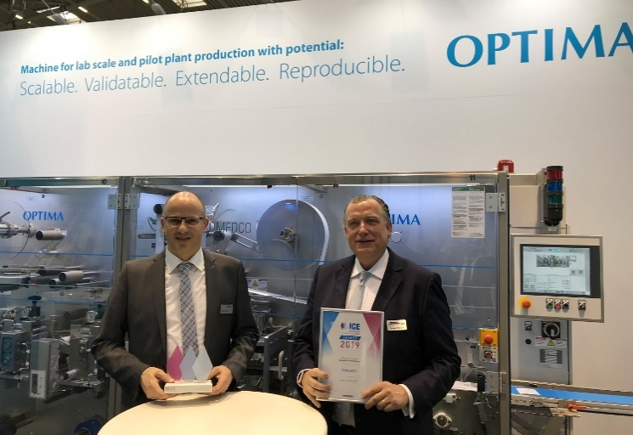
Werner Volk (Optima Life Science, left) and Thomas Kolbusch (Coatema) in front of the web processing section of a COMEDCO system, holding the 2019 ICE Award for “Special Film Innovations”, won by the alliance.

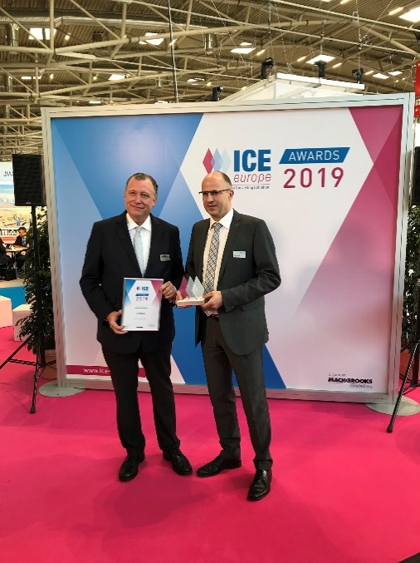
Successful alliance: Coatema and Optima Life Science have combined their expertise to create the COMEDCO machine solution. The COMEDCO turnkey solution received the 2019 ICE Award for “Special Film Innovations”. Thomas Kolbusch (Coatema, left) and Werner Volk (Optima Life Science) accepted the award at the trade show.

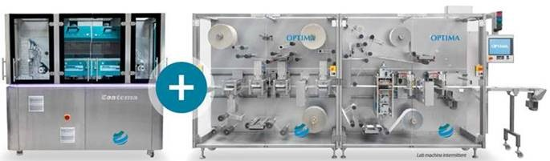
COMEDCO systems cover the entire manufacturing process for ODF and TDP products, including packaging. They are perfect for companies entering this sector. COMEDCO received the 2019 ICE Award in the “Special Film Innovations” category at ICE Europe in Munich.

Characters (incl. spaces): 2,859

Press contact:
OPTIMA packaging group GmbH
Jan Deininger
Editor
+49 (0)791 / 506-1472
jan.deininger@optima-packaging.com
www.optima-packaging.com
Thank you very much for your publication. We look forward to receiving a specimen copy.

