PRESS RELEASE
Schwaebisch Hall, July 22, 2020

Sustainable and honest packaging for the world of the future
OPTIMA sets up a Sustainability Department

The Optima Group based in Schwaebisch Hall, Germany, has made sustainability one of its central tenets. To this end, a Sustainability Department has been set up to concentrate on developing ideas and solutions.
The issue of sustainability has become increasingly important. Discussions with major food and paper hygiene groups, and with partner companies, have confirmed the need for a comprehensive approach to the issue along the entire value chain. So for Optima, Sustainability is one of the four core issues, along with Flexibility, Safety and Digitalization.
The Sustainability Department is provided with support by project teams
The newly created "Sustainable Solutions" department also highlights the importance of this issue. From now on, Dominik Broellochs and Ulrich Burkart will be coordinating all of the sustainability initiatives for the Optima Group. They will be supported by project teams that are created on the basis of the expertise required and the specific issue. This means that the "Sustainable Solutions" team has at its disposal the largest possible capacity and an extensive network.

"We are shouldering the responsibility for the world of tomorrow," Joachim Dittrich, Chairman of the Optima Consumer Division, explains the new approach. "What will tomorrow's world need? What are consumers expecting and what will their purchasing behavior be like?" For Optima, these and other issues will be pivotal in the coming years. "Honest packaging" is particularly important to the team. After all, not everything that looks sustainable actually is sustainable. "Frequently, on first sight packaging may look highly environmentally friendly. However, when you compare the ecological assessment with other packaging materials, it soon becomes clear that appearances can often be deceptive," explains Dominik Broellochs. "Poorly designed packaging systems result in waste," says Broellochs. Comprehensive approaches to managing recycling prevent waste and make it possible to reuse or reprocess packaging in a sustainable way.
The honest, sustainable packaging of the future
This is why Optima has set itself the goal of developing the "honest, sustainable packaging" of the future. Already today, there is considerable expertise being fed into machine development. The best solutions for the future are being identified, working in collaboration with customers, packaging material suppliers and material manufacturers. Safety still plays an important role, but always from the point of view of environmental compatibility. This is also regularly checked working closely with research bodies. Wherever possible, the use of new barrier solutions should ensure product protection as well as material degradability and recyclability. For example, cellulose and other materials that have been somewhat overlooked, like cellophane, are being tested.

Compliance with legal requirements is checked and validated
The implementation of legal requirements and guidelines in the company is checked and validated as part of its Corporate Social Responsibility.
"We are pleased that we have been able to recruit two experienced Optima employees and pioneers for this challenging job – Ulrich Burkart and Dominik Broellochs. Their previous jobs mean that both have a good insight into the field of sustainable packaging," explains Joachim Dittrich. In the future, Optima will be reporting on the latest developments and solutions on a regular basis.

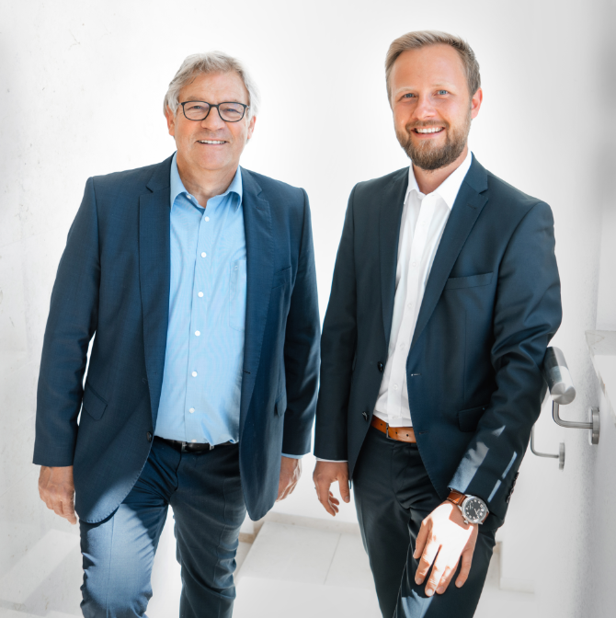
From now on, Ulrich Burkart (left) and Dominik Broellochs will be coordinating all of the Optima Group's sustainability initiatives. (Source: Optima)

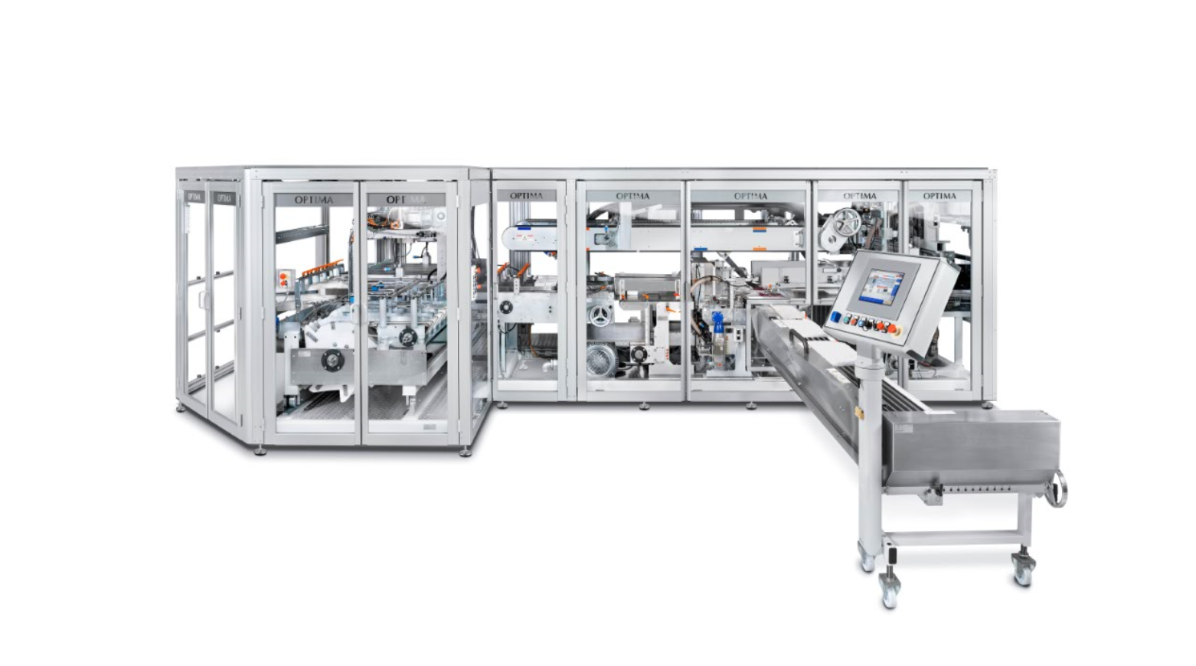
Optima is currently implementing projects with paper packaging. For instance, this is possible with the OPTIMA OSR packaging machine (pictured) for toilet rolls. Systems like these can be adapted from film or paper packaging in a flexible way. Optima is working with pure paper, and no coatings are needed for this packaging. (Source: Optima)

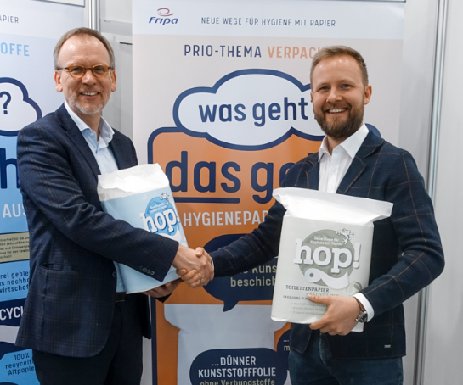
Working together with Fripa, one of the first paper packaging projects was completed. Torsten Bahl (left), a member of the Fripa management board, and Dominik Broellochs from the Team Sustainable Solutions with the new paper packaging. (Source: Optima)

Characters (incl. spaces): 3,557

Press contact:
OPTIMA packaging group GmbH
Jan Deininger
Editor
+49 (0)791 / 506-1472
jan.deininger@optima-packaging.com
www.optima-packaging.com
Thank you very much for your publication. We look forward to receiving a specimen copy.

